6 Practices to enhance the performance of a Text Classification Model

1. Domain Specific Features in the Corpus

For a classification problem, it is important to choose the test and training corpus very carefully. For a variety of features to act in the classification algorithm, domain knowledge plays an integral part.

For example, if the problem is “Sentiment Classification on social media data”, the training corpus should consist of the data from social sources like twitter and facebook.

2. Use An Exhaustive Stopword List

Stopwords are defined as the most commonly used words in a corpus. Most commonly used stopwords are “a, the, of, on, … etc”. These words are used to define the structure of a sentence. But, are of no use in defining the context. Treating these type of words as feature words would result in poor performance in text classification. These words can be directly ignored from the corpus in order to obtain a better performance. Apart from language stopwords, There are some other supporting words as well which are of lesser importance than any other terms.

 3. Noise Free Corpus

In most of the data science problems, it is recommended to undertake a classification algorithm on a cleaned corpus rather than a noisy corpus. Noisy corpus refers to unimportant entities of the text such as punctuations marks, numerical values, links and urls etc. Removal of these entities from the text would increase the accuracy, because size of sample space of possible features set decreases.

4. Eliminating features with extremely low frequency

Keywords which occur in lesser frequency in the corpus usually does not play a role in text classification. One can get rid of these low occurring features, resulting in better performance of the model.

5. Normalized Corpus

Words are the integral part of any classification technique. However, these words are often used with different variations in the text depending on their grammar (verb, adjective, noun, etc.). It is always a good practice to normalize the terms to their root forms. This technique is known as Lemmatization. For example, the words:

* Playing
* Player
* Plays
* Play
* Players
* Played

6. Use Complex Features: n-grams and part of speech tags

In some cases, features as the combination of words provides better significance rather than considering single words as features. Combination of N words together are called N-grams. It is known that Bigrams are the most informative N-Gram combinations. Adding bigrams to feature set will improve the accuracy of text classification model..

Bag of words [Bag of Words](https://en.wikipedia.org/wiki/Bag-of-words_model) (BoW) is an algorithm that counts how many times a word appears in a document. Those word counts allow us to compare documents and gauge their similarities for applications like search, document classification and topic modeling. BoW is a method for preparing text for input in a deep-learning net.

The bag-of-words model is simple to understand and implement and has seen great success in problems such as language modeling and document classification.

BoW lists words with their word counts per document. In the table where the words and documents effectively become vectors are stored, each row is a word, each column is a document and each cell is a word count. Each of the documents in the corpus is represented by columns of equal length. Those are wordcount vectors, an output stripped of context.

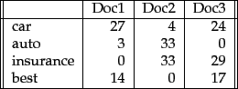

Before they’re fed to the neural net, each vector of wordcounts is normalized such that all elements of the vector add up to one. Thus, the frequencies of each word is effectively converted to represent the probabilities of those words’ occurrence in the document. Probabilities that surpass certain levels will activate nodes in the net and influence the document’s classification.

[Term Frequency-Inverse Document Frequency (TF-IDF)](https://deeplearning4j.org/bagofwords-tf-idf.html#term-frequency-inverse-document-frequency-tf-idf)

* **TF: Term Frequency**, which measures how frequently a term occurs in a document. Since every document is different in length, it is possible that a term would appear much more times in long documents than shorter ones. Thus, the term frequency is often divided by the document length (aka. the total number of terms in the document) as a way of normalization:   
    
  TF(t) = (Number of times term t appears in a document) / (Total number of terms in the document).
* **IDF: Inverse Document Frequency**, which measures how important a term is. While computing TF, all terms are considered equally important. However it is known that certain terms, such as "is", "of", and "that", may appear a lot of times but have little importance. Thus we need to weigh down the frequent terms while scale up the rare ones, by computing the following:   
    
  IDF(t) = log\_e(Total number of documents / Number of documents with term t in it).

See below for a simple example.

**Example:**

Consider a document containing 100 words wherein the word *cat* appears 3 times. The term frequency (i.e., tf) for *cat* is then (3 / 100) = 0.03. Now, assume we have 10 million documents and the word *cat* appears in one thousand of these. Then, the inverse document frequency (i.e., idf) is calculated as log(10,000,000 / 1,000) = 4. Thus, the Tf-idf weight is the product of these quantities: 0.03 \* 4 = 0.12.

In code

The code here is tested on Python 3 with [TextBlob 0.6.1](https://textblob.readthedocs.org/en/latest/). If you're using Python 2, you'll probably need to add from \_\_future\_\_ import division, unicode\_literals at the top.

**import** **math**

**from** **textblob** **import** TextBlob **as** tb

**def** tf(word, blob):

**return** blob.words.count(word) / len(blob.words)

**def** n\_containing(word, bloblist):

**return** sum(1 **for** blob **in** bloblist **if** word **in** blob.words)

**def** idf(word, bloblist):

**return** math.log(len(bloblist) / (1 + n\_containing(word, bloblist)))

**def** tfidf(word, blob, bloblist):

**return** tf(word, blob) \* idf(word, bloblist)

14 lines and we're already [flying](http://xkcd.com/353/).

* tf(word, blob) computes "term frequency" which is the number of times a word appears in a document blob, normalized by dividing by the total number of words in blob. We use TextBlob for breaking up the text into words and getting the word counts.
* n\_containing(word, bloblist) returns the number of documents containing word. A [generator expression](http://www.python.org/dev/peps/pep-0289/) is passed to the sum() function.
* idf(word, bloblist) computes "inverse document frequency" which measures how common a word is among all documents in bloblist. The more common a word is, the lower its idf. We take the ratio of the total number of documents to the number of documents containing word, then take the log of that. Add 1 to the divisor to prevent division by zero.
* tfidf(word, blob, bloblist) computes the TF-IDF score. It is simply the product of tf and idf.

Now to test it out on some real documents taken from Wikipedia.

document1 = tb("""Python is a 2000 made-for-TV horror movie directed by Richard

Clabaugh. The film features several cult favorite actors, including William

Zabka of The Karate Kid fame, Wil Wheaton, Casper Van Dien, Jenny McCarthy,

Keith Coogan, Robert Englund (best known for his role as Freddy Krueger in the

A Nightmare on Elm Street series of films), Dana Barron, David Bowe, and Sean

Whalen. The film concerns a genetically engineered snake, a python, that

escapes and unleashes itself on a small town. It includes the classic final

girl scenario evident in films like Friday the 13th. It was filmed in Los Angeles,

California and Malibu, California. Python was followed by two sequels: Python

II (2002) and Boa vs. Python (2004), both also made-for-TV films.""")

document2 = tb("""Python, from the Greek word (πύθων/πύθωνας), is a genus of

nonvenomous pythons[2] found in Africa and Asia. Currently, 7 species are

recognised.[2] A member of this genus, P. reticulatus, is among the longest

snakes known.""")

document3 = tb("""The Colt Python is a .357 Magnum caliber revolver formerly

manufactured by Colt's Manufacturing Company of Hartford, Connecticut.

It is sometimes referred to as a "Combat Magnum".[1] It was first introduced

in 1955, the same year as Smith &amp; Wesson's M29 .44 Magnum. The now discontinued

Colt Python targeted the premium revolver market segment. Some firearm

collectors and writers such as Jeff Cooper, Ian V. Hogg, Chuck Hawks, Leroy

Thompson, Renee Smeets and Martin Dougherty have described the Python as the

finest production revolver ever made.""")

bloblist = [document1, document2, document3]

**for** i, blob **in** enumerate(bloblist):

**print**("Top words in document {}".format(i + 1))

scores = {word: tfidf(word, blob, bloblist) **for** word **in** blob.words}

sorted\_words = sorted(scores.items(), key=**lambda** x: x[1], reverse=True)

**for** word, score **in** sorted\_words[:3]:

**print**("**\t**Word: {}, TF-IDF: {}".format(word, round(score, 5)))

For each document, we store the TF-IDF scores in a dictionary scores mapping word => score using a [dict comprehension](http://www.python.org/dev/peps/pep-0274/). We then sort the words by their scores and output the top 3 words.

The full script is [here](https://gist.github.com/6407257). The output of the program is:

Top words in document 1

Word: films, TF-IDF: 0.00997

Word: film, TF-IDF: 0.00665

Word: California, TF-IDF: 0.00665

Top words in document 2

Word: genus, TF-IDF: 0.02192

Word: among, TF-IDF: 0.01096

Word: Currently, TF-IDF: 0.01096

Top words in document 3

Word: Magnum, TF-IDF: 0.01382

Word: revolver, TF-IDF: 0.01382

Word: Colt, TF-IDF: 0.01382

There may be ways to improve the our TF-IDF algorithm, such as by ignoring stopwords or using a different tf scheme. I'll leave it up to the reader to experiment.

[Term-frequency-inverse document frequency](https://en.wikipedia.org/wiki/Tf%E2%80%93idf) (TF-IDF) is another way to judge the topic of an article by the words it contains. With TF-IDF, words are given weight – TF-IDF measures relevance, not frequency. That is, wordcounts are replaced with TF-IDF scores across the whole dataset.

First, TF-IDF measures the number of times that words appear in a given document (that’s term frequency). But because words such as “and” or “the” appear frequently in all documents, those are systematically discounted. That’s the inverse-document frequency part. The more documents a word appears in, the less valuable that word is as a signal. That’s intended to leave only the frequent AND distinctive words as markers. Each word’s TF-IDF relevance is a normalized data format that also adds up to one.

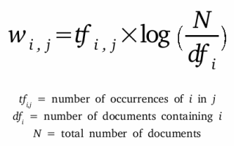

Those marker words are then fed to the neural net as features in order to determine the topic covered by the document that contains them.

While simple, TF-IDF is incredibly powerful, and contributes to such ubiquitous and useful tools as Google search.

BoW is different from [Word2vec](https://deeplearning4j.org/word2vec.html), which we’ll cover next. The main difference is that Word2vec produces one vector per word, whereas BoW produces one number (a wordcount). Word2vec is great for digging into documents and identifying content and subsets of content. Its vectors represent each word’s context, the ngrams of which it is a part. BoW is good for classifying documents as a whole.

## The Problem with Text

A problem with modeling text is that it is messy, and techniques like machine learning algorithms prefer well defined fixed-length inputs and outputs.

Machine learning algorithms cannot work with raw text directly; the text must be converted into numbers. Specifically, vectors of numbers.

A popular and simple method of feature extraction with text data is called the bag-of-words model of text.

A bag-of-words is a representation of text that describes the occurrence of words within a document. It involves two things:

1. A vocabulary of known words.
2. A measure of the presence of known words.

It is called a “bag” of words, because any information about the order or structure of words in the document is discarded. The model is only concerned with whether known words occur in the document, not where in the document.

*A very common feature extraction procedures for sentences and documents is the bag-of-words approach (BOW). In this approach, we look at the histogram of the words within the text, i.e. considering each word count as a feature.*

The bag-of-words can be as simple or complex as you like. The complexity comes both in deciding how to design the vocabulary of known words (or tokens) and how to score the presence of known words.

We will take a closer look at both of these concerns.

## Example of the Bag-of-Words Model

Let’s make the bag-of-words model concrete with a worked example.

### Step 1: Collect Data

### Step 2: Design the Vocabulary

Now we can make a list of all of the words in our model vocabulary.

The unique words here (ignoring case and punctuation) are:

Step 3: Create Document Vectors

The next step is to score the words in each document.

The objective is to turn each document of free text into a vector that we can use as input or output for a machine learning model.

## Managing Vocabulary

As the vocabulary size increases, so does the vector representation of documents.

## Scoring Words

Once a vocabulary has been chosen, the occurrence of words in example documents needs to be scored.

### word Hashing

You may remember from computer science that a [hash function](https://en.wikipedia.org/wiki/Hash_function) is a bit of math that maps data to a fixed size set of numbers.

## Limitations of Bag-of-Words

The bag-of-words model is very simple to understand and implement and offers a lot of flexibility for customization on your specific text data.

It has been used with great success on prediction problems like language modeling and documentation classification.

Nevertheless, it suffers from some shortcomings, such as:

* **Vocabulary**: The vocabulary requires careful design, most specifically in order to manage the size, which impacts the sparsity of the document representations.
* **Sparsity**: Sparse representations are harder to model both for computational reasons (space and time complexity) and also for information reasons, where the challenge is for the models to harness so little information in such a large representational space.
* **Meaning**: Discarding word order ignores the context, and in turn meaning of words in the document (semantics). Context and meaning can offer a lot to the model, that if modeled could tell the difference between the same words differently arranged (“this is interesting” vs “is this interesting”), synonyms (“old bike” vs “used bike”), and much more.

**Decision Trees**

**Decision Trees (DTs)** are a non-parametric supervised learning method used for [classification](http://scikit-learn.org/stable/modules/tree.html#tree-classification) and [regression](http://scikit-learn.org/stable/modules/tree.html#tree-regression). The goal is to create a model that predicts the value of a target variable by learning simple decision rules inferred from the data features.

**Some advantages of decision trees are:**

* Simple to understand and to interpret. Trees can be visualised.
* Requires little data preparation. Other techniques often require data normalisation, dummy variables need to be created and blank values to be removed. Note however that this module does not support missing values.
* The cost of using the tree (i.e., predicting data) is logarithmic in the number of data points used to train the tree.
* Able to handle both numerical and categorical data. Other techniques are usually specialised in analysing datasets that have only one type of variable. See [algorithms](http://scikit-learn.org/stable/modules/tree.html#tree-algorithms) for more information.
* Able to handle multi-output problems.
* Uses a white box model. If a given situation is observable in a model, the explanation for the condition is easily explained by boolean logic. By contrast, in a black box model (e.g., in an artificial neural network), results may be more difficult to interpret.
* Possible to validate a model using statistical tests. That makes it possible to account for the reliability of the model.
* Performs well even if its assumptions are somewhat violated by the true model from which the data were generated.

**The disadvantages of decision trees include:**

* Decision-tree learners can create over-complex trees that do not generalise the data well. This is called overfitting. Mechanisms such as pruning (not currently supported), setting the minimum number of samples required at a leaf node or setting the maximum depth of the tree are necessary to avoid this problem.
* Decision trees can be unstable because small variations in the data might result in a completely different tree being generated. This problem is mitigated by using decision trees within an ensemble.
* The problem of learning an optimal decision tree is known to be NP-complete under several aspects of optimality and even for simple concepts. Consequently, practical decision-tree learning algorithms are based on heuristic algorithms such as the greedy algorithm where locally optimal decisions are made at each node. Such algorithms cannot guarantee to return the globally optimal decision tree. This can be mitigated by training multiple trees in an ensemble learner, where the features and samples are randomly sampled with replacement.
* There are concepts that are hard to learn because decision trees do not express them easily, such as XOR, parity or multiplexer problems.
* Decision tree learners create biased trees if some classes dominate.

*In following sections we define few terms related to decision tree and then perform those calculation with sample example.*

### 1. Impurity

In above division, we had clear separation of classes. But what if we had following case?

Impurity is when we have a traces of one class division into other. This can arise due to following reason

1. We run out of available features to divide the class upon.
2. We tolerate some percentage of impurity (we stop further division) for faster performance. (There is always trade off between accuracy and performance).

For example in second case we may stop our division when we have x number of fewer number of elements left. This is also known as **gini impurity.**

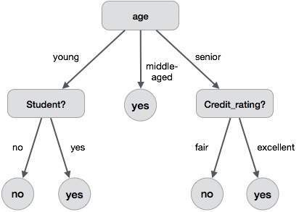

Division based on some features.

### 2. Entropy

Entropy is degree of randomness of elements or in other words it is **measure of impurity.**Mathematically, it can be calculated with the help of probability of the items as:

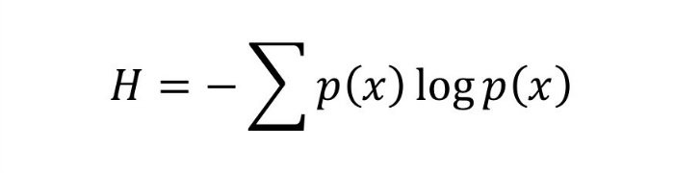

p(x) is probability of item x.

It is negative summation of probability times the log of probability of item x.

**For example,**   
if we have items as number of dice face occurrence in a throw event as **1123,  
the entropy is** p(1) = 0.5  
 p(2) = 0.25  
 p(3) = 0.25  
entropy = - (0.5 \* log(0.5)) - (0.25 \* log(0.25)) -(0.25 \* log(0.25)  
 = 0.45

### 3. Information Gain

Suppose we have multiple features to divide the current working set. What feature should we select for division? Perhaps one that gives us less impurity.

Suppose we divide the classes into multiple branches as follows, the information gain at any node is defined as

Information Gain (n) =  
 Entropy(x) — ([weighted average] \* entropy(children for feature))

This need a bit explanation!

Suppose we have following class to work with intially

112234445

Suppose we divide them based on property: divisible by 2

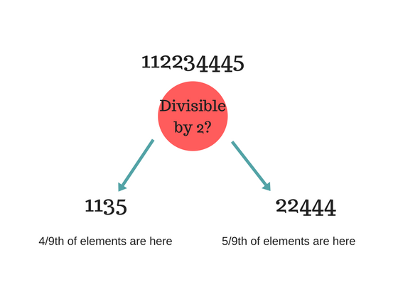

Entropy at root level : 0.66  
Entropy of left child : 0.45 , weighted value = (4/9) \* 0.45 = 0.2  
Entropy of right child: 0.29 , weighted value = (5/9) \* 0.29 = 0.16

**Information Gain** = 0.66 - [0.2 + 0.16] = **0.3**

*Check what information gain we get if we take decision as***prime number instead of divide by 2.**Which one is better for this case?

Decision tree at every stage selects the one that gives best information gain. **When information gain is 0 means the feature does not divide the working set at all.**

### Lets solve an example

Now that you know basic stuff about decision tree, lets solve example and look how it works.

Suppose we have a following data for playing a golf on various conditions.

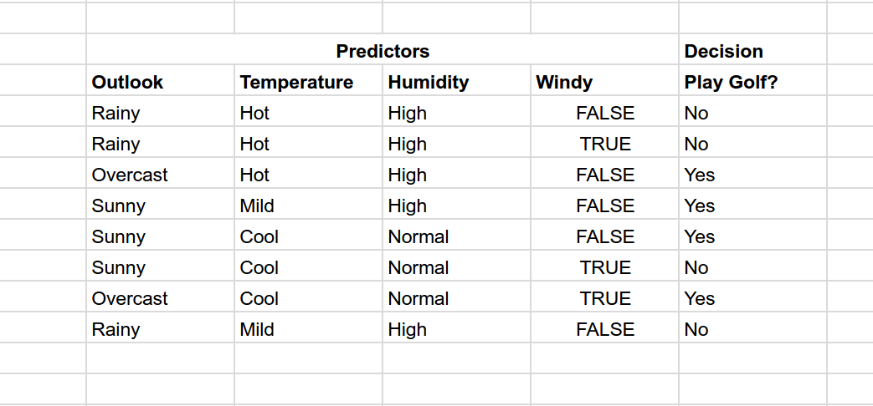

Now if the weather condition is given as :

**Outlook** : Rainy, **Temperature**: Cool, **Humidity**: High, **Windy**: False

#### **Should we play golf?**

We have outcomes at beginning as NNYYYNYN (Y = Yes and N = No) taken in given order. Entropy at this root node is 0.3

Now try to divide on various predictors outlook, temperature, humidity and Windy.  
Calculate the information gain in each case. Which one has highest information gain?

For example, if we divide based on Outlook, we have divisions as  
 Rainy : NNN (entropy = 0)  
 Sunny : YYN (entropy = 0.041)  
 Overcast : YY (entropy = 0)

So information gain = 0.3 - [0 + (3/8)\*0.041 + 0]  
 = 0.28

Try out for other cases.

The information gain is max when divided based on Outlook.  
Now the impurity for Rainy and Overcast is 0. We stop for them here.

Next we need to separate Sunny,  
If we divide by Windy, we get max information gain.  
Sunny  
 YYN  
 Windy? Yes : N  
 No : YY

So decision tree look like something as shown in image below.

No the prediction data is   
**Outlook** : Rainy, **Temperature**: Cool, **Humidity**: High, **Windy**: False

Flowing down from tree according to result, we first check Rainy?  
So answer is No, we don't play golf.

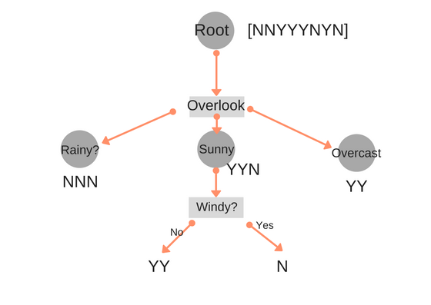

**Document clustering**

Procedures

document clustering often takes the following steps:

1. [**Tokenization**](https://en.wikipedia.org/wiki/Tokenization_(lexical_analysis))

Tokenization is the process of parsing text data into smaller units (tokens) such as words and phrases. Commonly used tokenization methods include [Bag-of-words model](https://en.wikipedia.org/wiki/Bag-of-words_model) and [N-gram model](https://en.wikipedia.org/wiki/N-gram_model).

2. [**Stemming**](https://en.wikipedia.org/wiki/Stemming)**and**[**lemmatization**](https://en.wikipedia.org/wiki/Lemmatization)

Different tokens might carry out similar information (e.g. tokenization and tokenizing). And we can avoid calculating similar information repeatedly by reducing all tokens to its base form using various stemming and lemmatization dictionaries.

3. **Removing**[**stop words**](https://en.wikipedia.org/wiki/Stop_words)**and**[**punctuation**](https://en.wikipedia.org/wiki/Punctuation)

Some tokens are less important than others. For instance, common words such as "the" might not be very helpful for revealing the essential characteristics of a text. So usually it is a good idea to eliminate stop words and punctuation marks before doing further analysis.

4. **Computing term frequencies or [tf-idf](https://en.wikipedia.org/wiki/Tf-idf" \o "Tf-idf)**

After pre-processing the text data, we can then proceed to generate features. For document clustering, one of the most common ways to generate features for a document is to calculate the term frequencies of all its tokens. Although not perfect, these frequencies can usually provide some clues about the topic of the document. And sometimes it is also useful to weight the term frequencies by the inverse document frequencies. See [tf-idf](https://en.wikipedia.org/wiki/Tf-idf" \o "Tf-idf) for detailed discussions.

5**. Clustering**

We can then cluster different documents based on the features we have generated. See the algorithm section in [cluster analysis](https://en.wikipedia.org/wiki/Cluster_analysis) for different types of clustering methods.

6. **Evaluation and visualization**

Finally, the clustering models can be assessed by various metrics. And it is sometimes helpful to visualize the results by plotting the clusters into low (two) dimensional space. See [multidimensional scaling](https://en.wikipedia.org/wiki/Multidimensional_scaling) as a possible approach.

**Clustering v. Classifying[**[**edit**](https://en.wikipedia.org/w/index.php?title=Document_clustering&action=edit&section=4)**]**

Clustering algorithms in computational text analysis groups documents into grouping a set of text what are called subsets or *clusters* where the algorithm's goal is to create internally coherent clusters that are distinct from one another.[[3]](https://en.wikipedia.org/wiki/Document_clustering#cite_note-3) Classification on the other hand, is a form of [supervised learning](https://en.wikipedia.org/wiki/Supervised_learning) where the features of the documents are used to predict the "type" of documents.

Key Steps

1. **Read data**: read titles, genres, synopses, rankings into four arrays
2. **Tokenize and stem**: break paragraphs into sentences, then to words, stem the words (without removing stopwords) - each synopsis essentially becomes a bag of stemmed words.
3. **Generate tf-idf matrix**: each row is a term (unigram, bigram, trigram...generated from the bag of words in 2.), each column is a synopsis.
4. **Generate clusters**: based on the tf-idf matrix, 5 (or any number) clusters are generated using k-means. The top key terms are selected for each cluster.
5. **Calculate similarity**: generate the cosine similarity matrix using the tf-idf matrix (100x100), then generate the distance matrix (1 - similarity matrix), so each pair of synopsis has a distance number between 0 and 1.
6. **Plot clusters**: use multidimensional scaling (MDS) to convert distance matrix to a 2-dimensional array, each synopsis has (x, y) that represents their relative location based on the distance matrix. Plot the 100 points with their (x, y) using matplotlib (I added an example on using plotly.js).

Hierarchical clustering:

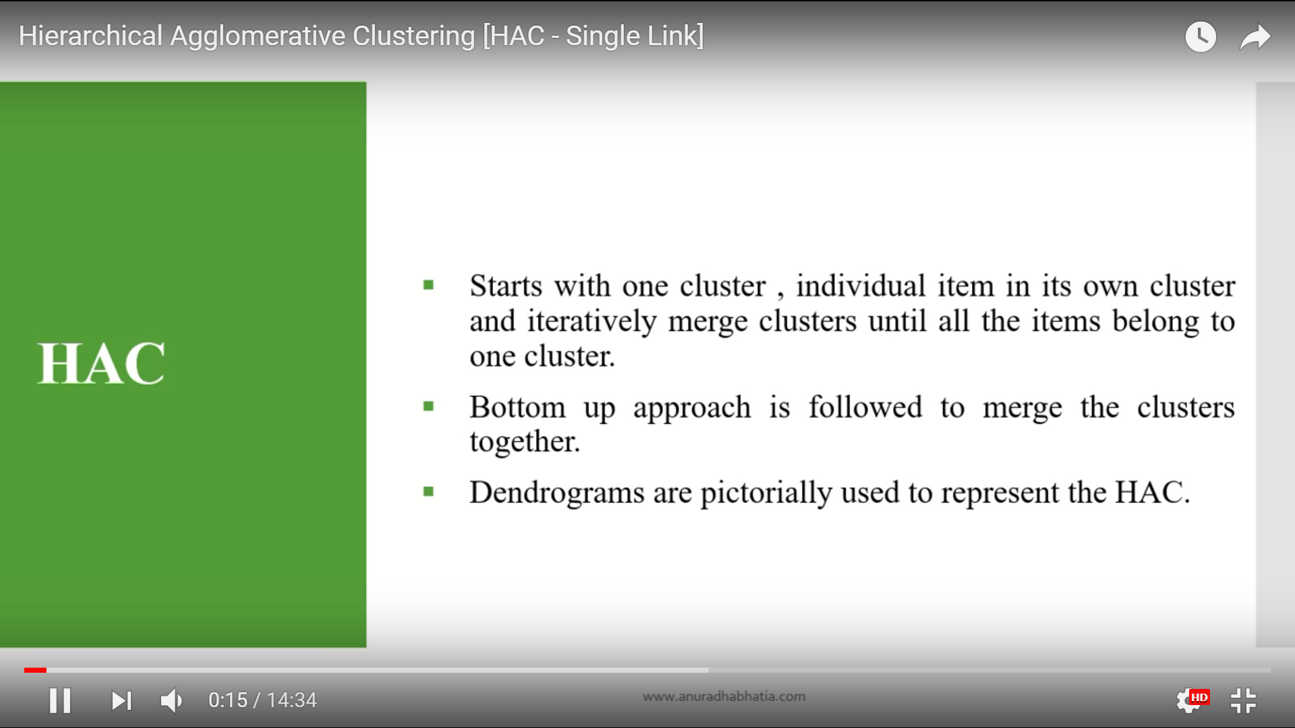

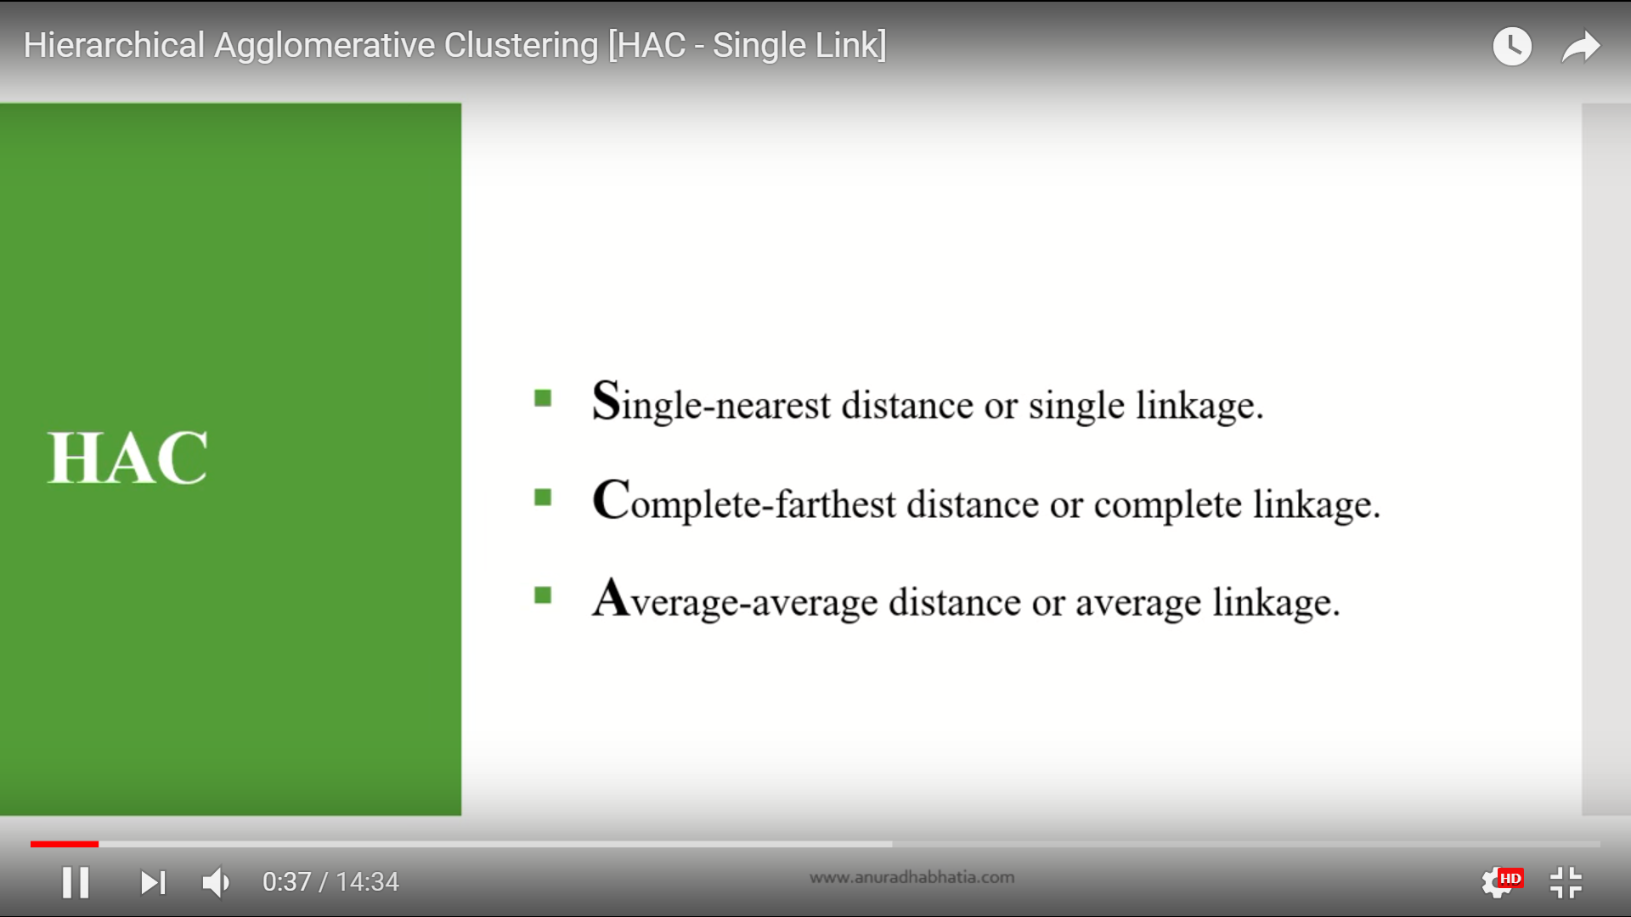

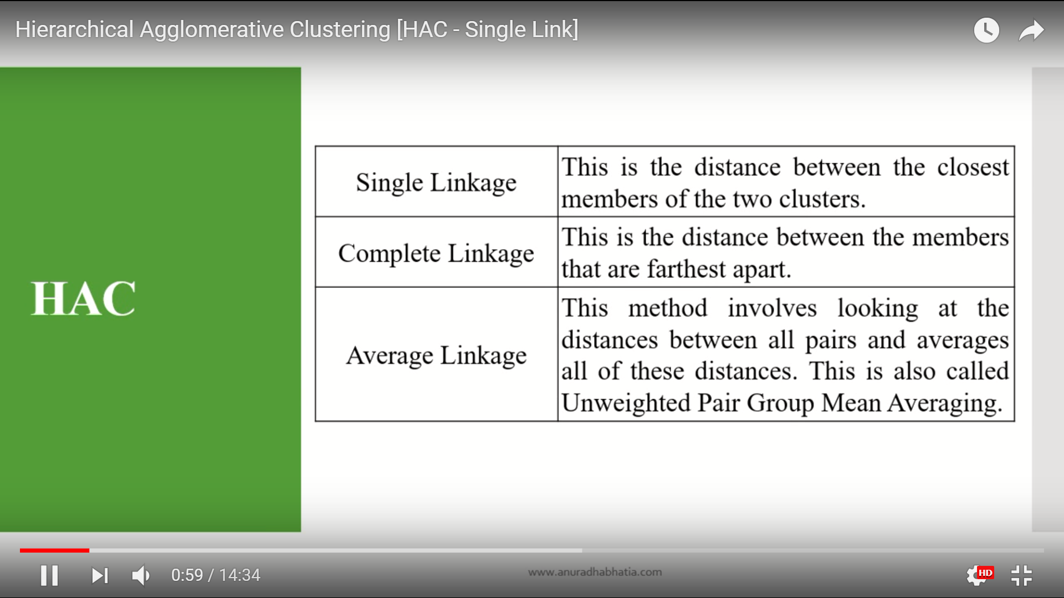

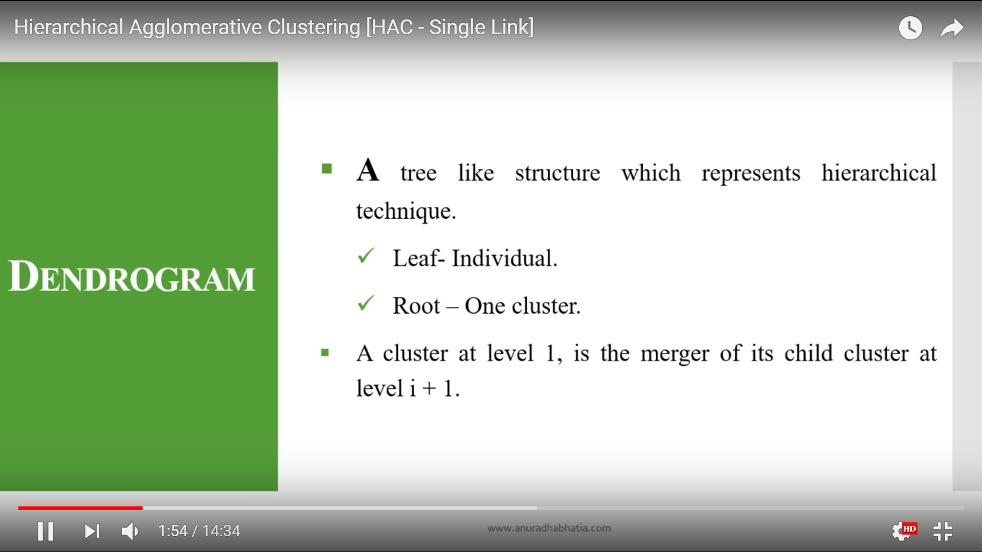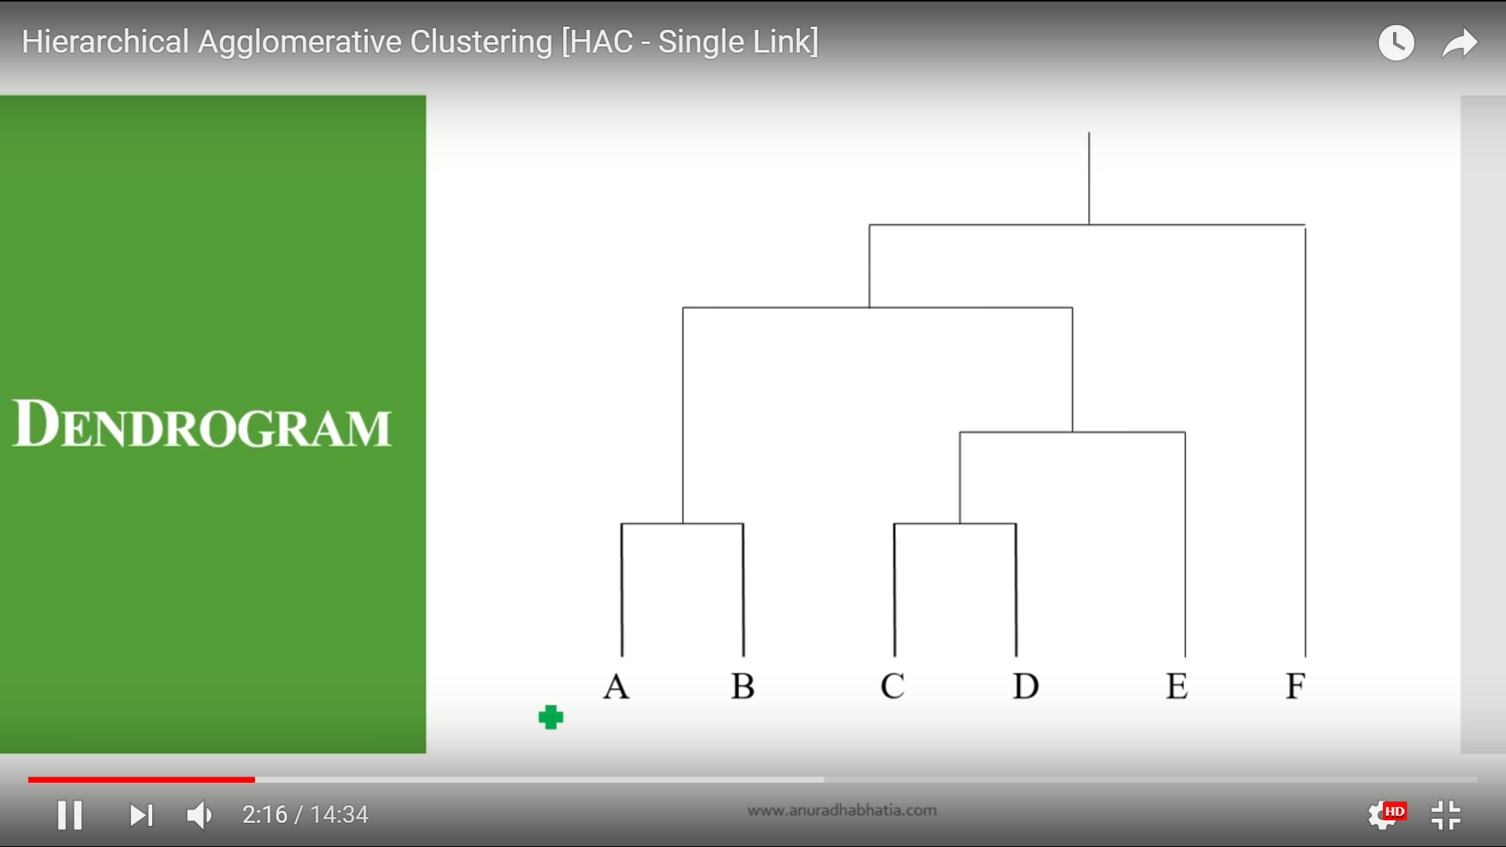

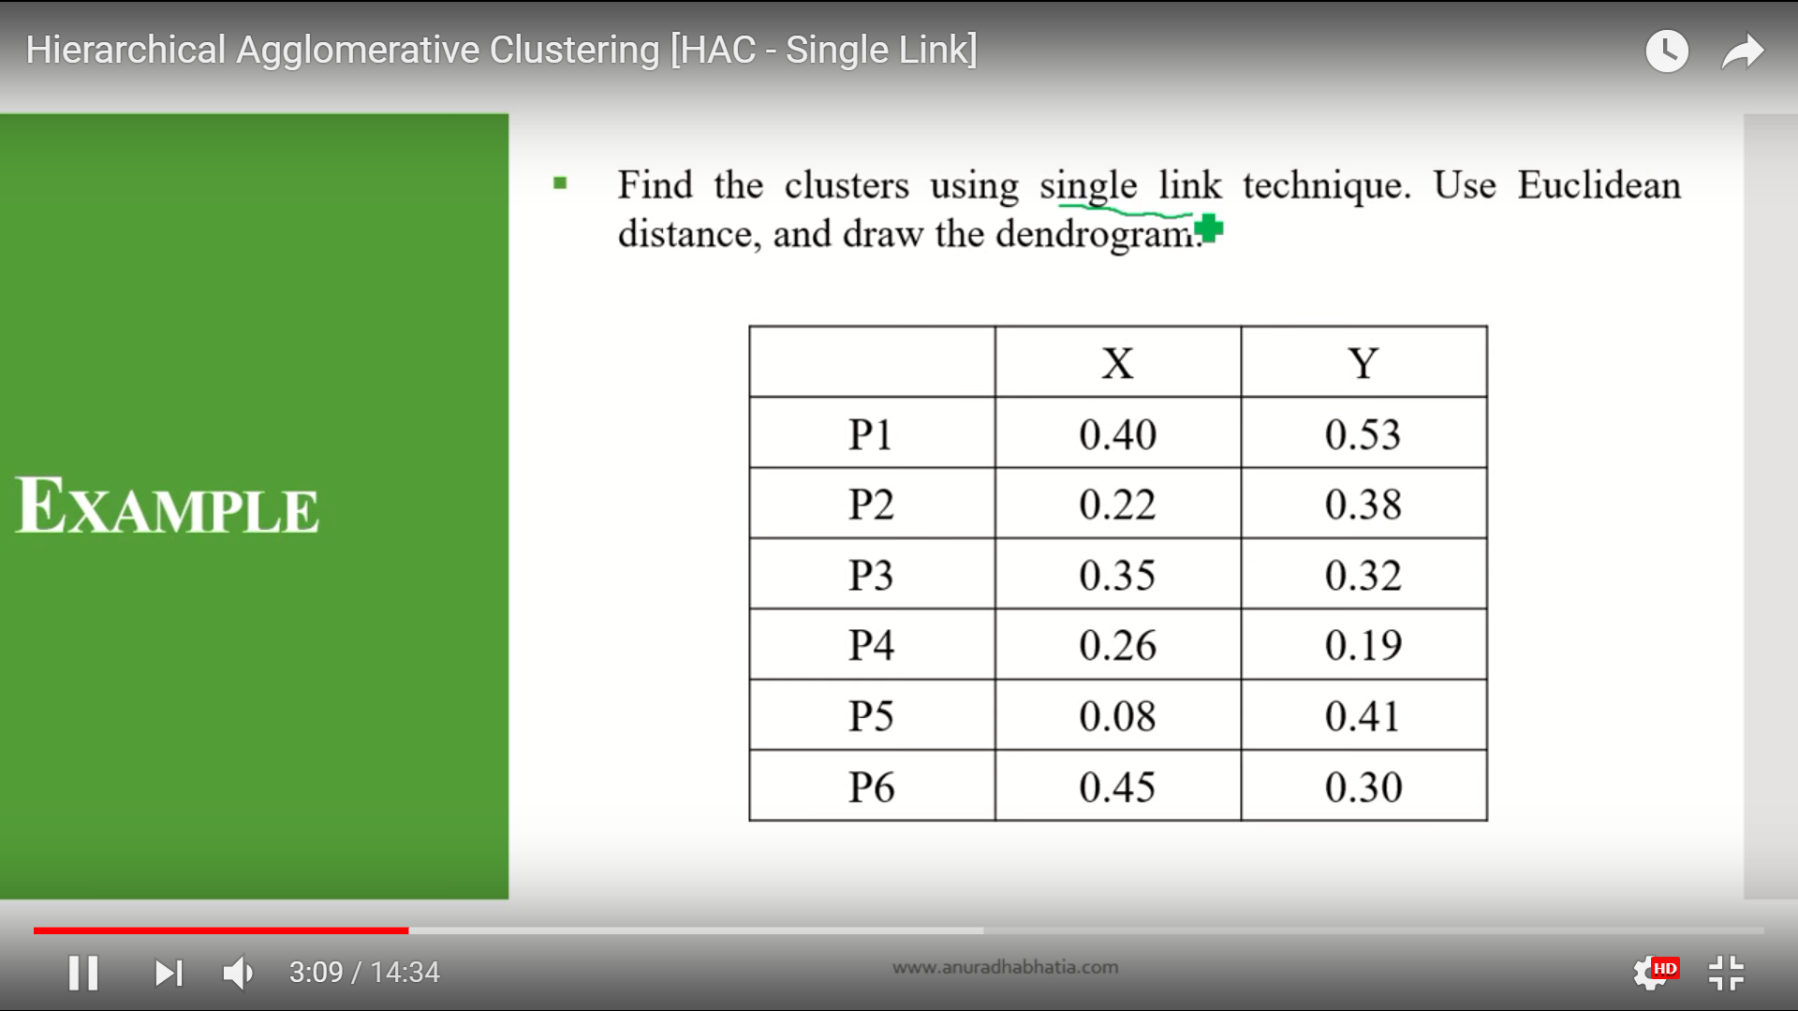

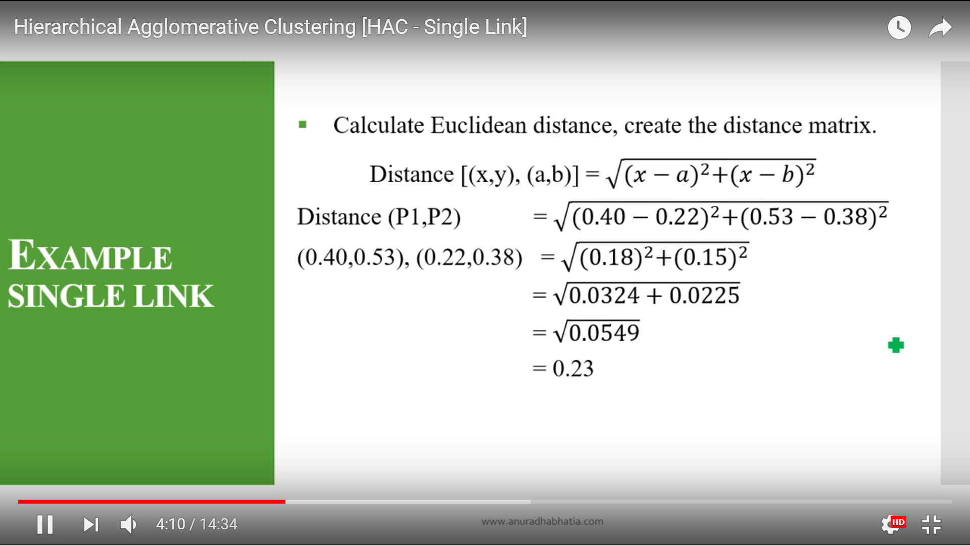

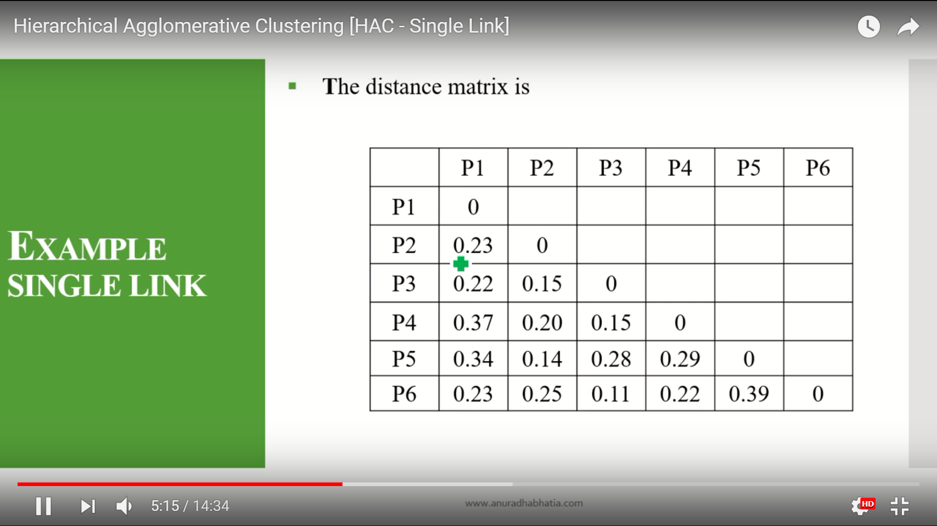

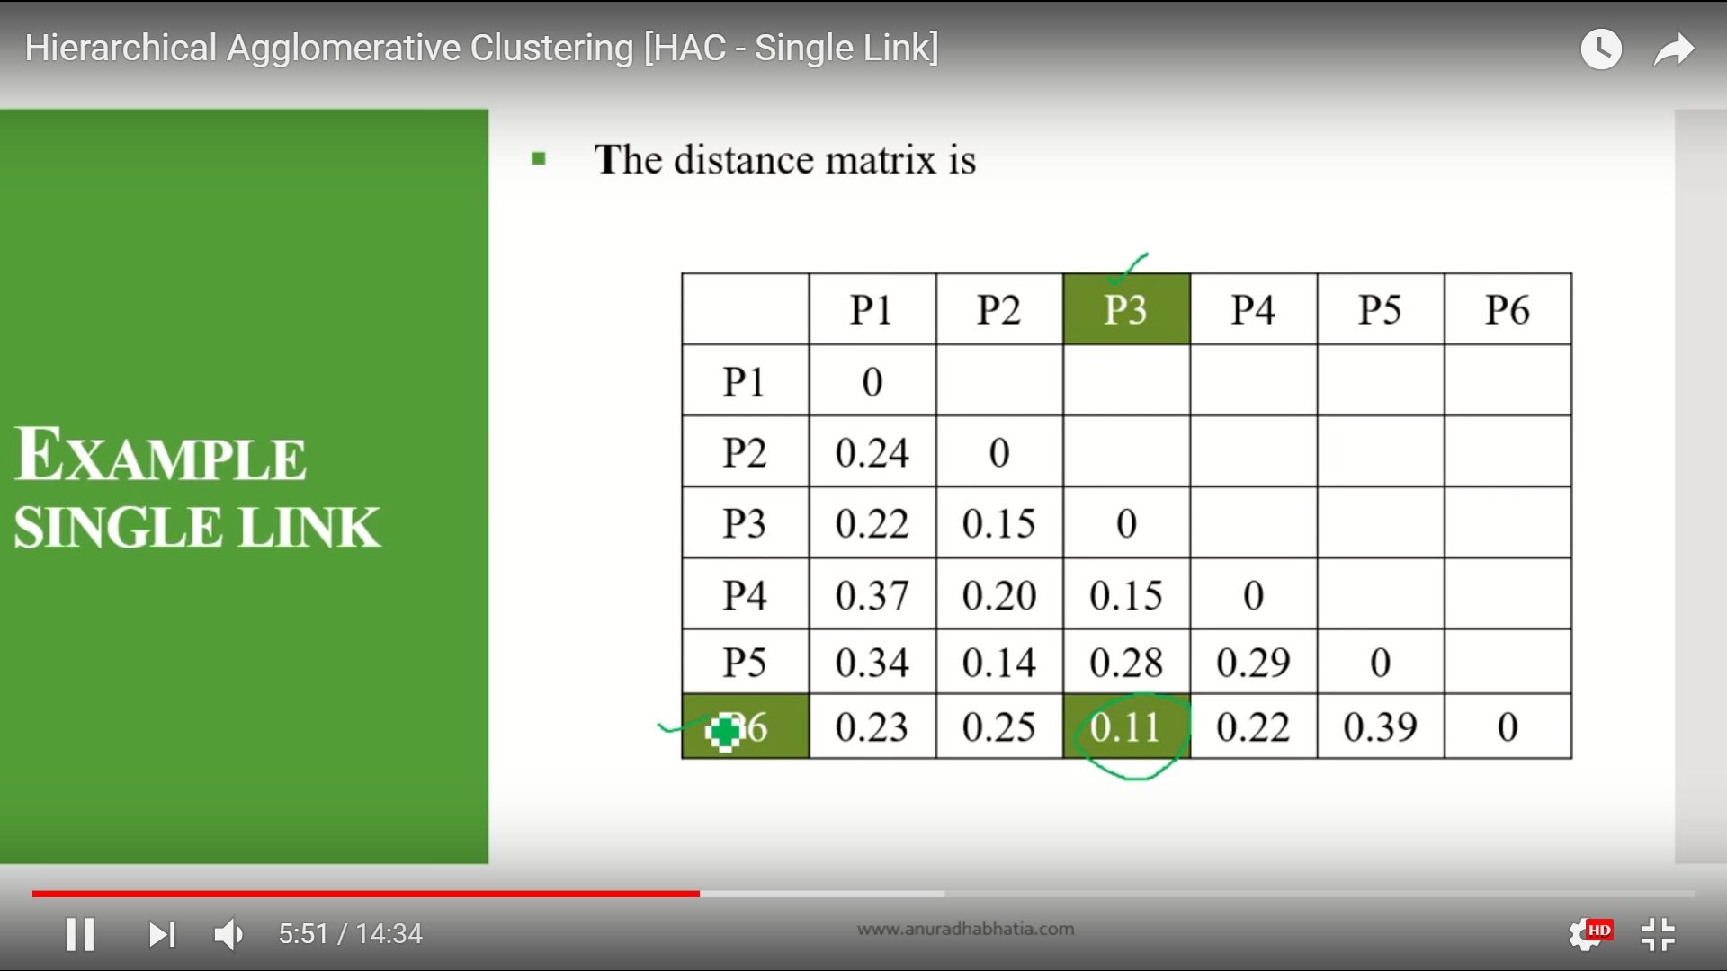

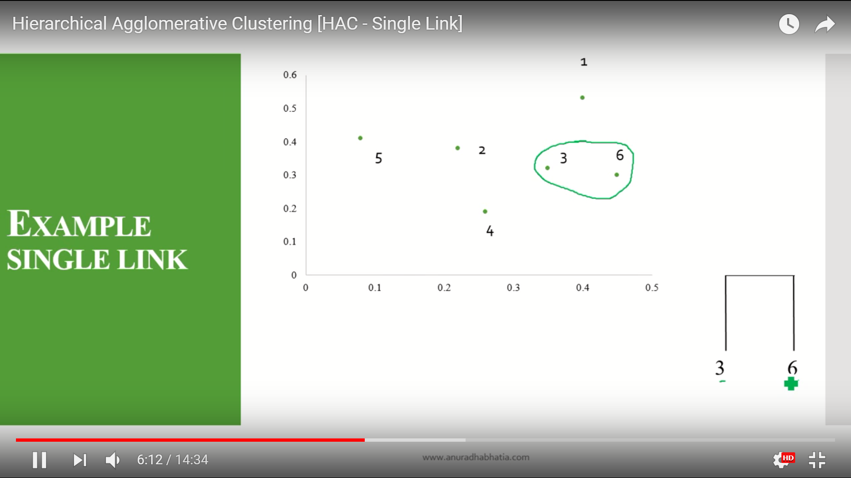

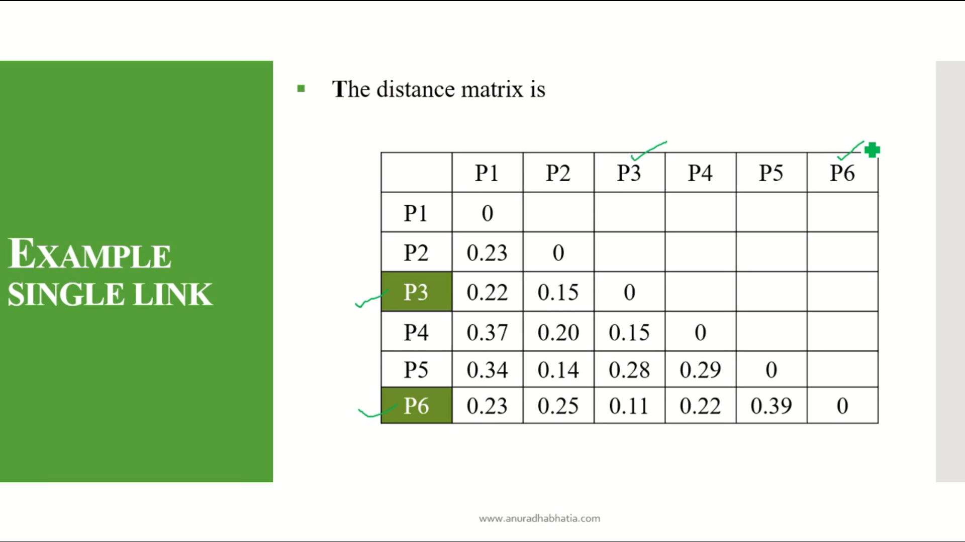

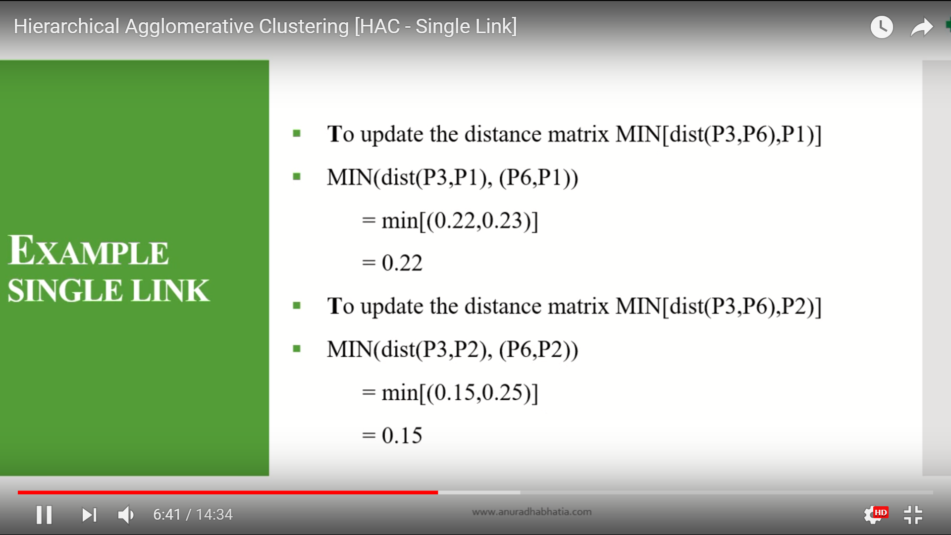

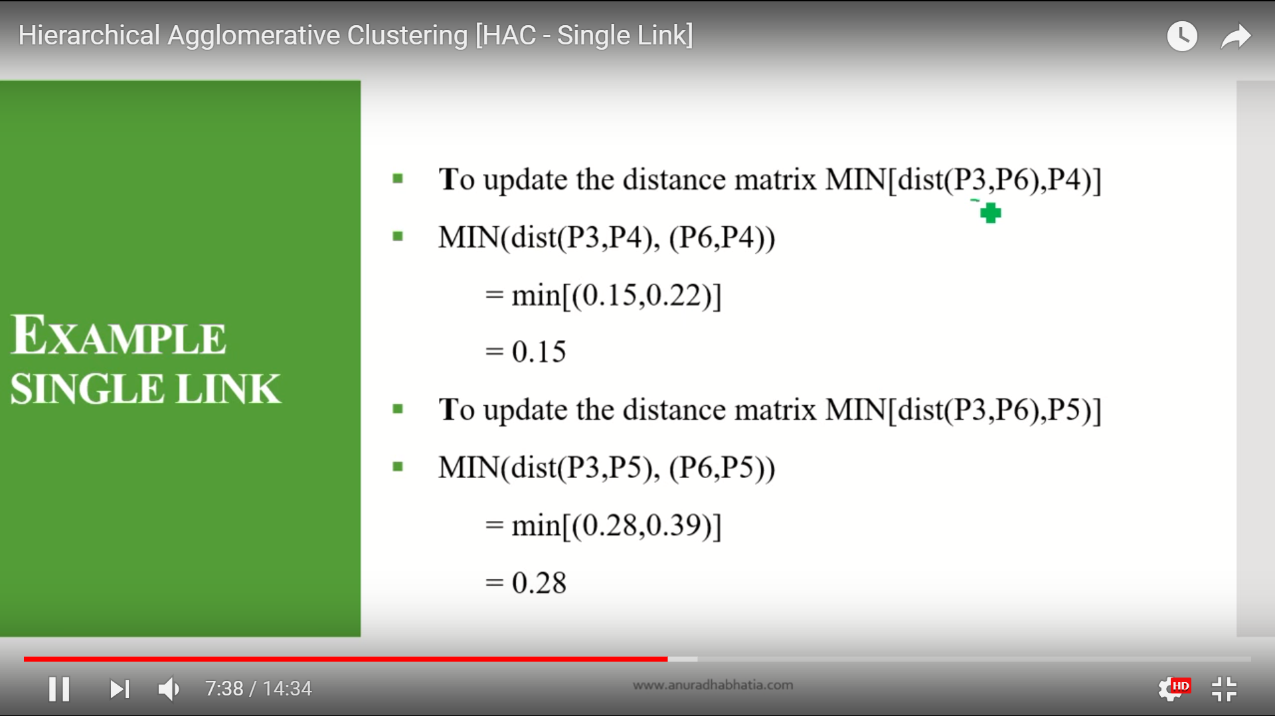

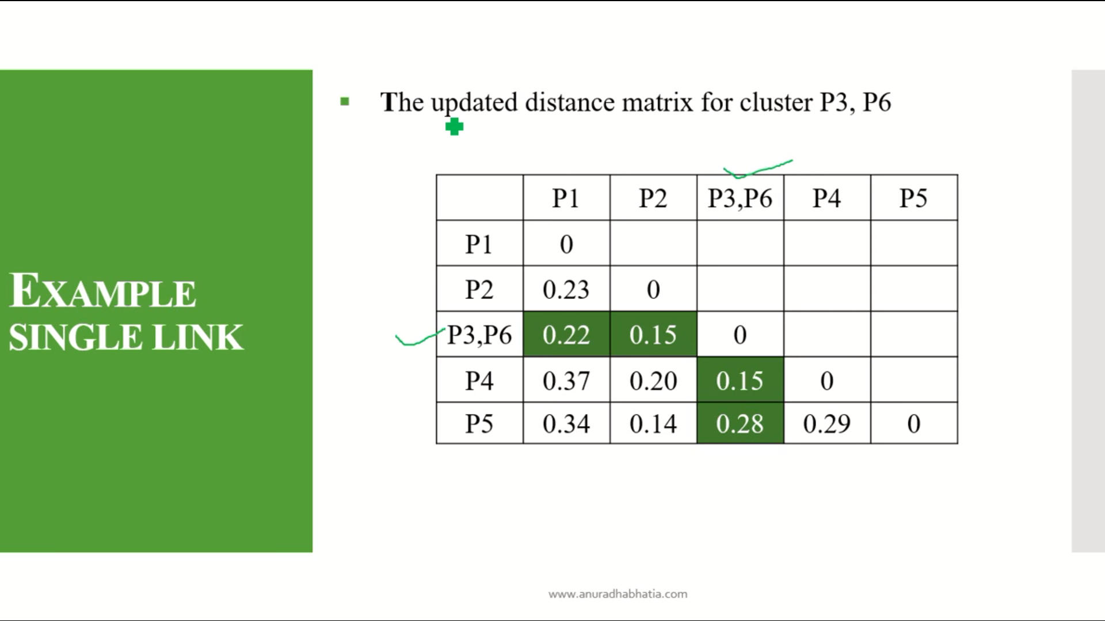

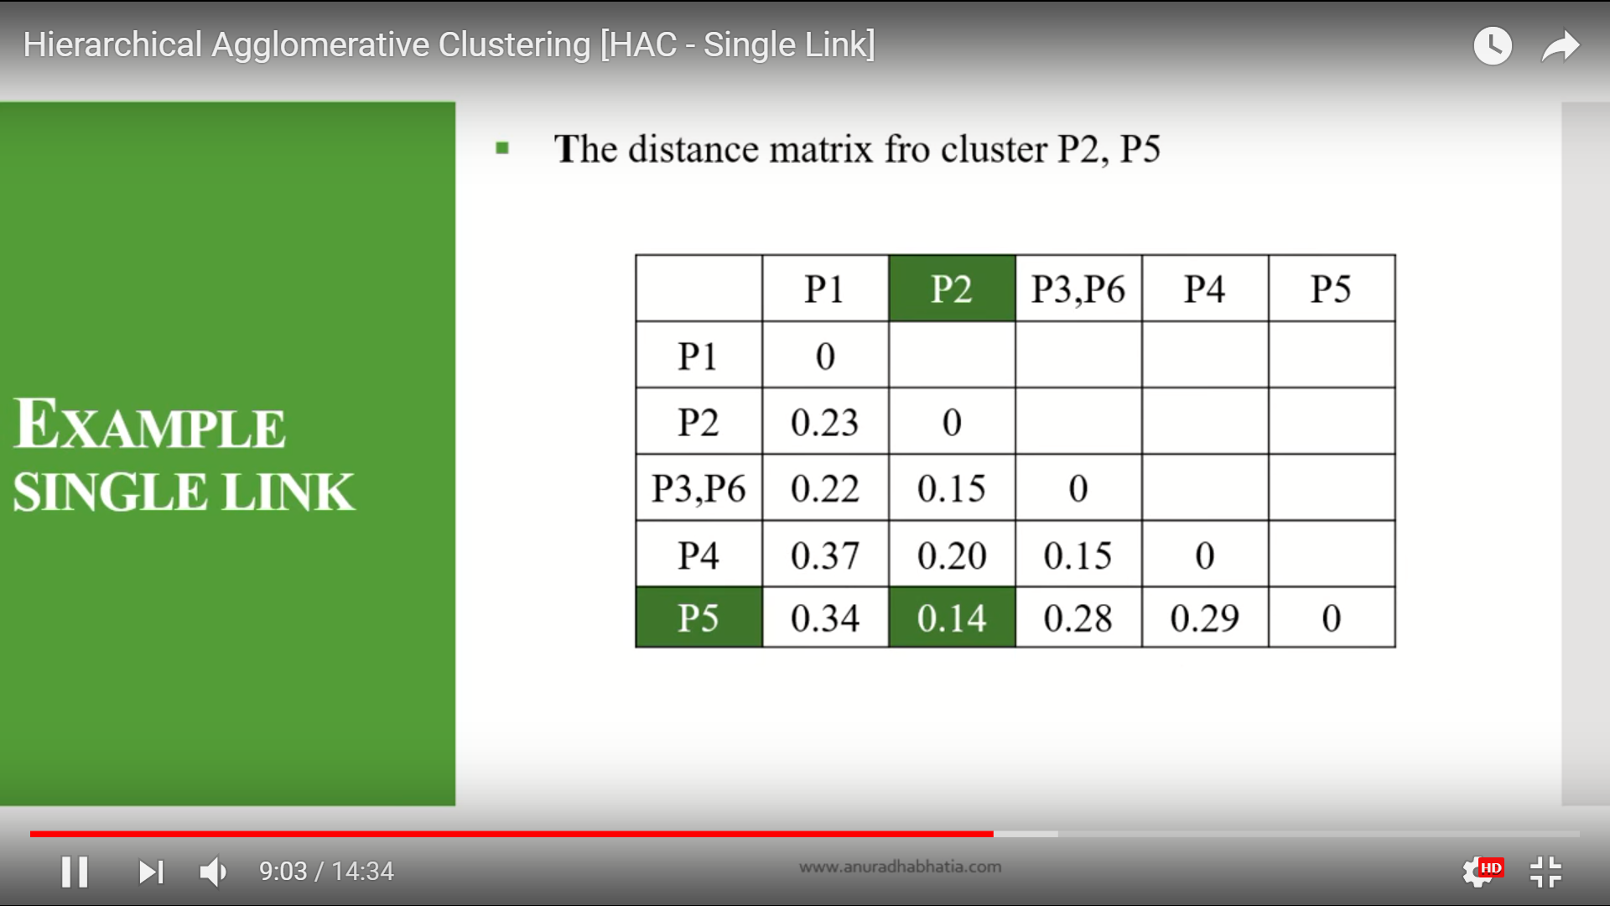

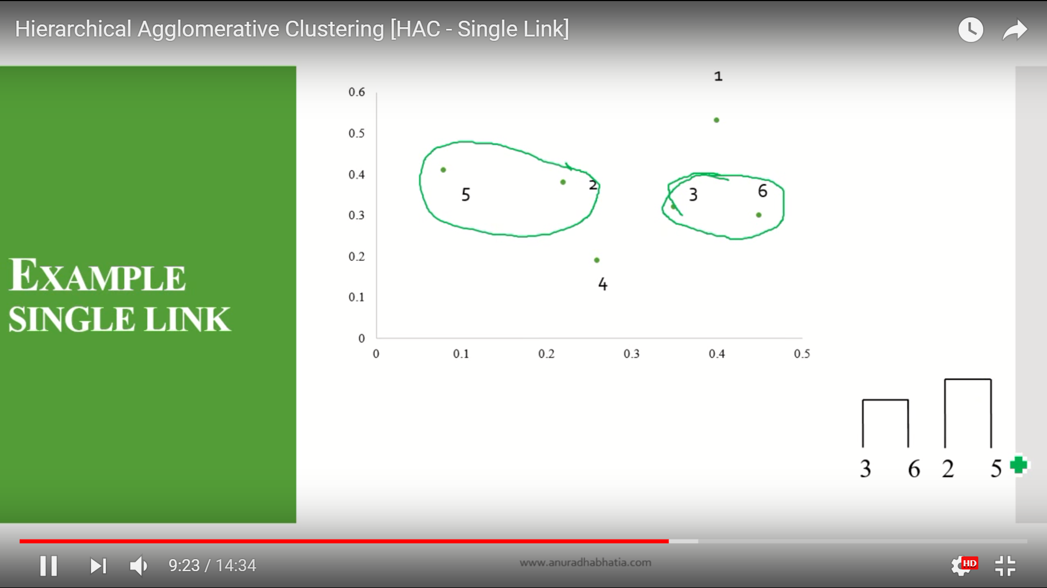

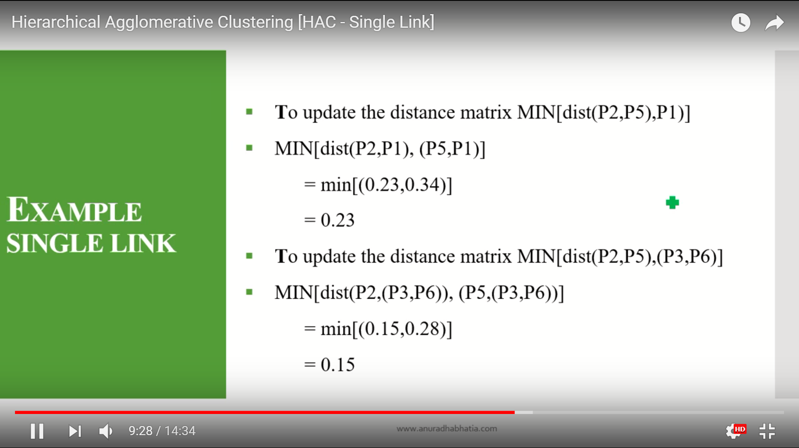

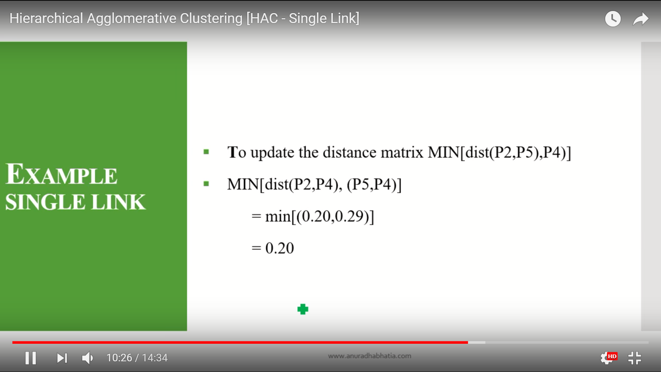

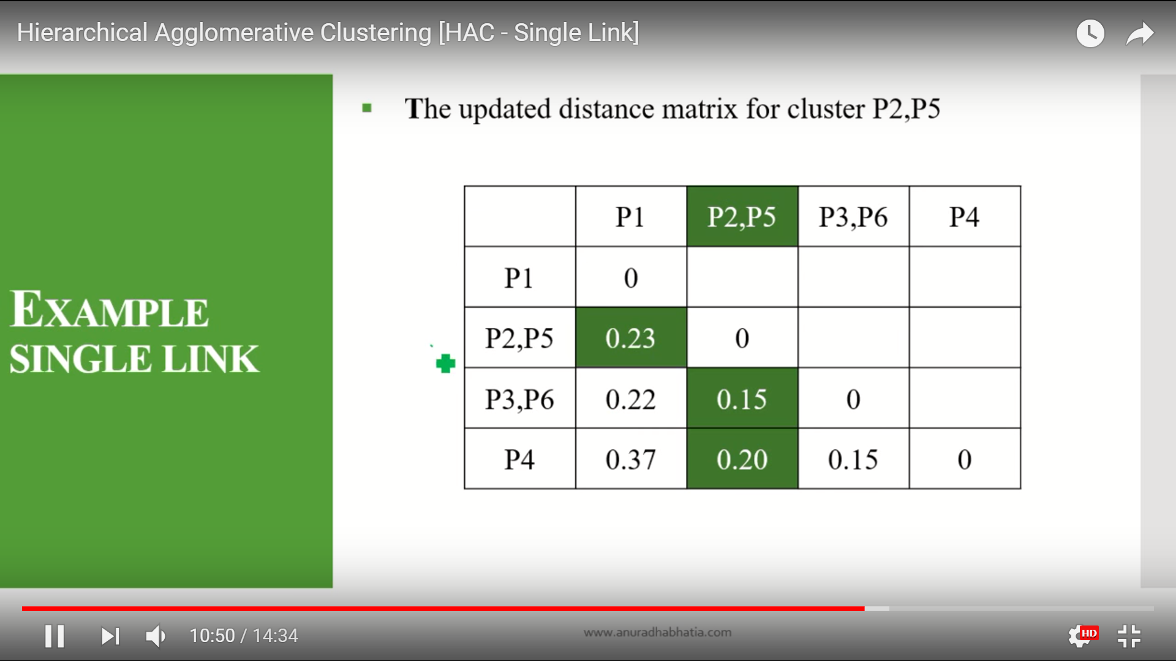

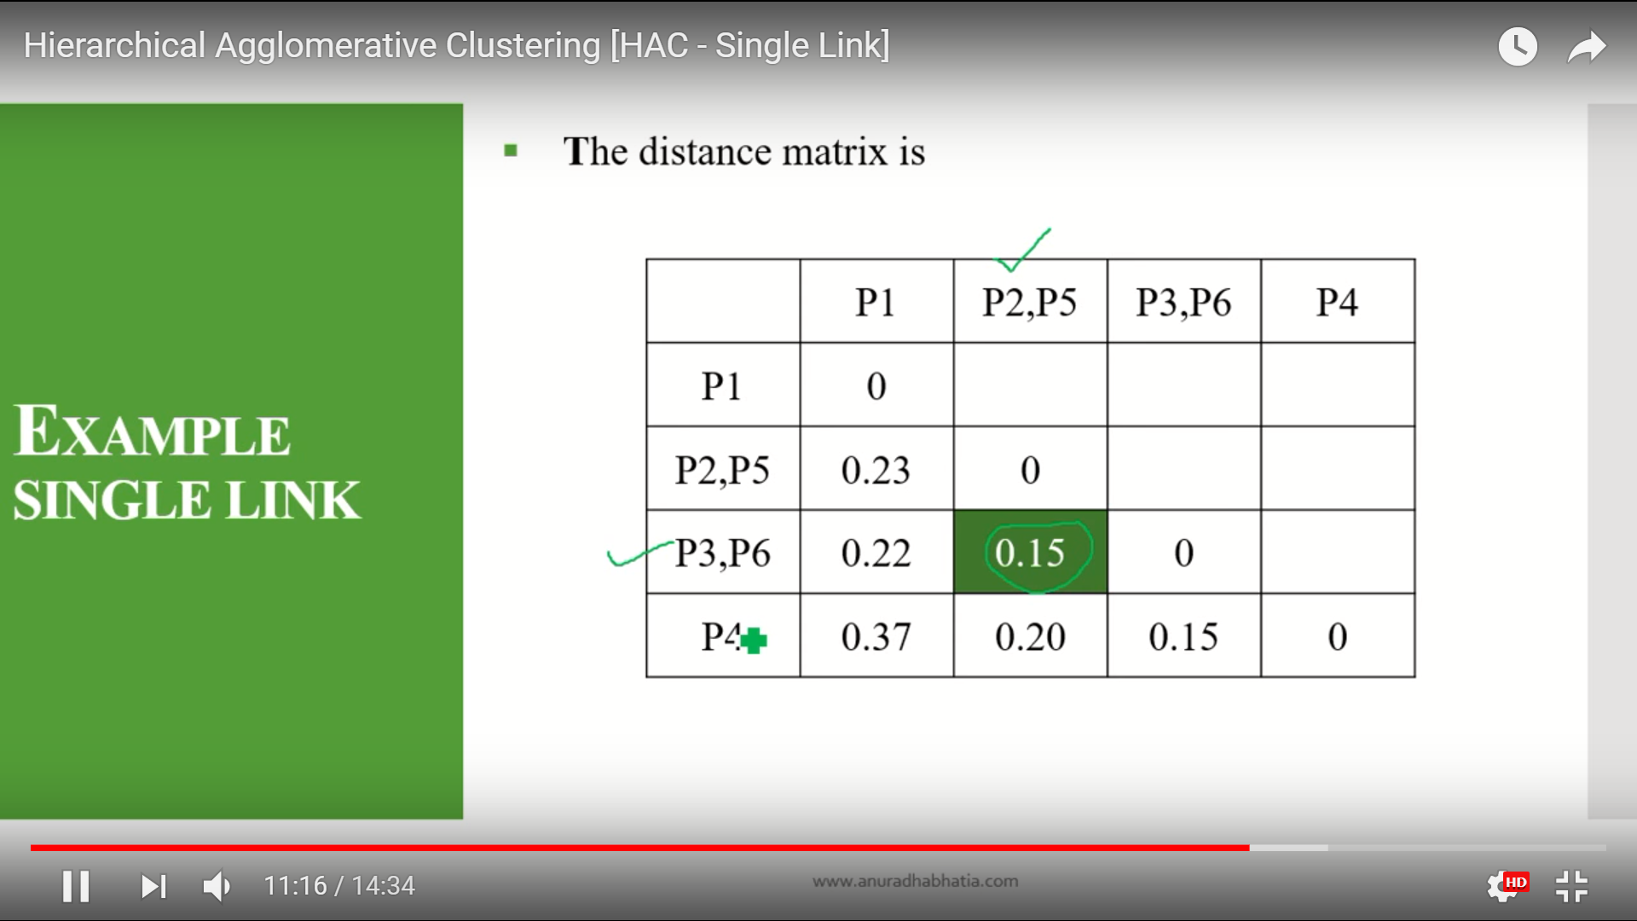

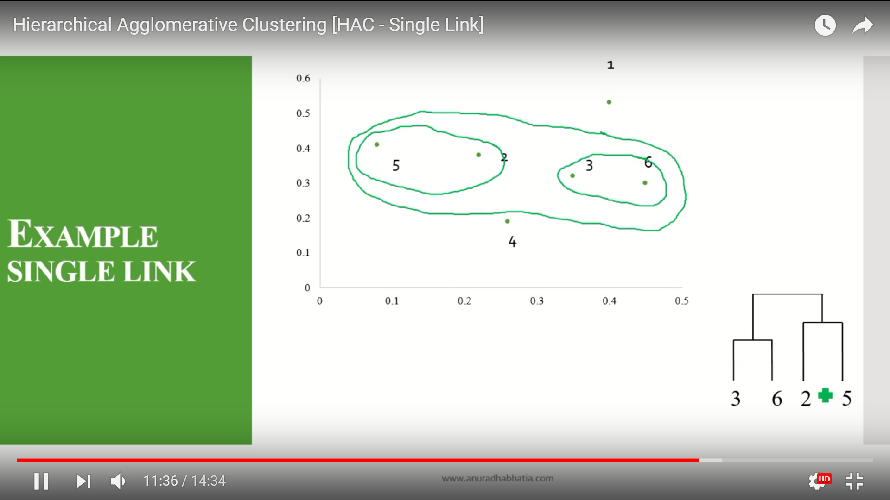

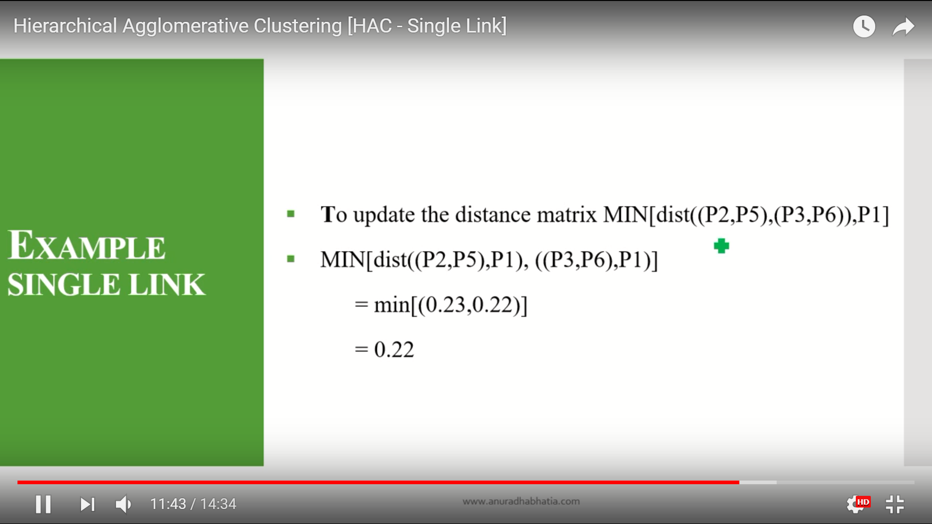

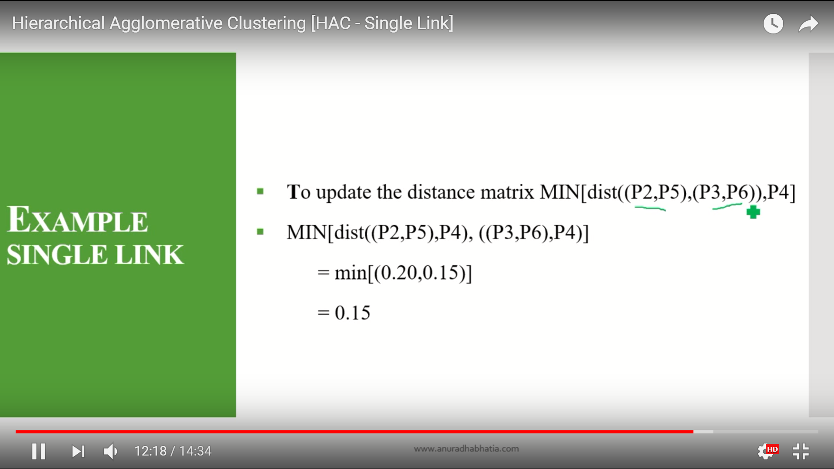

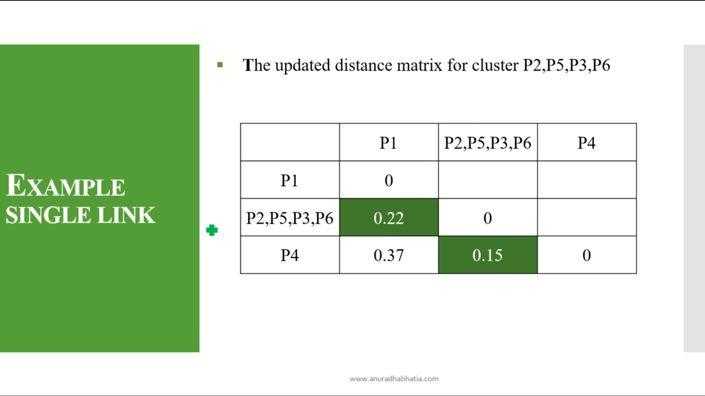

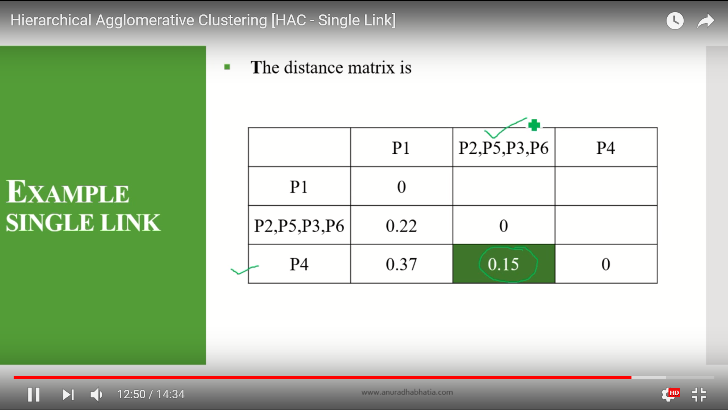

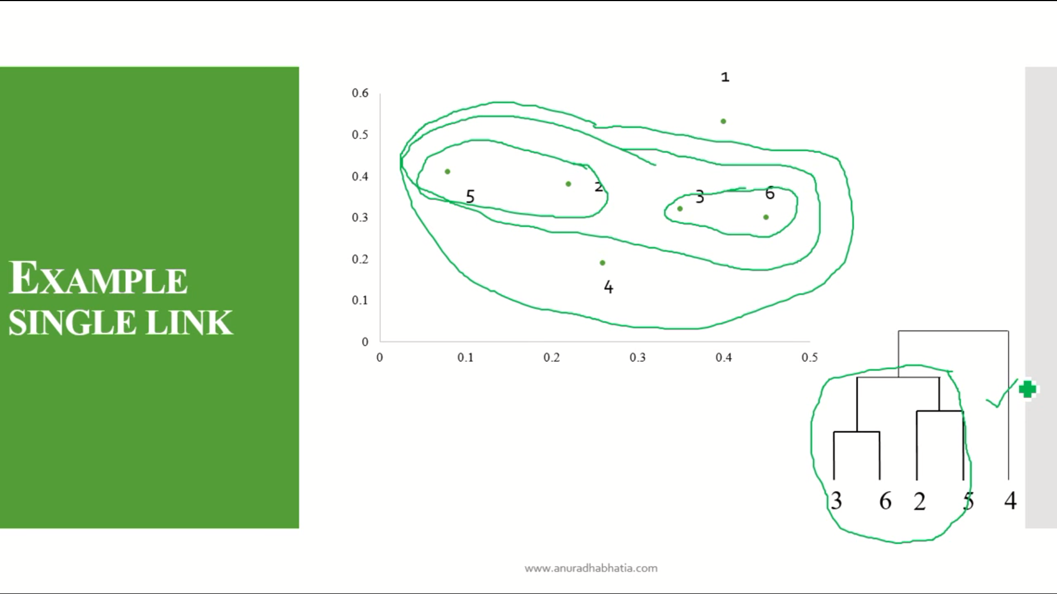

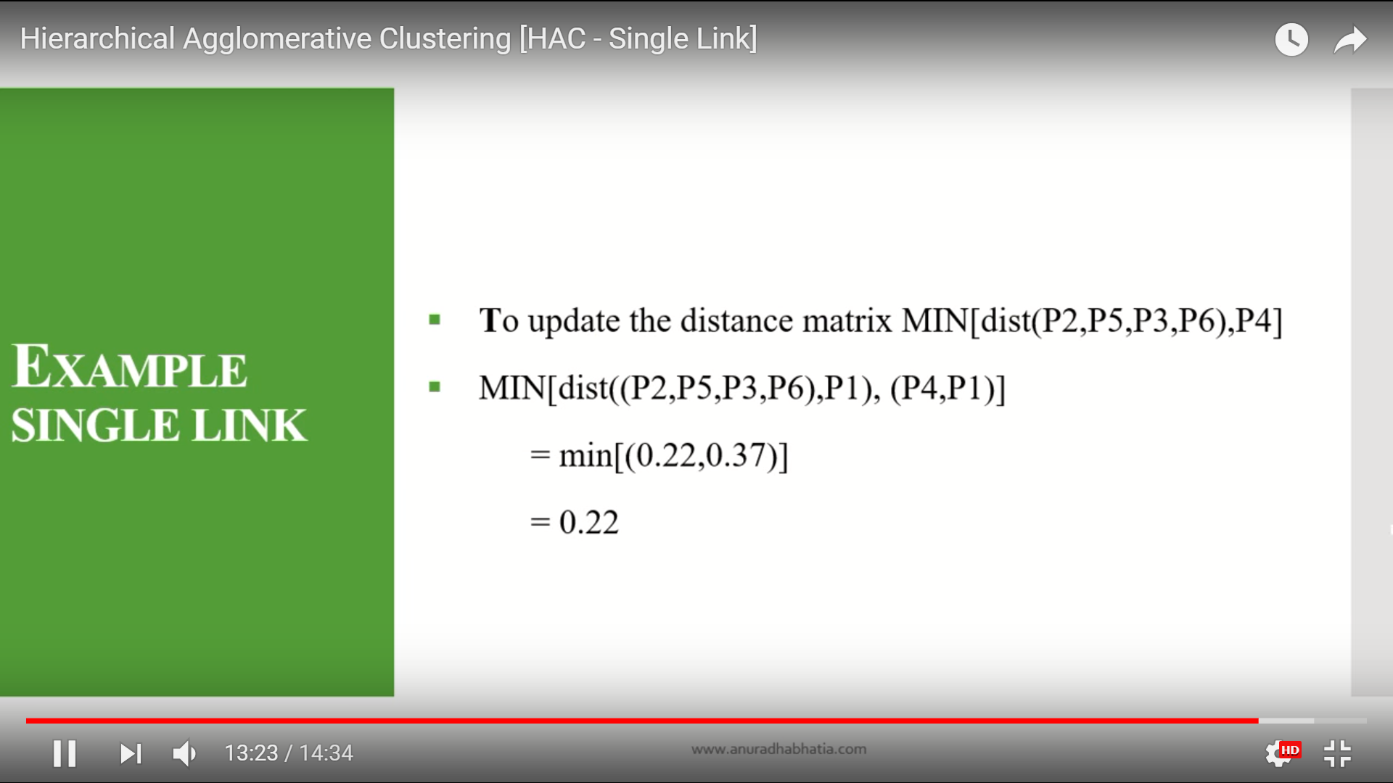

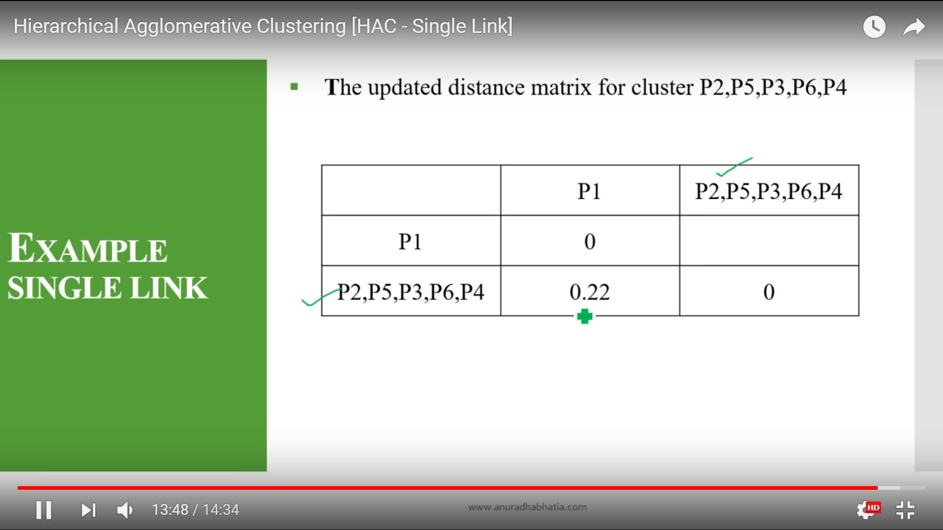

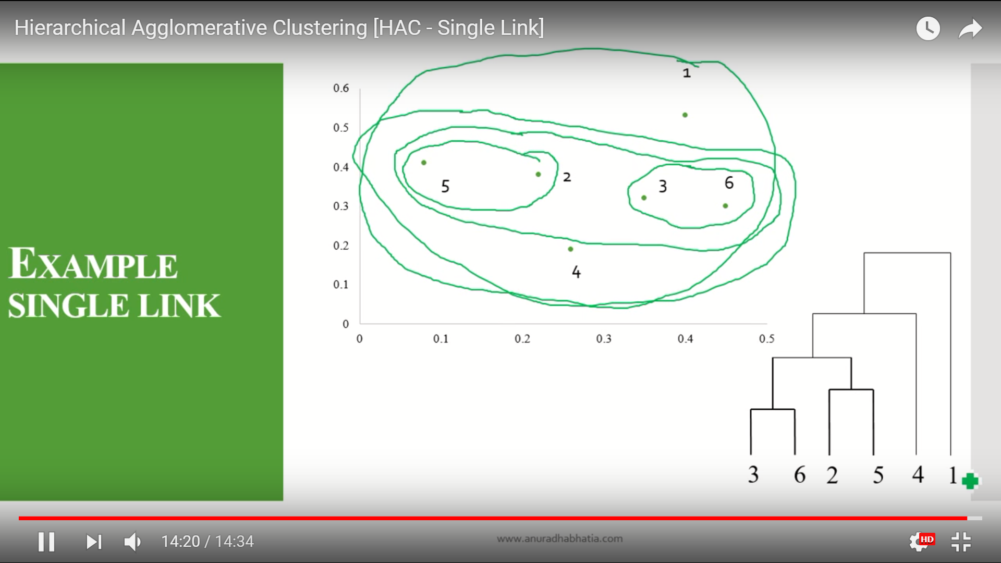

K-mean clustering

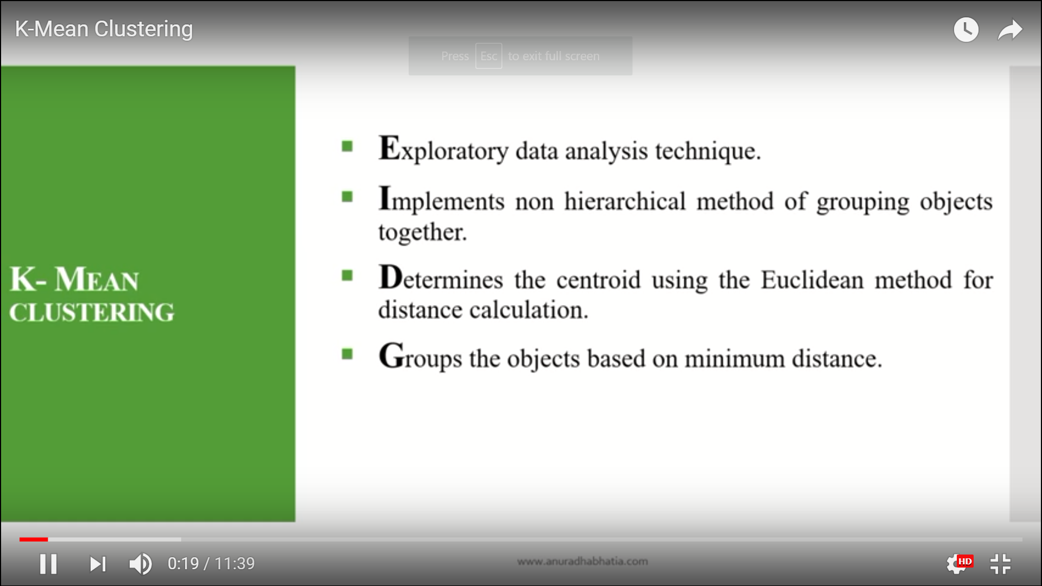

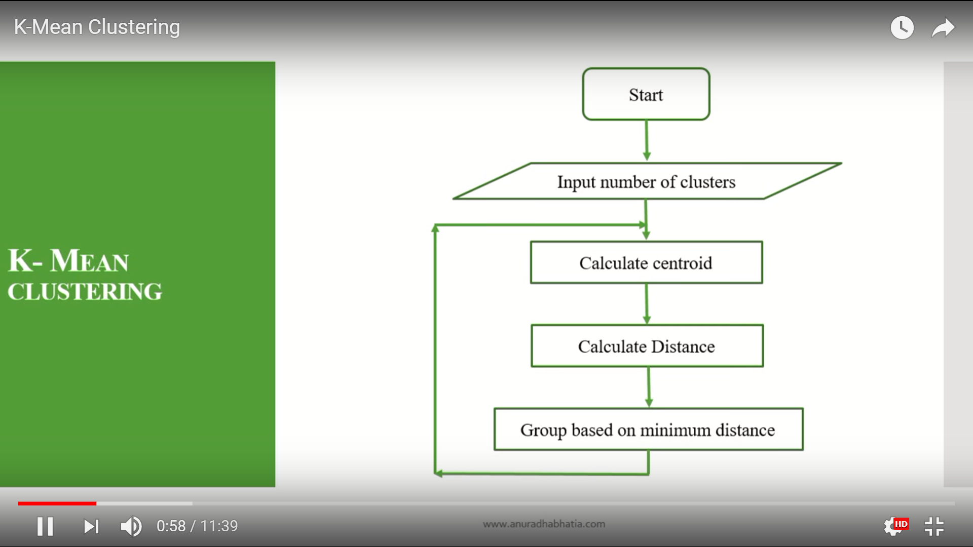

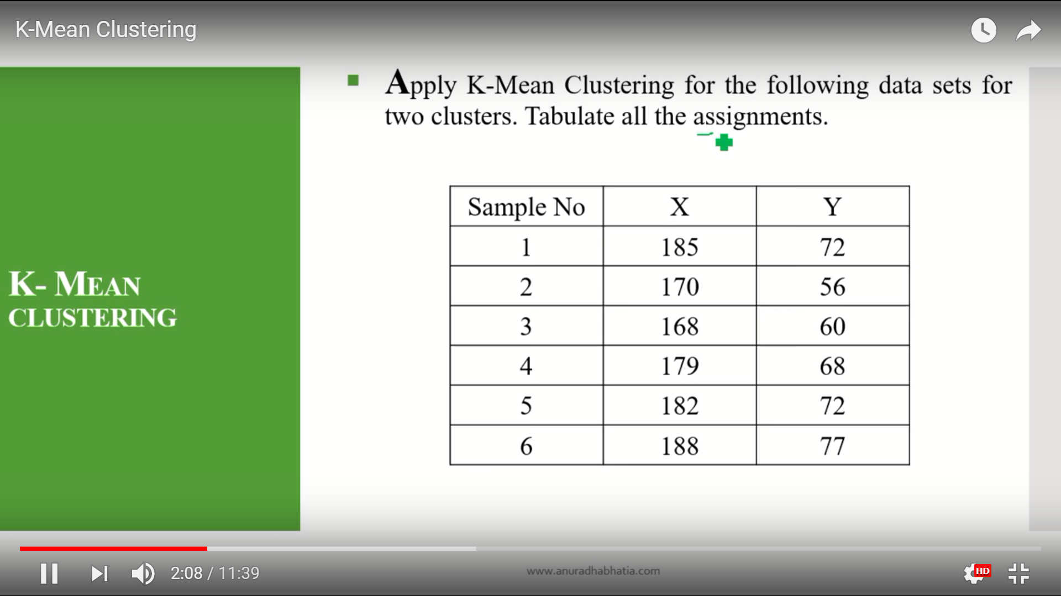

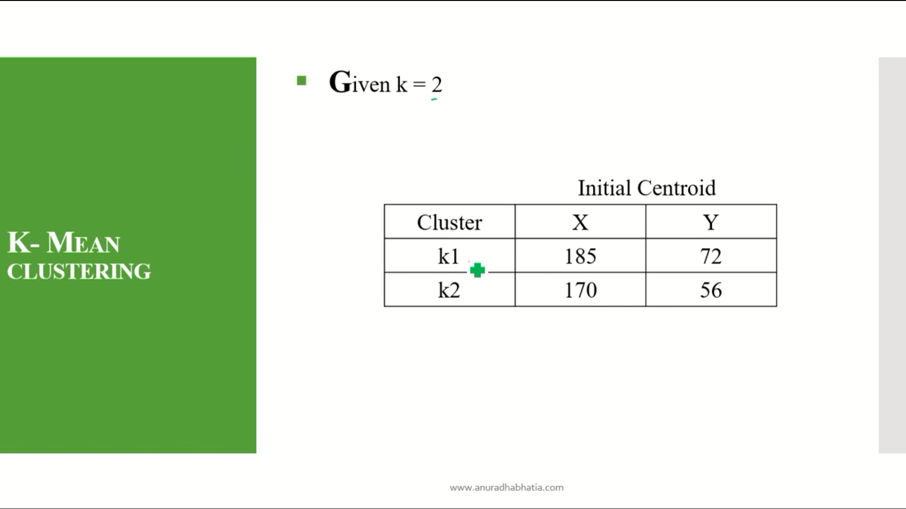

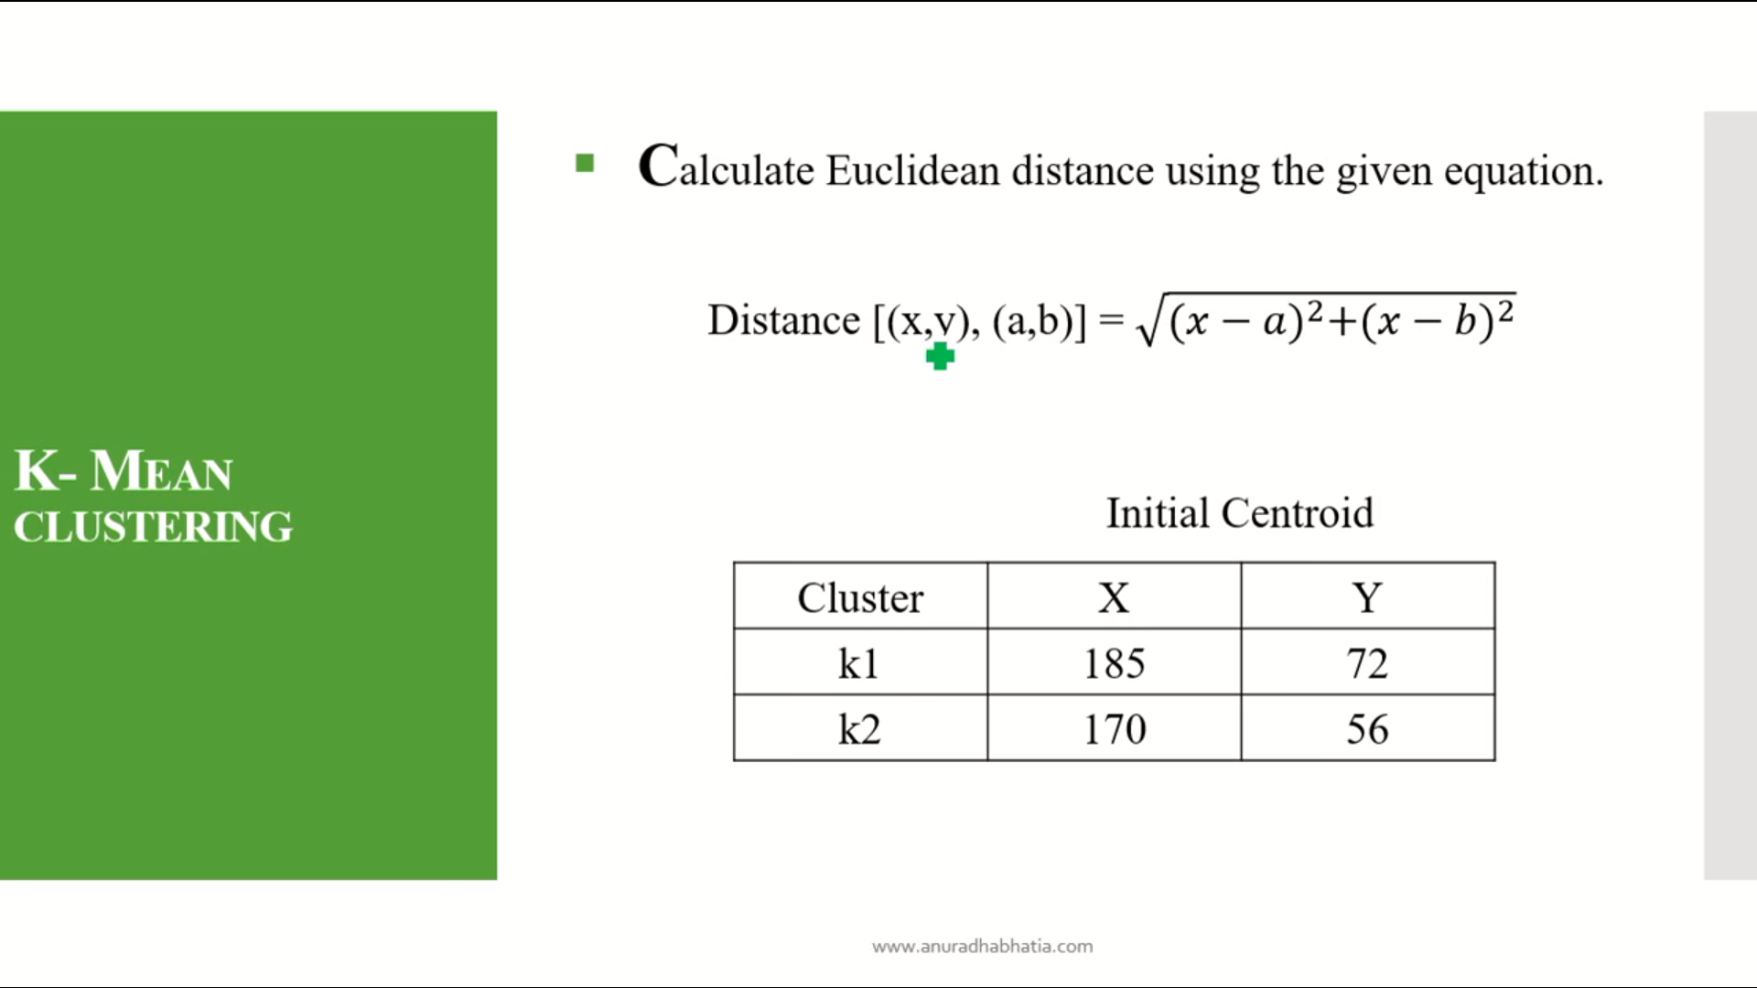

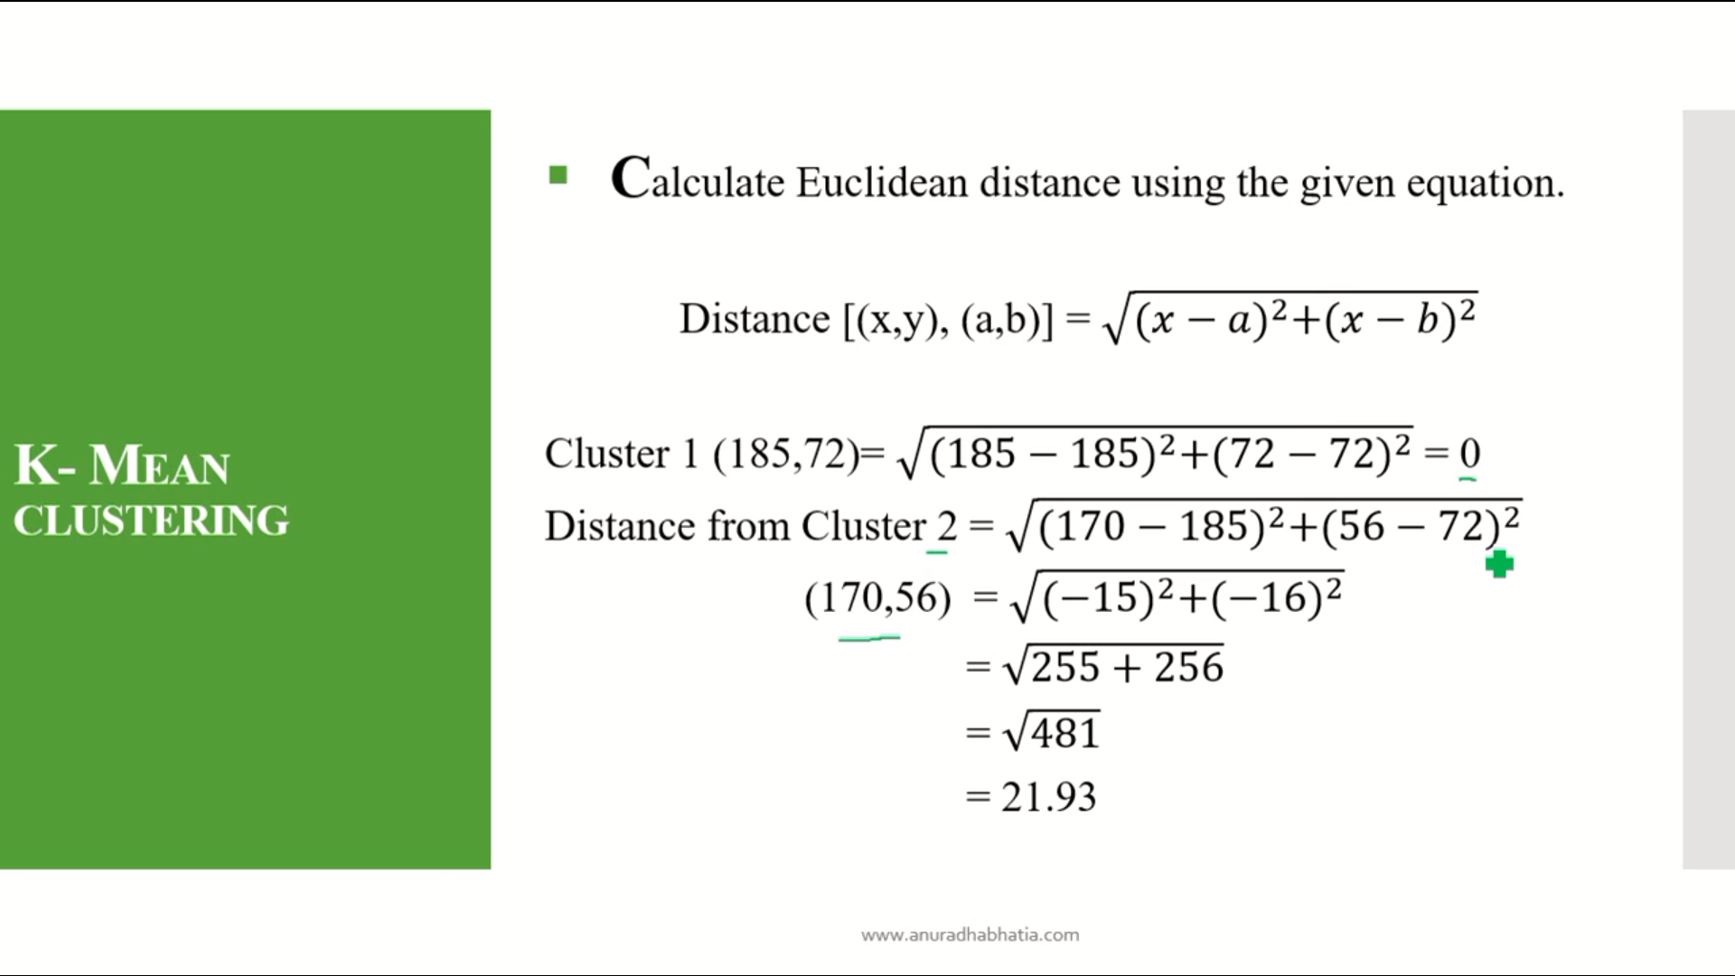

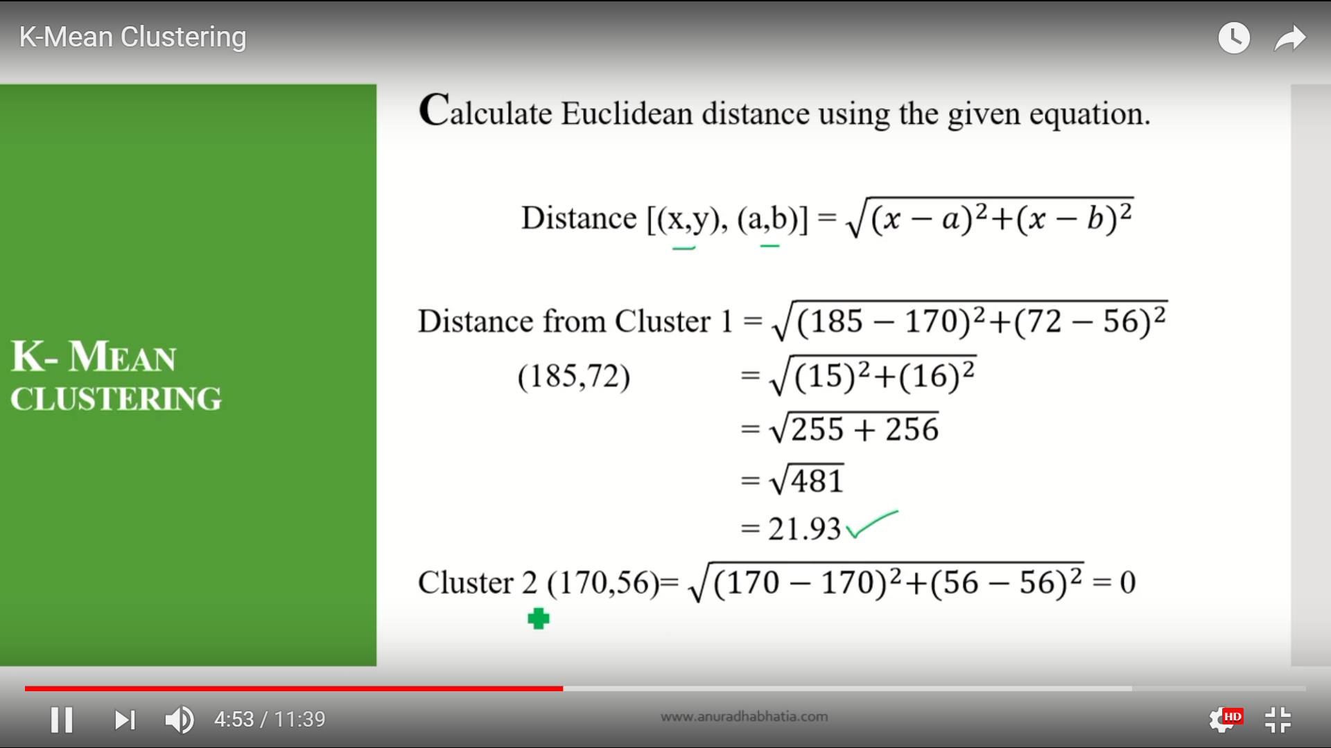

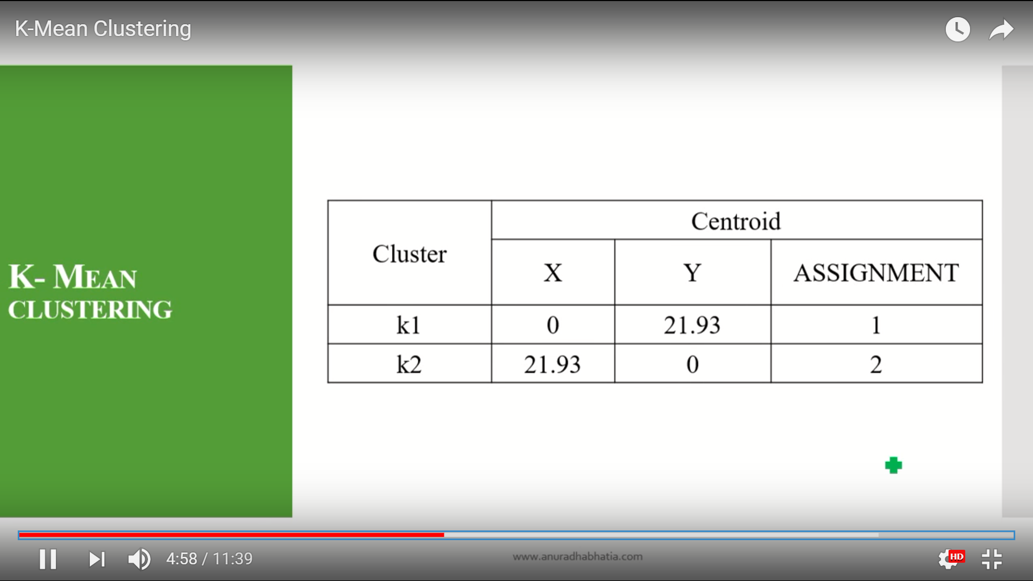

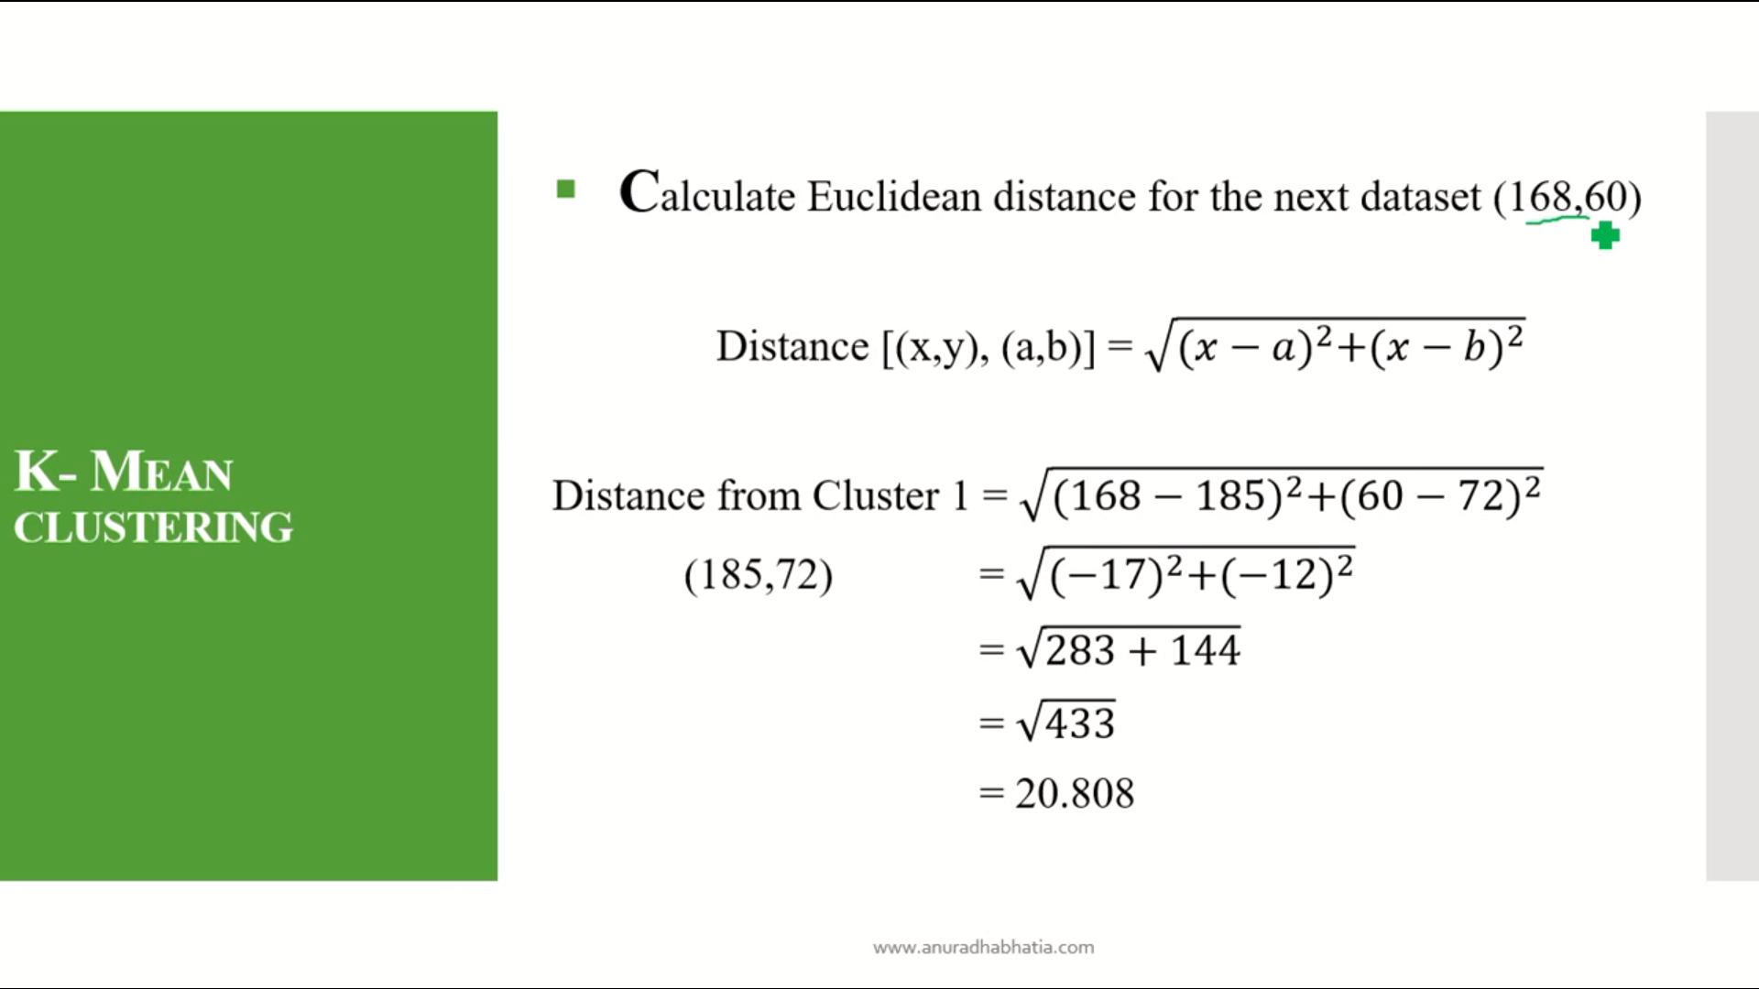

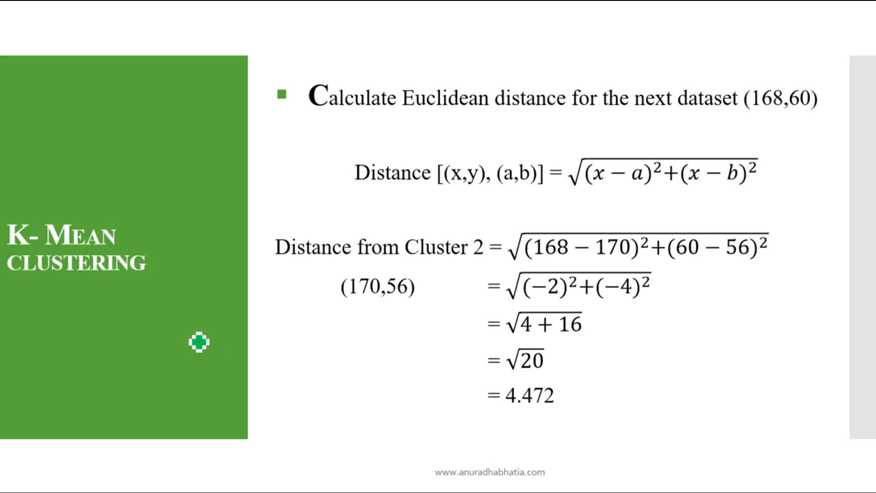

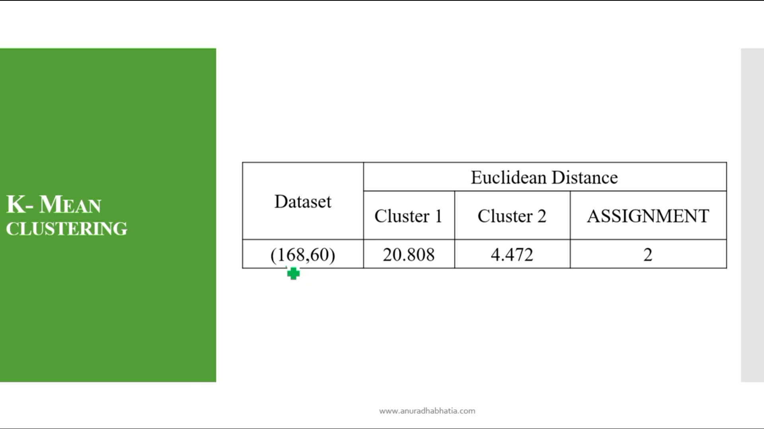

Here the minimum distance for cluster1 and cluster 2 is 4.472 so the assignment is 2.beacuse the min value is in cluster 2.

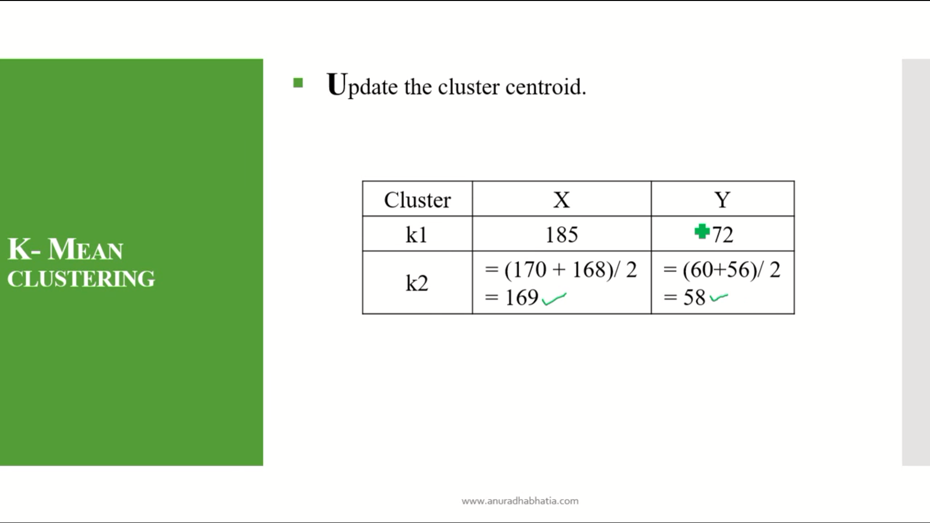

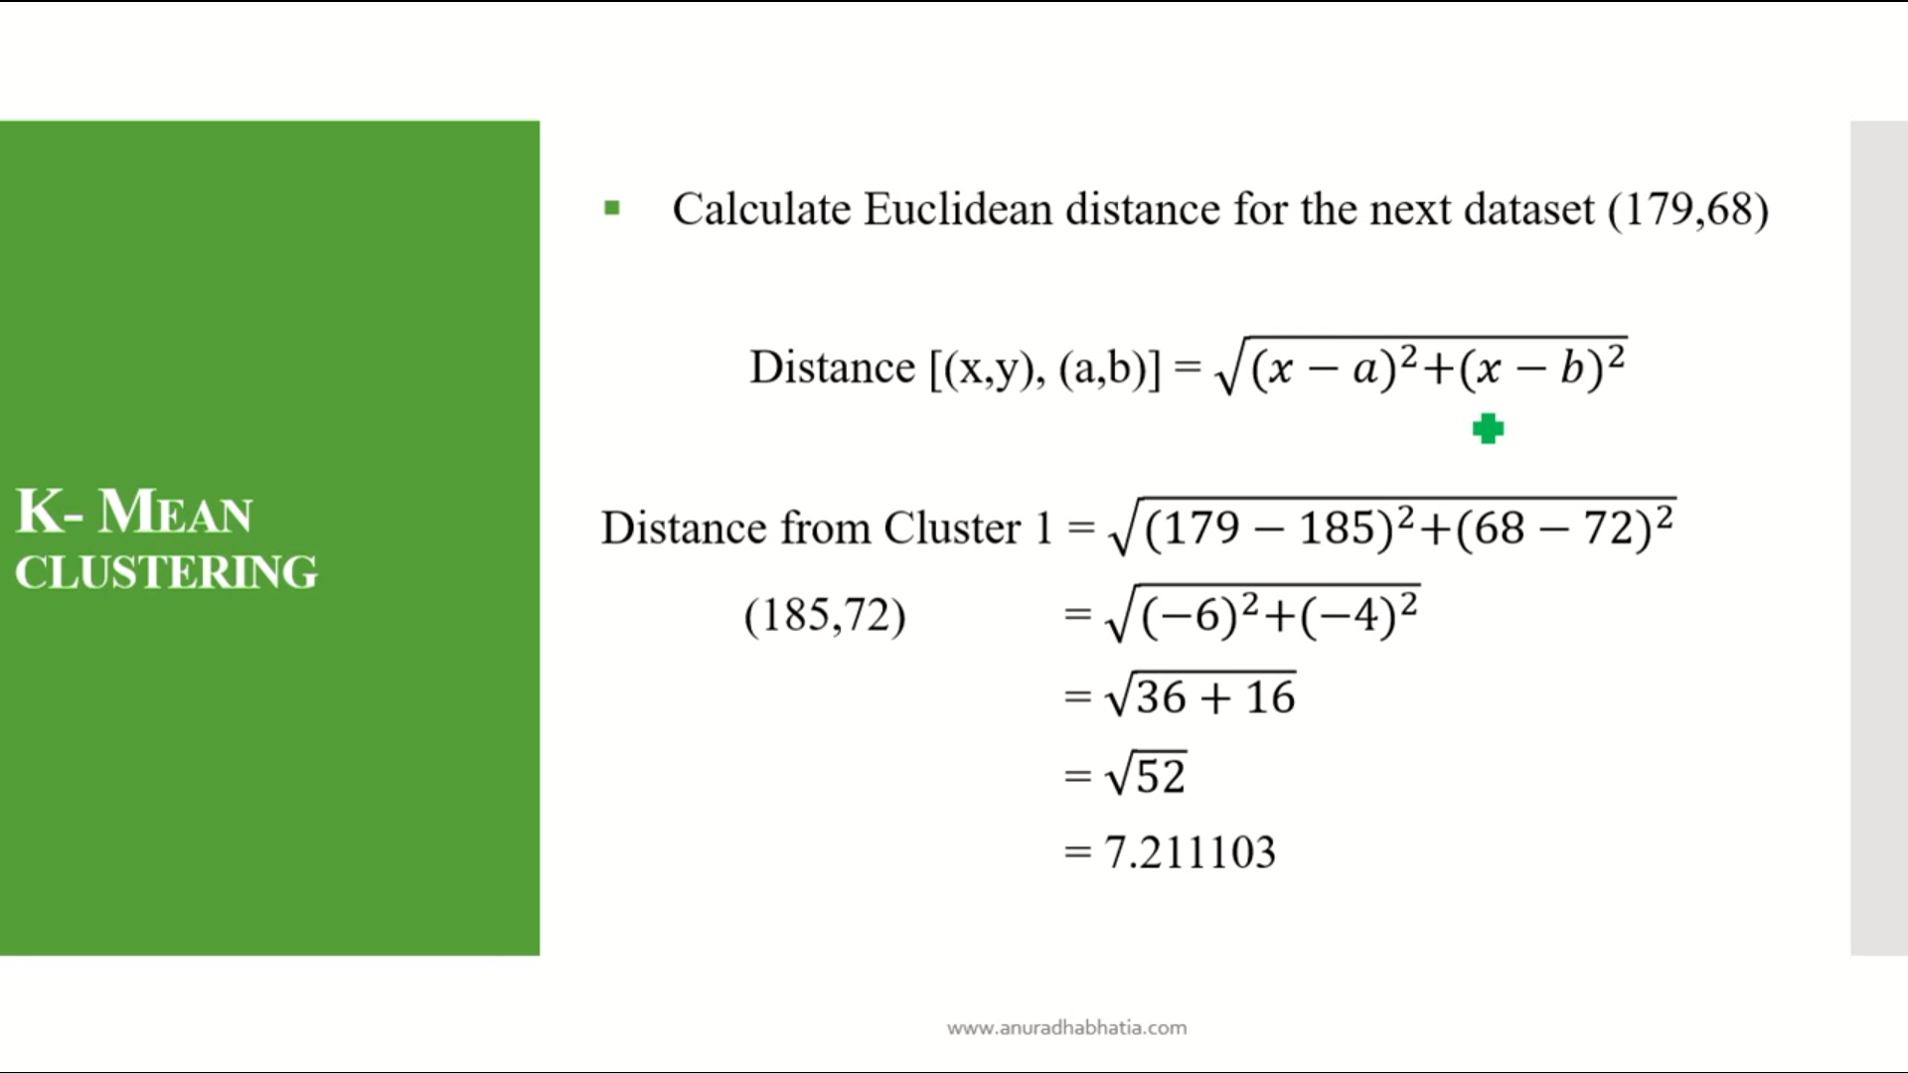

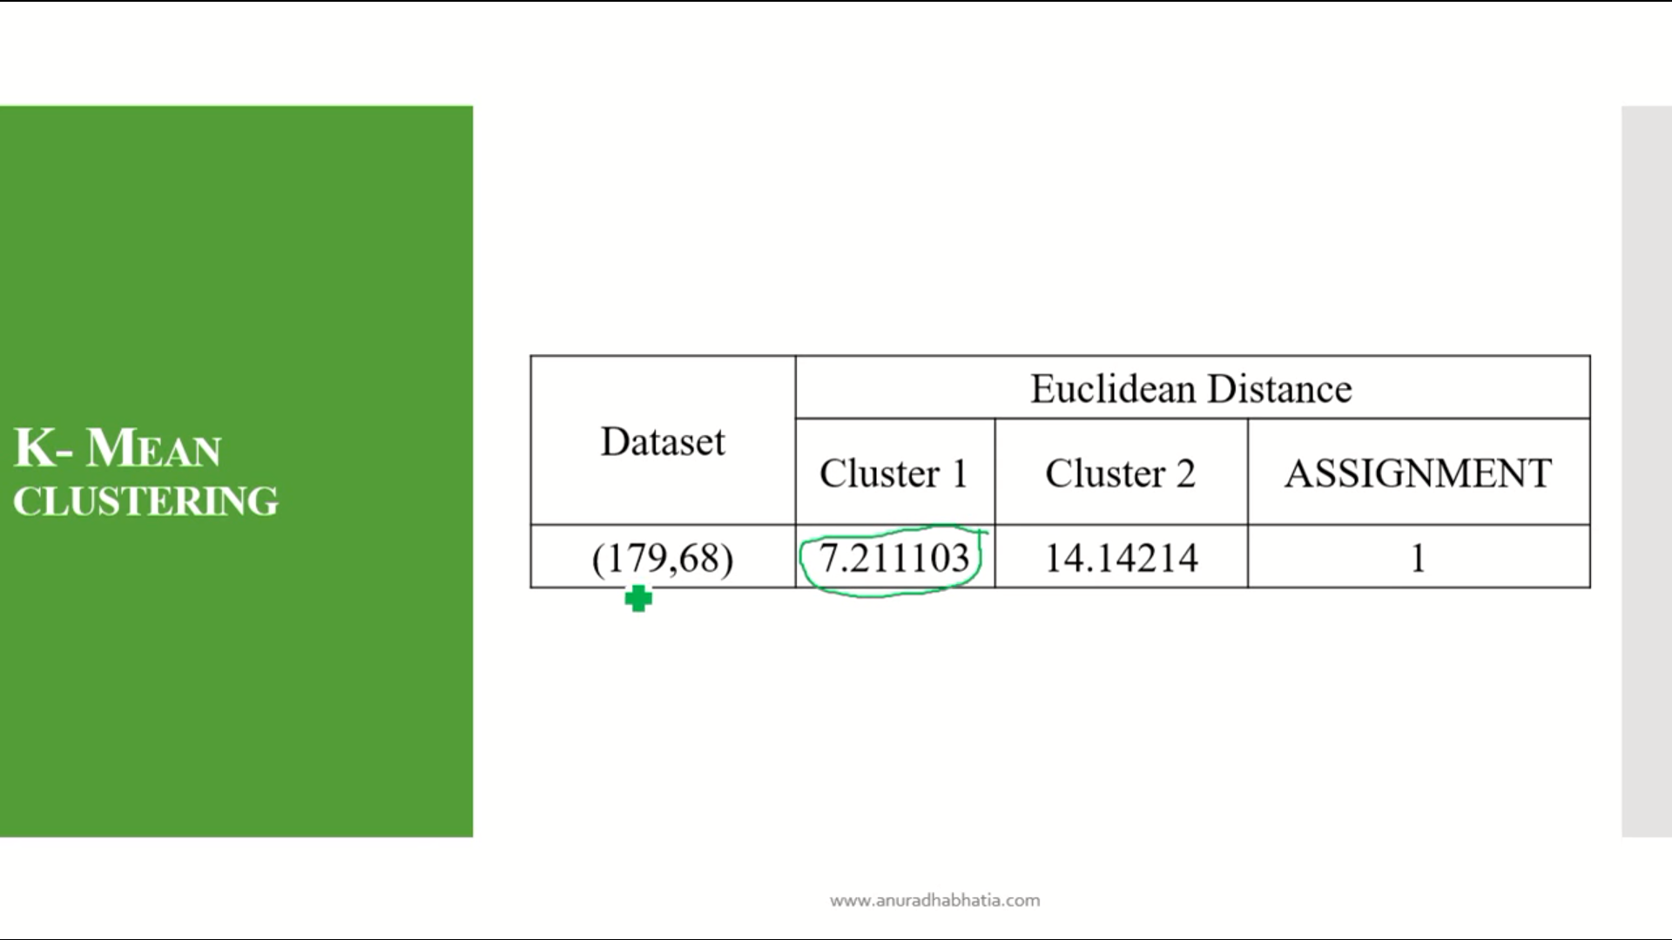

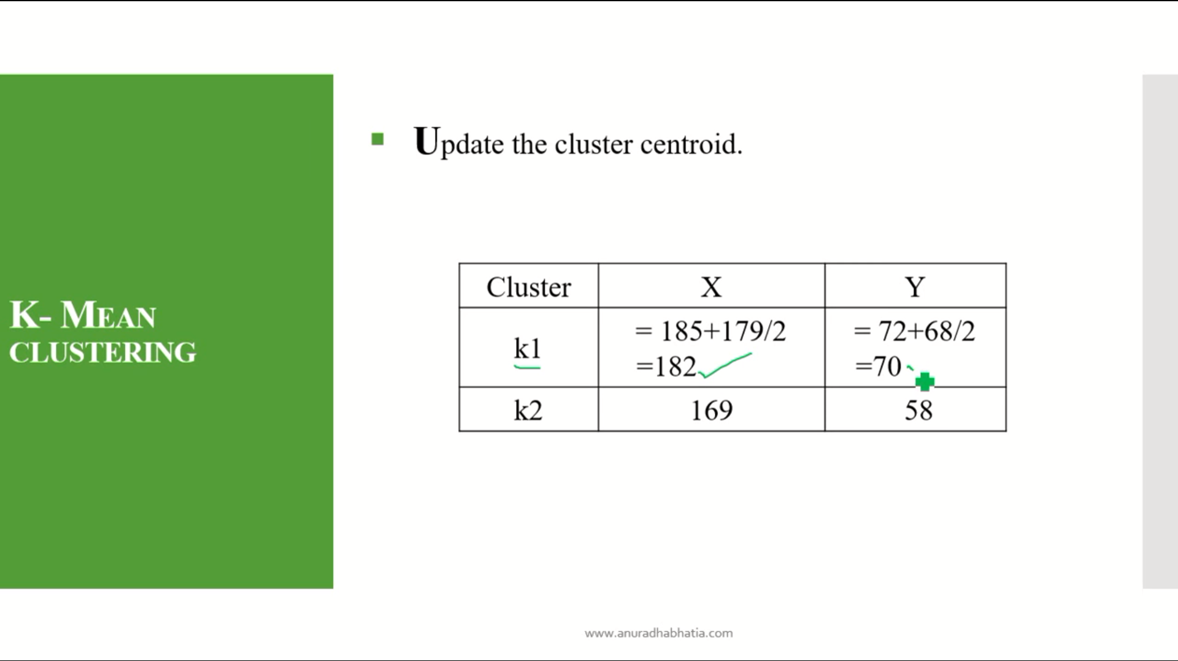

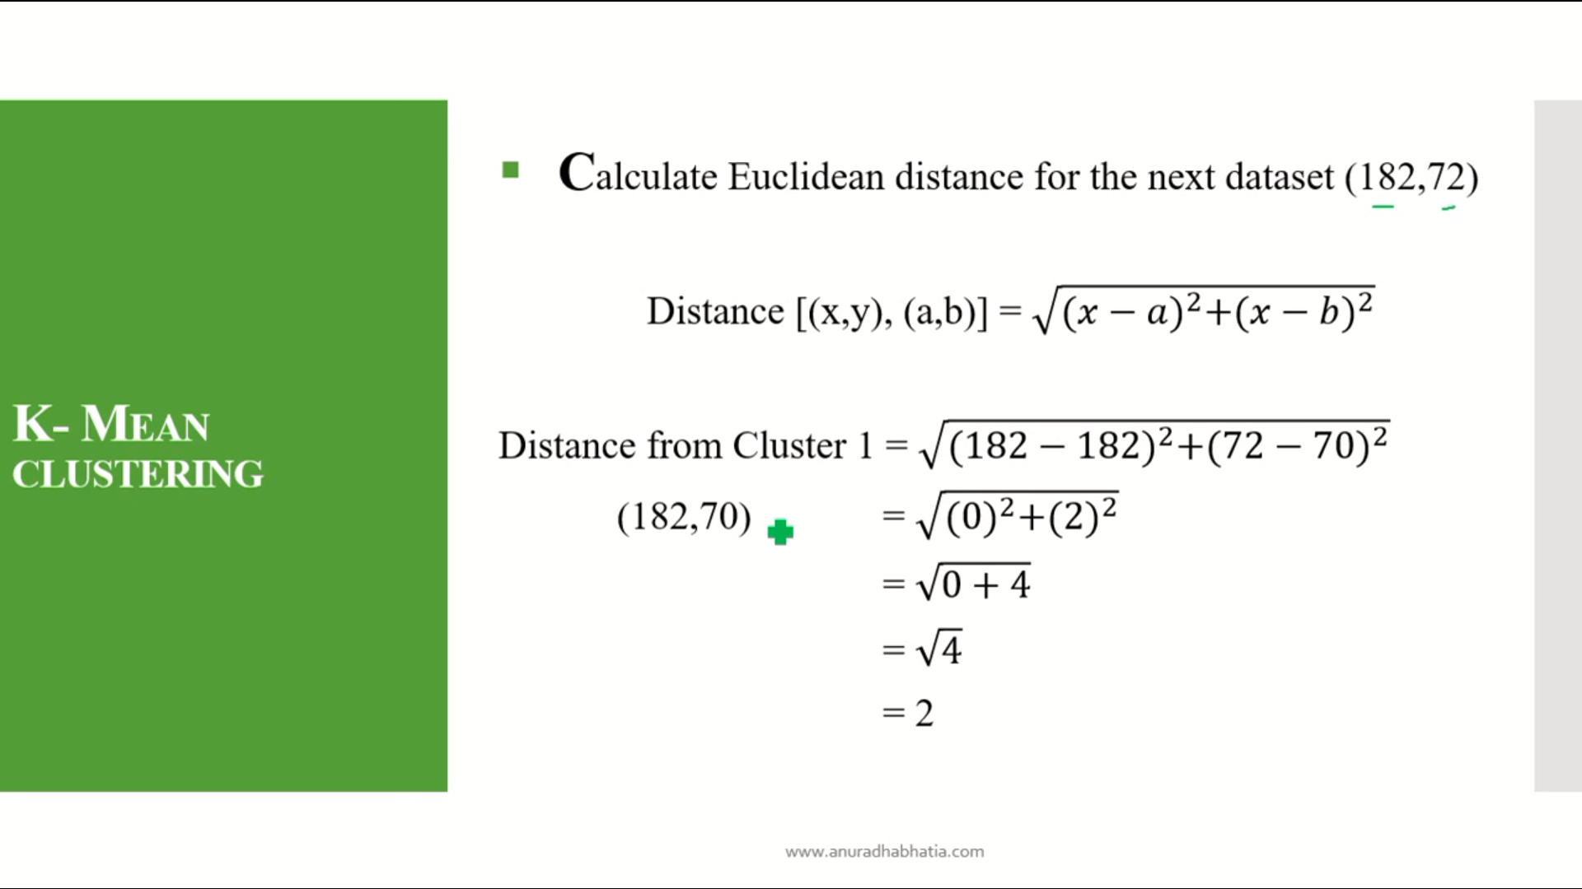

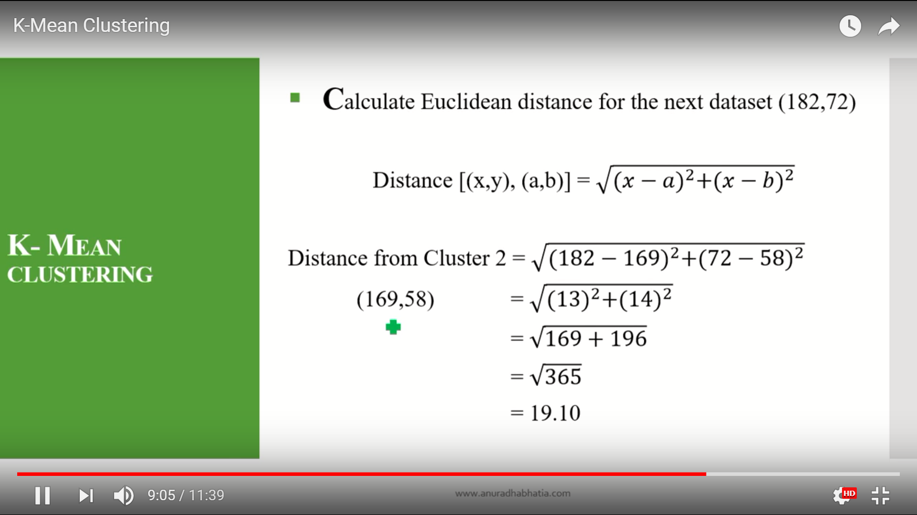

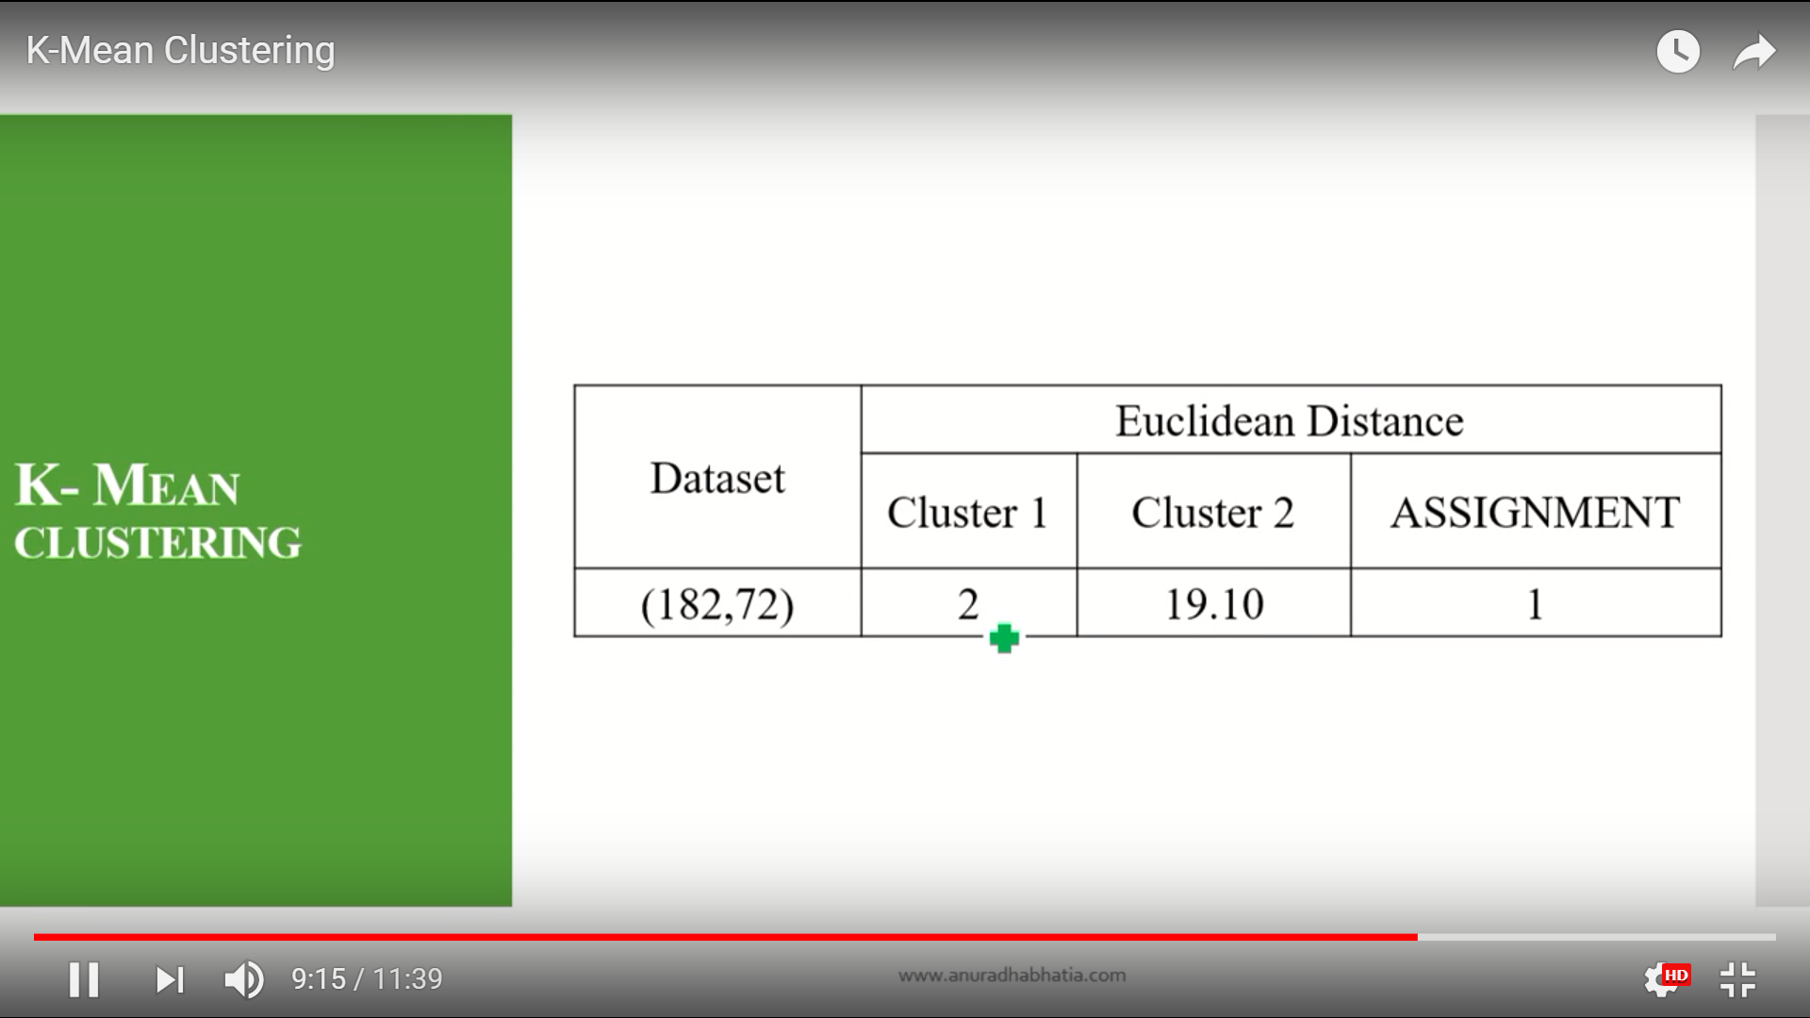

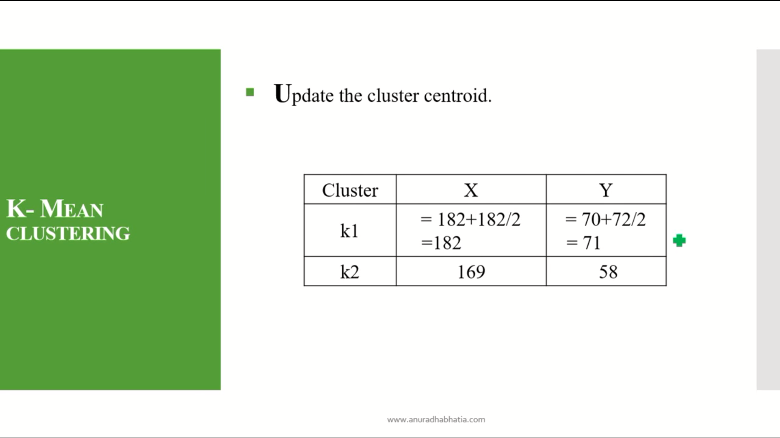

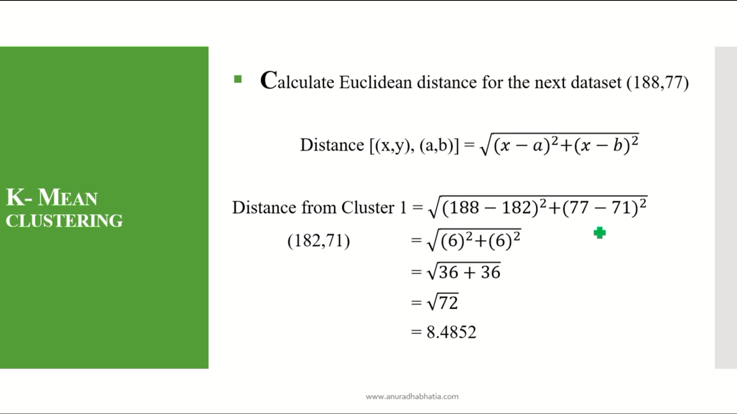

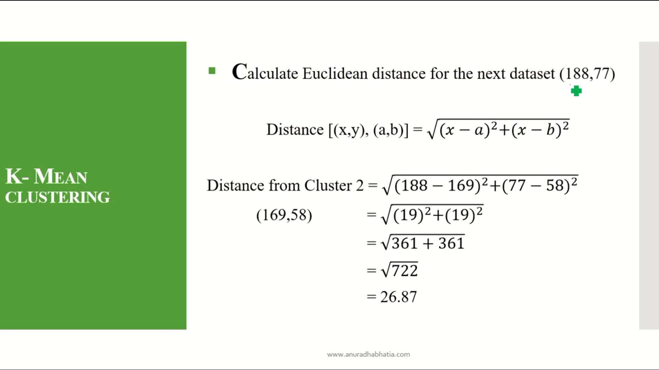

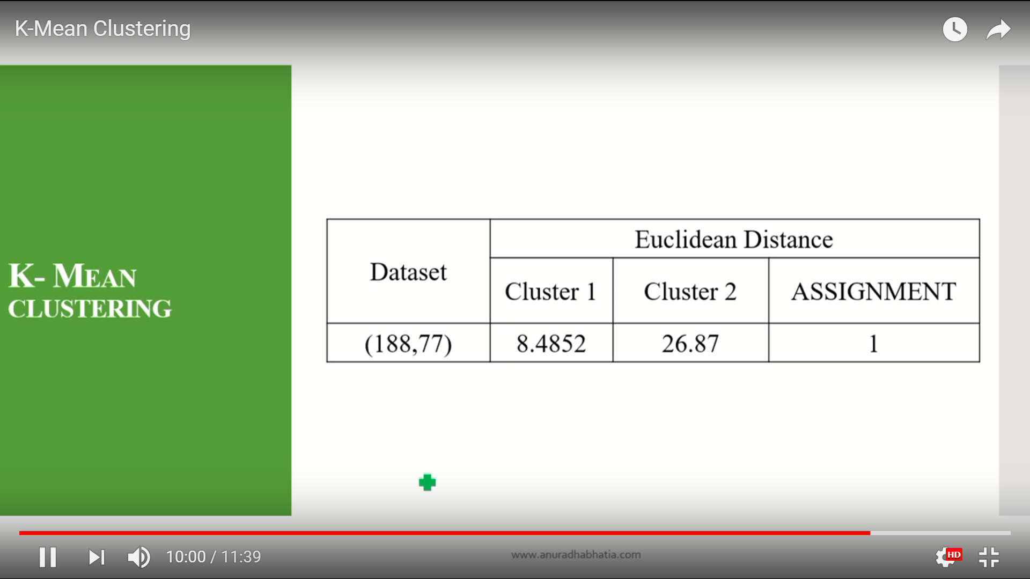

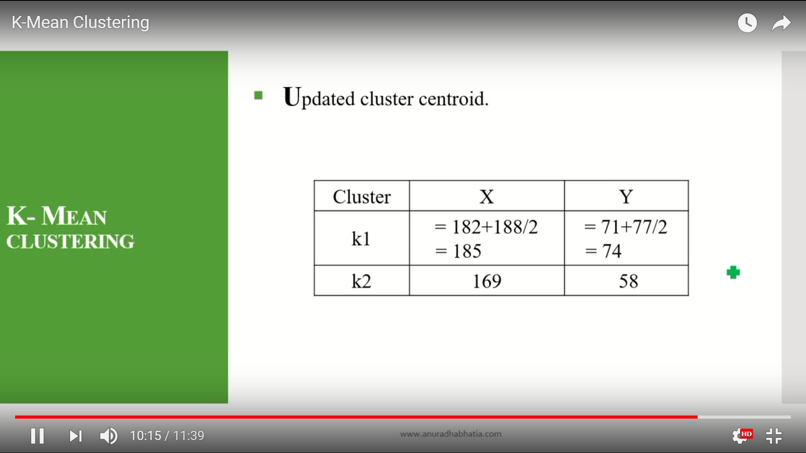

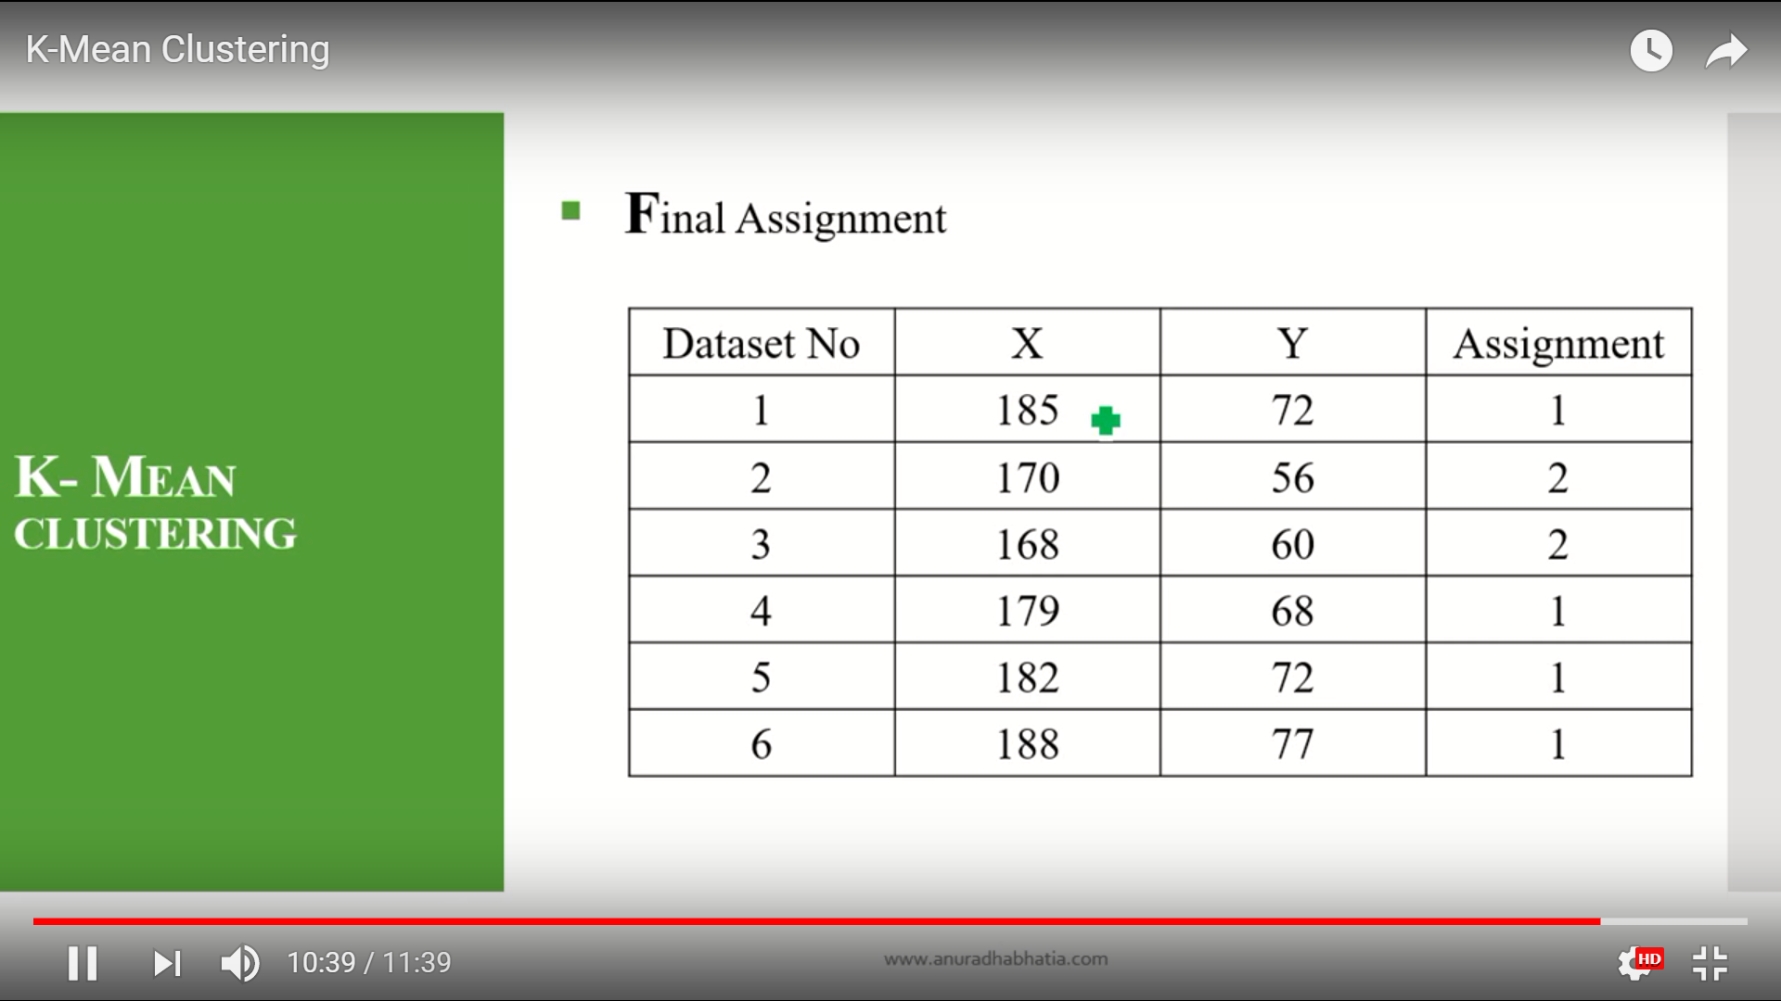

k-mean for single data set.

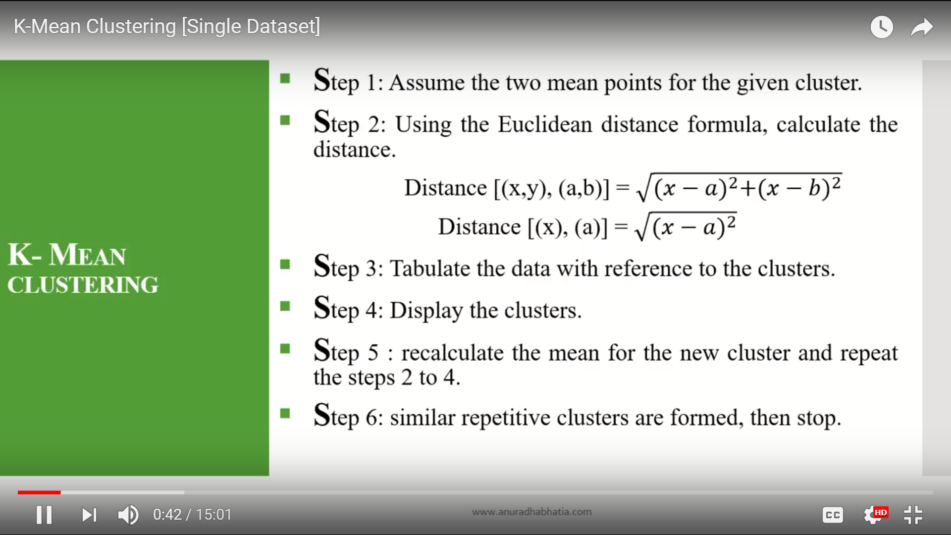

Here in the first step if they gave 3 cluster so assume that three mean points for the given cluster.

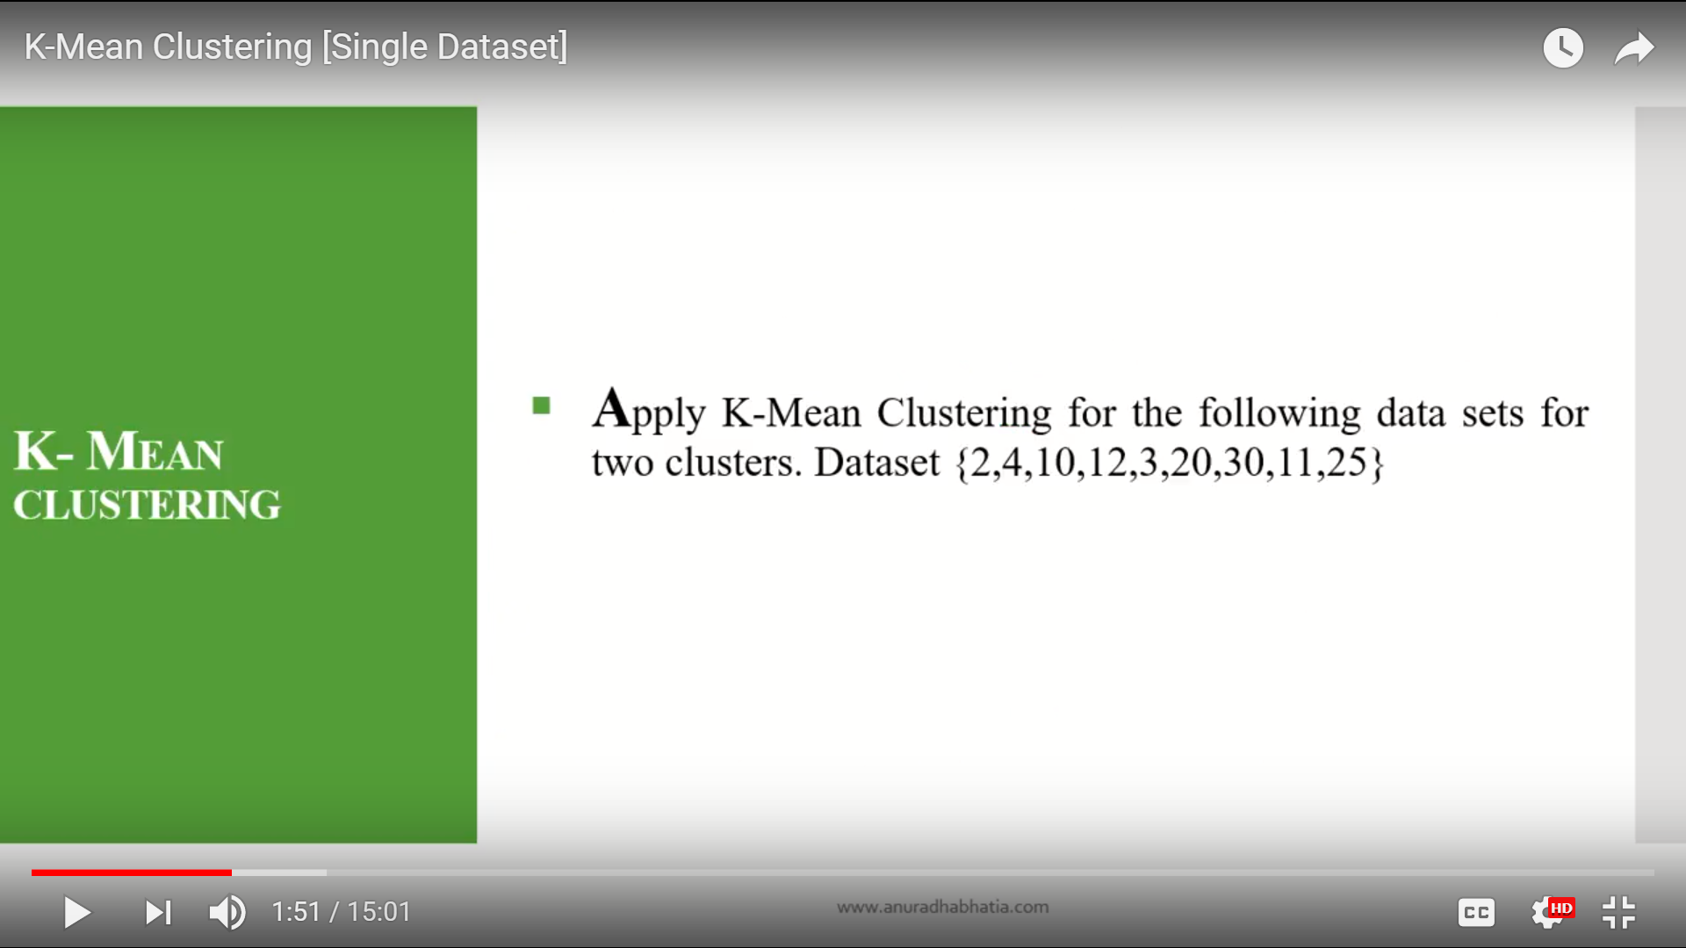

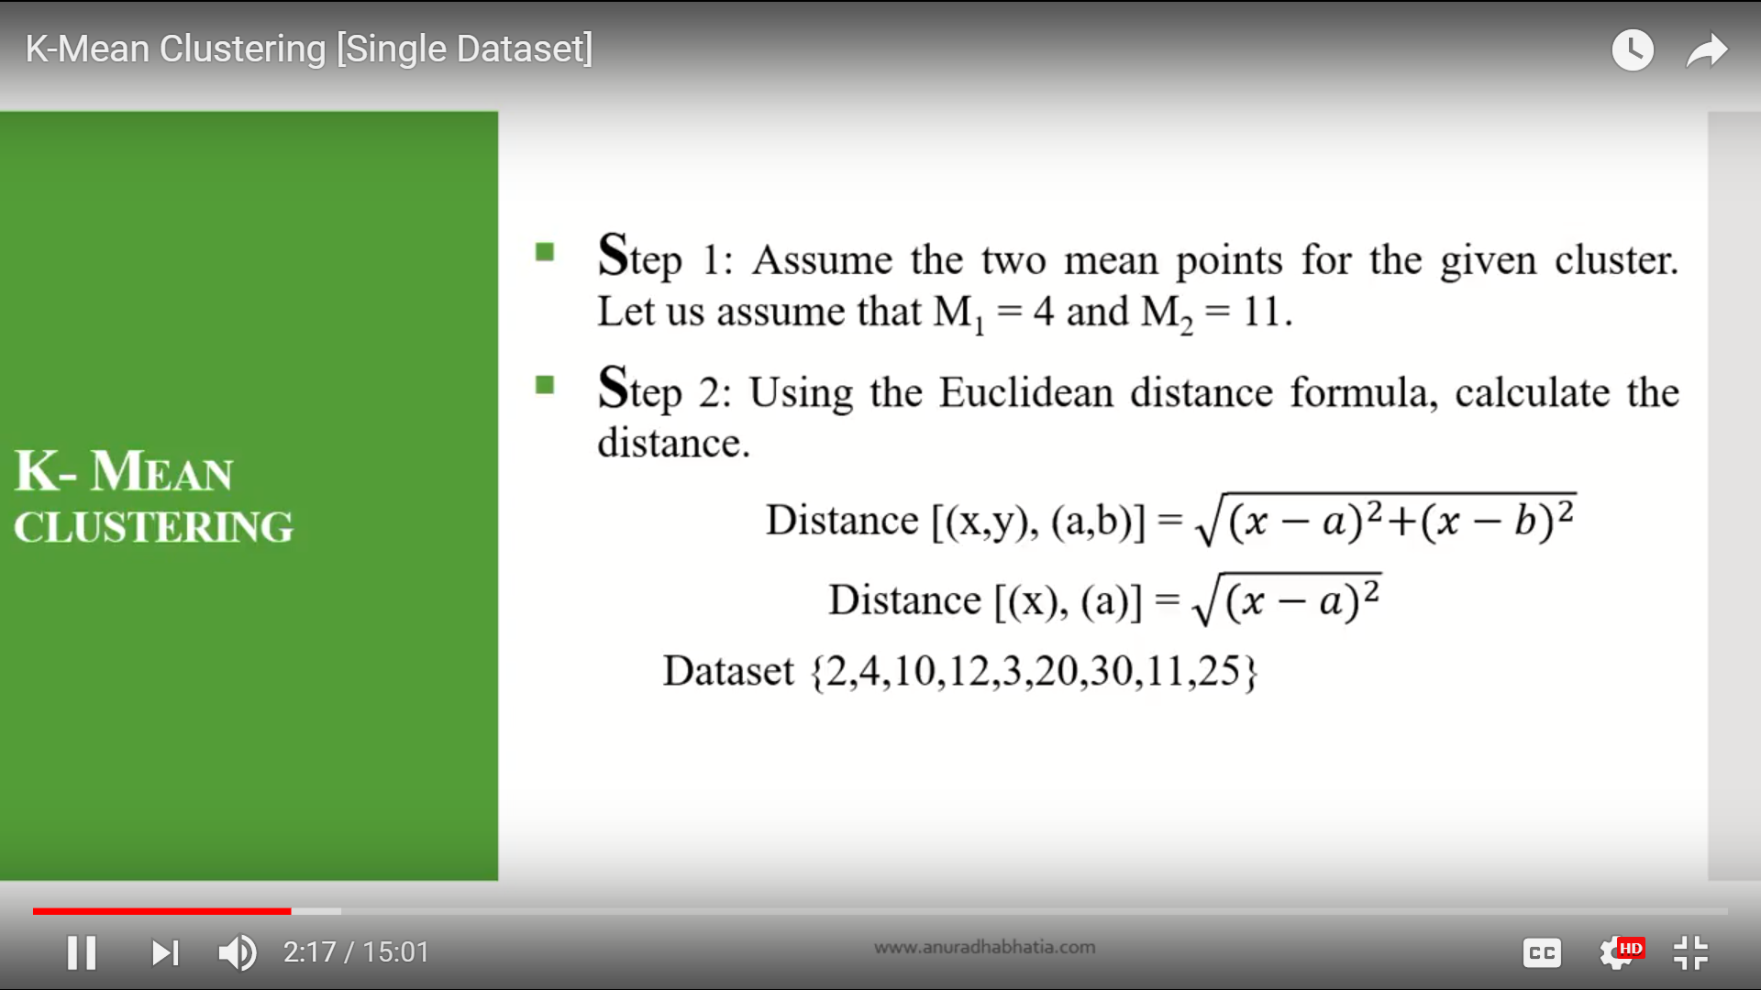

Here in the step one we have to assume the two mean values in the data. any values you can take from the set.if they

tell three mean points in the first step you have to take 3 mean values from the given data set.

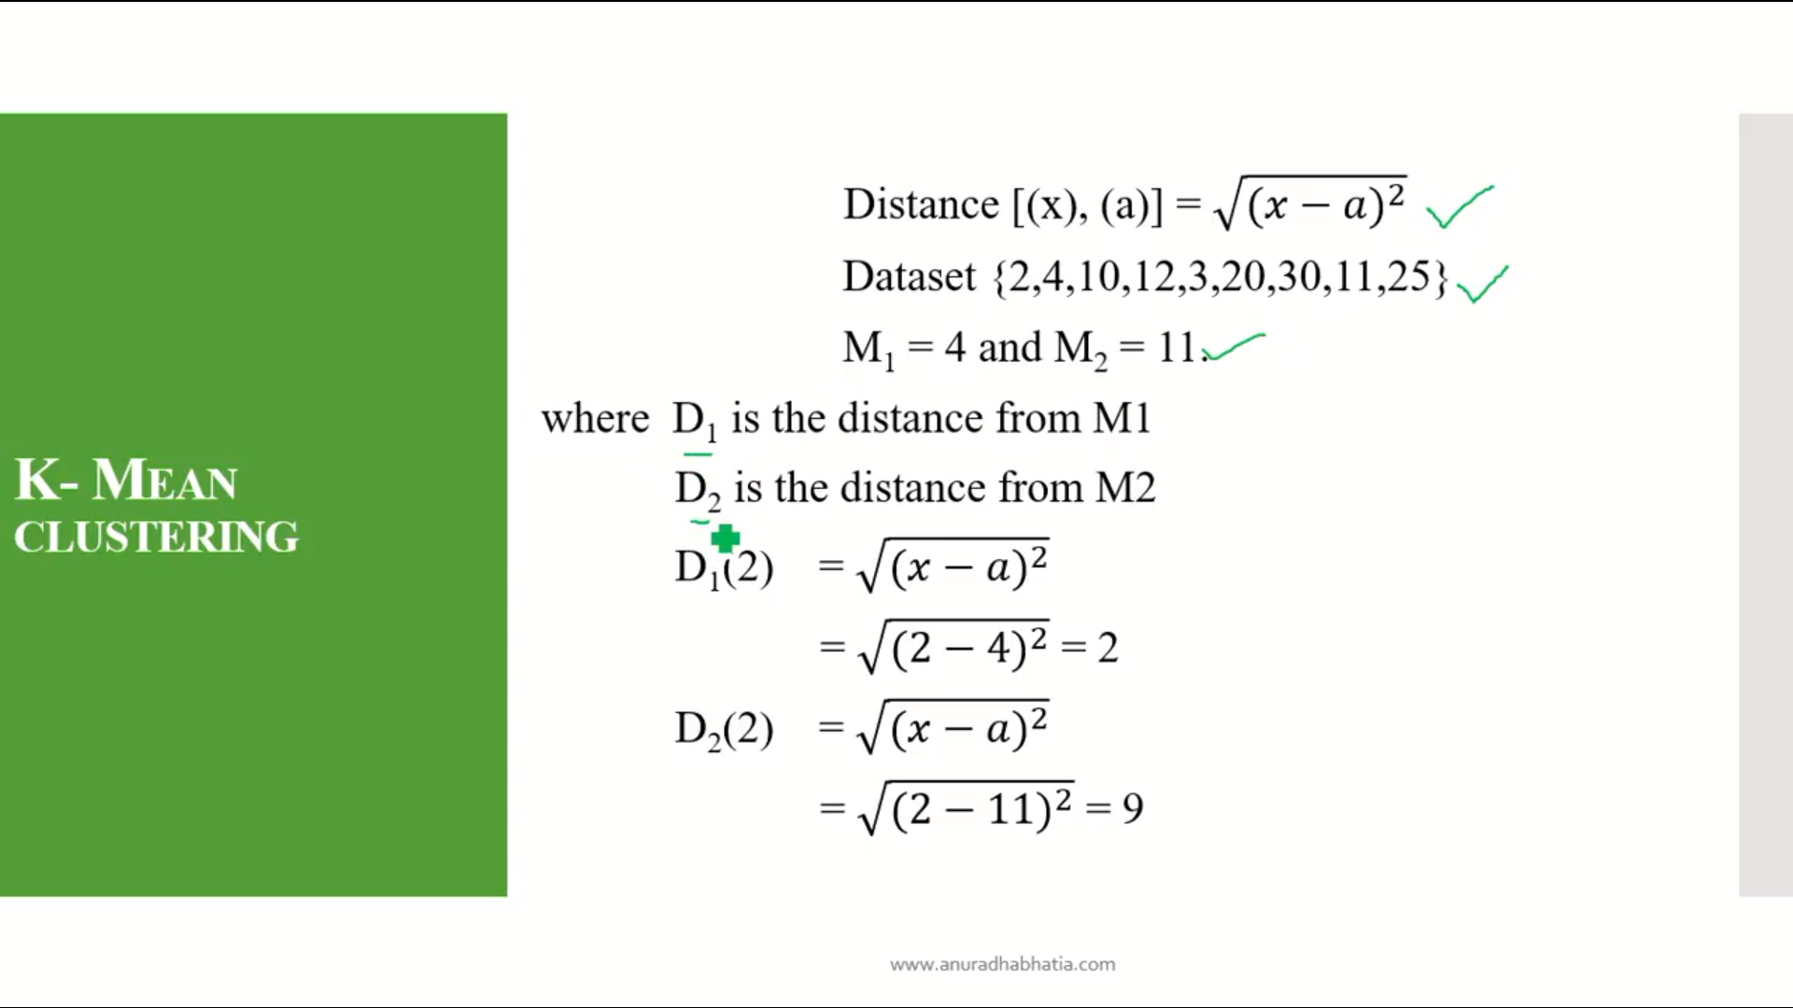

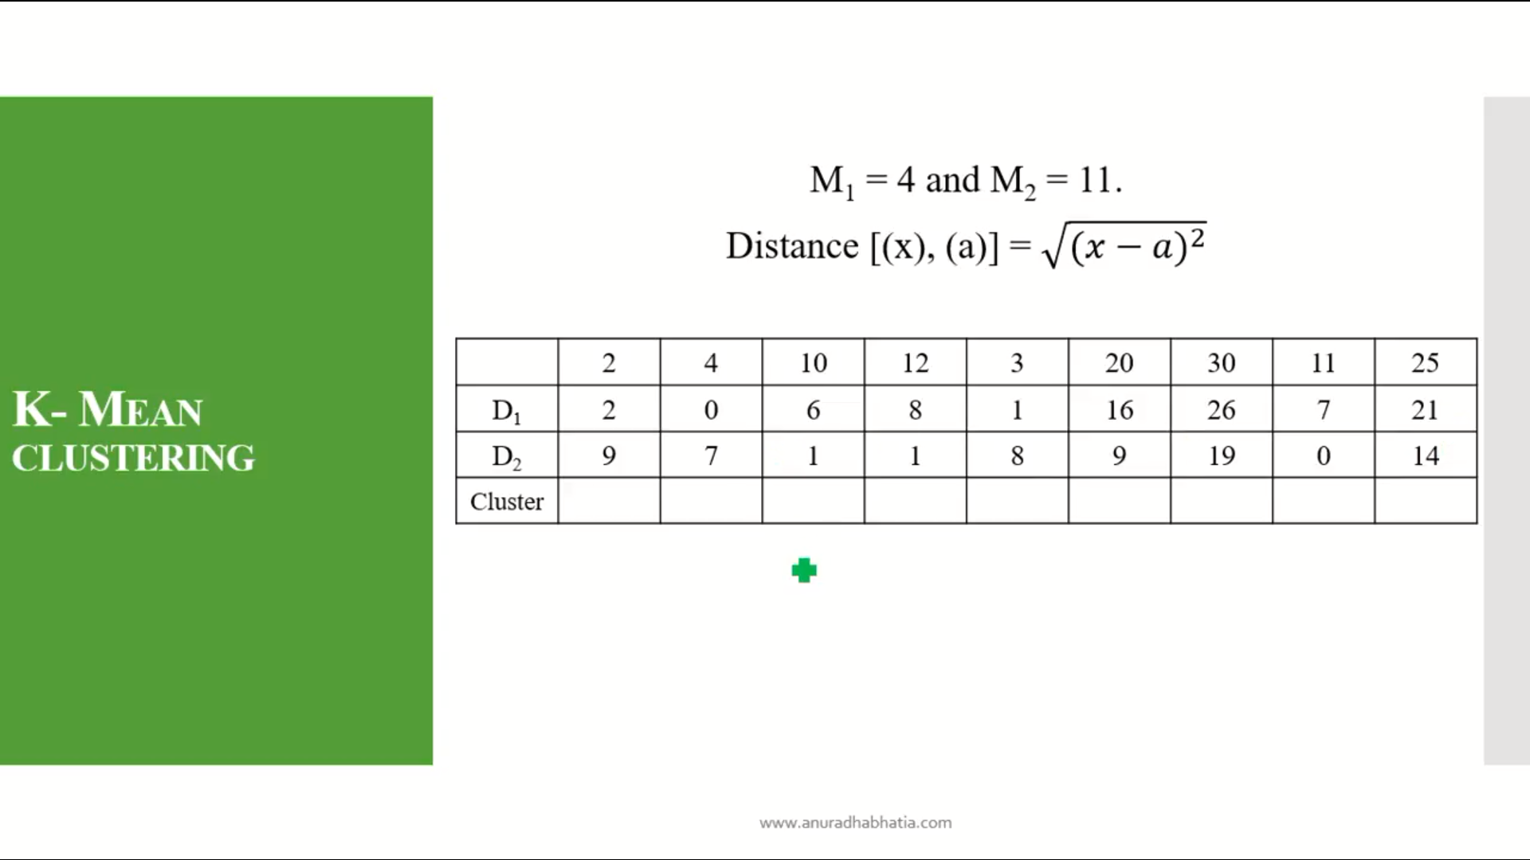

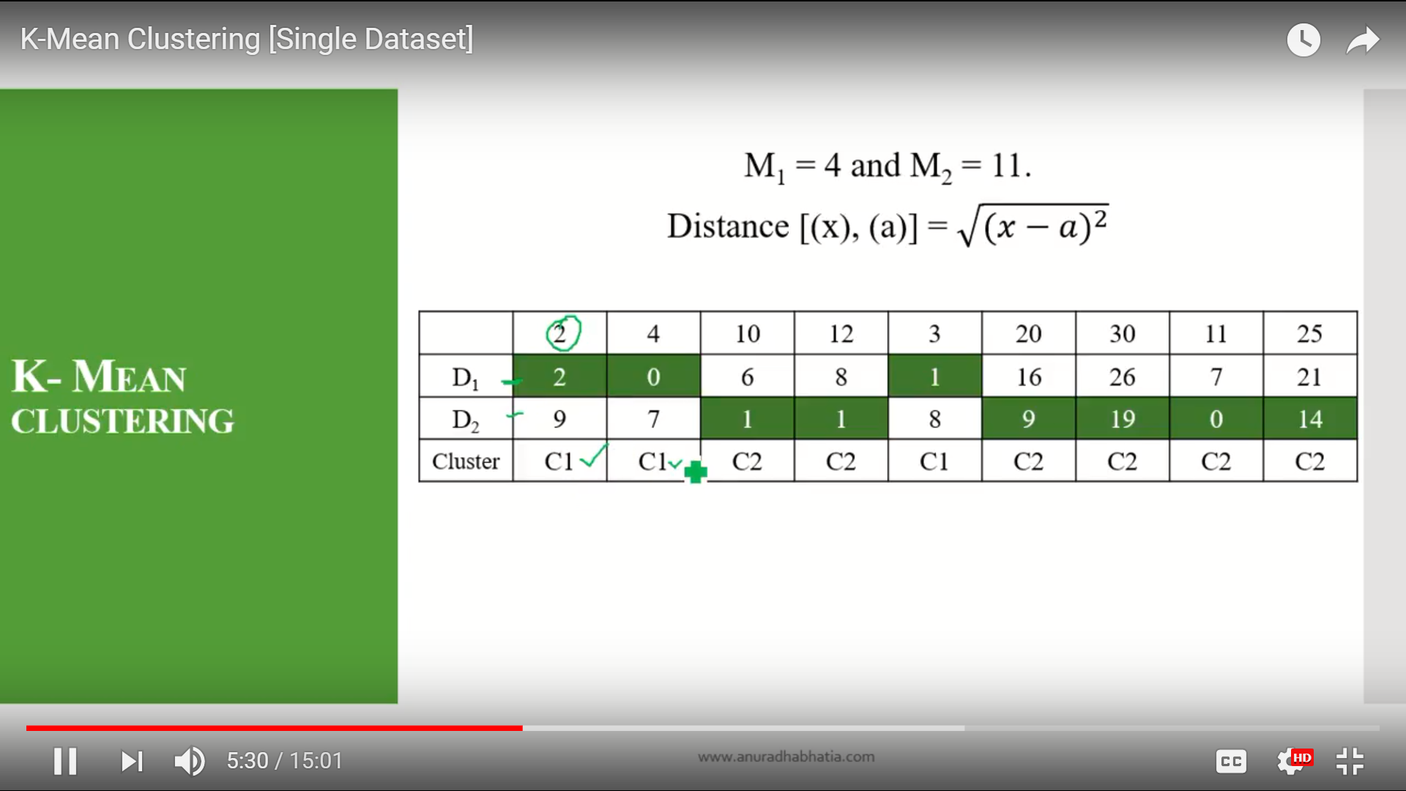

Here minimum values are heighleted for D1 and D2.

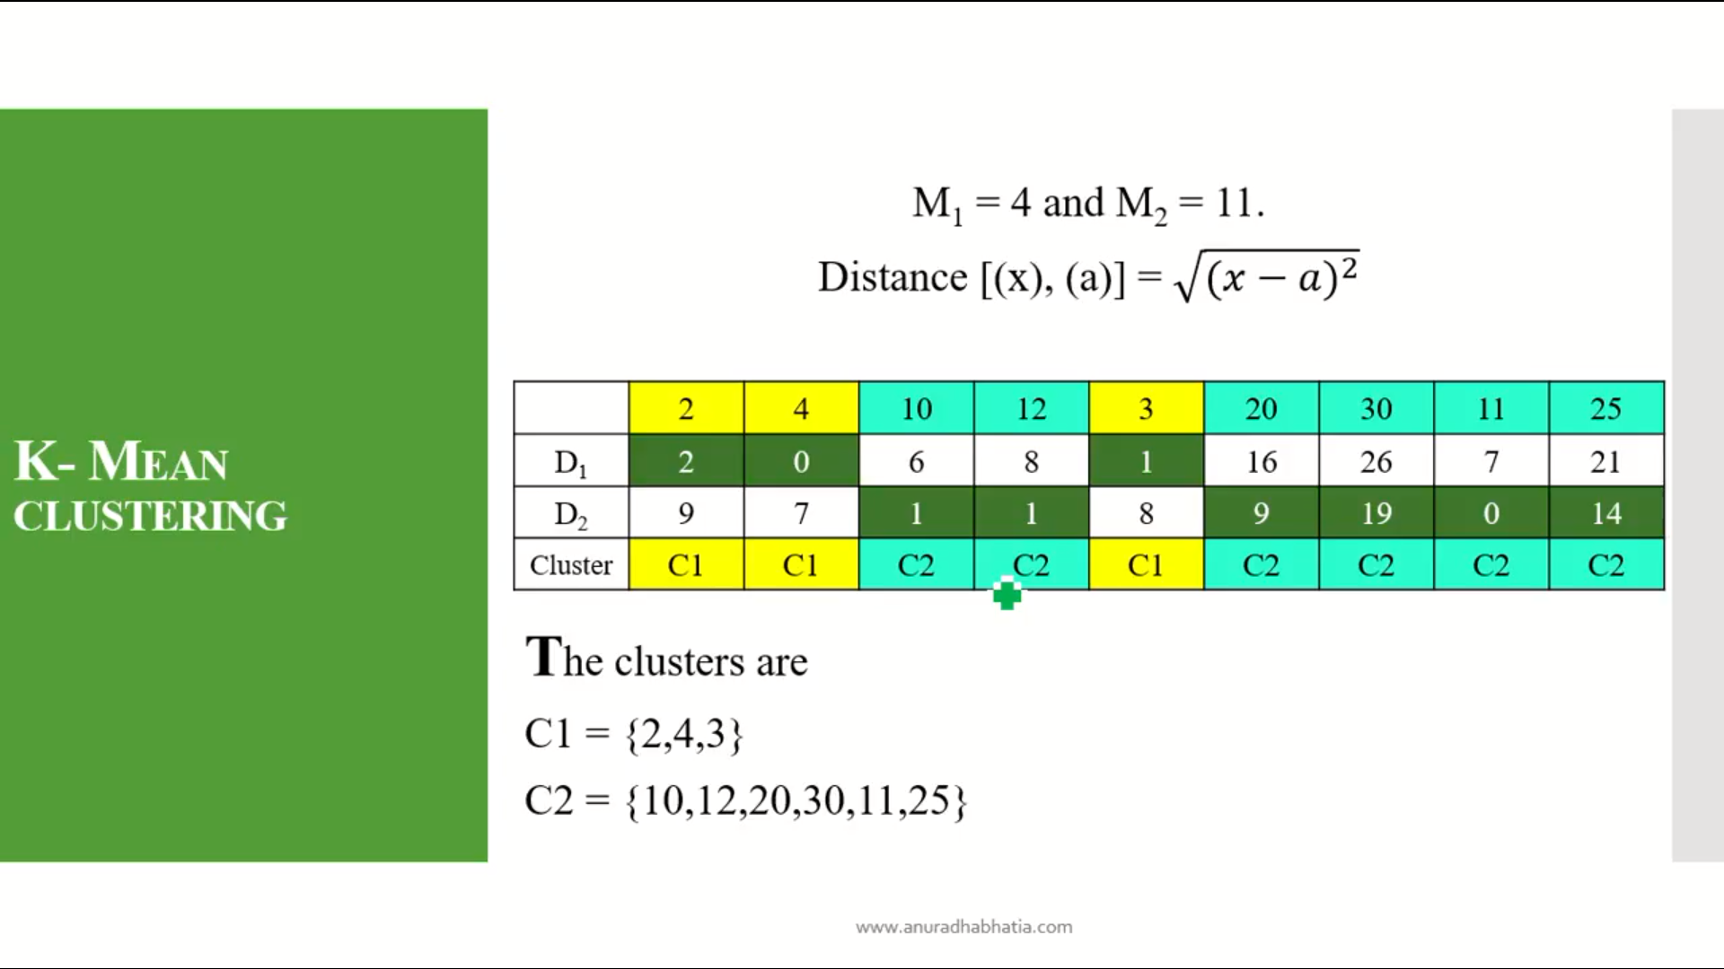

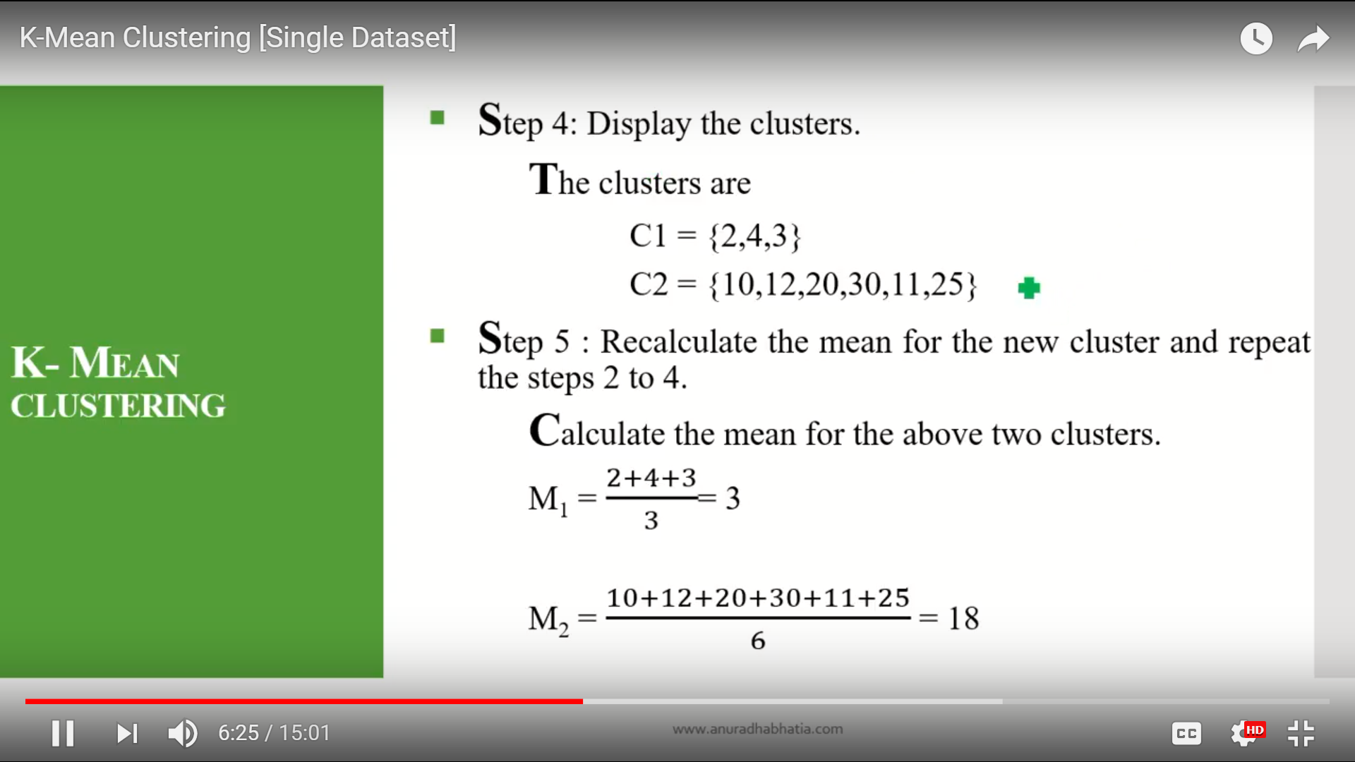

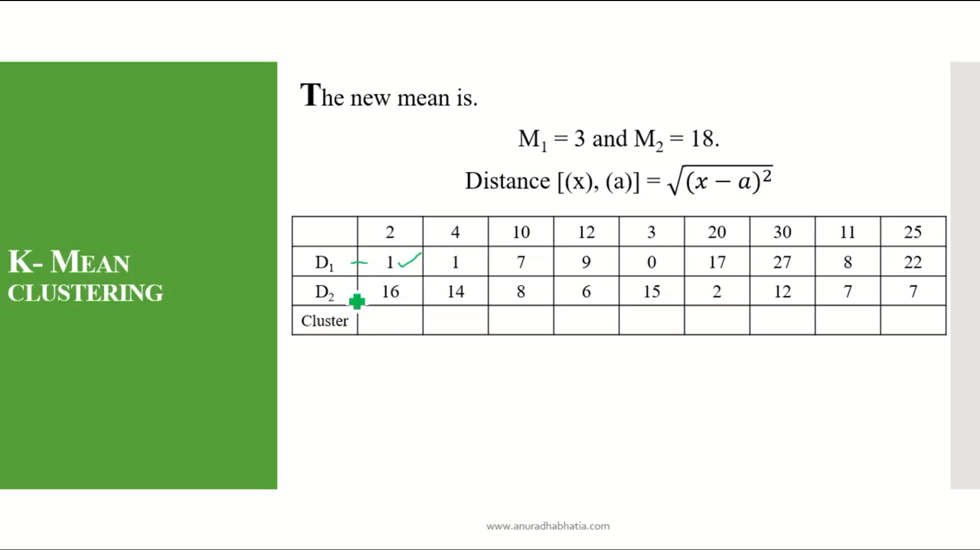

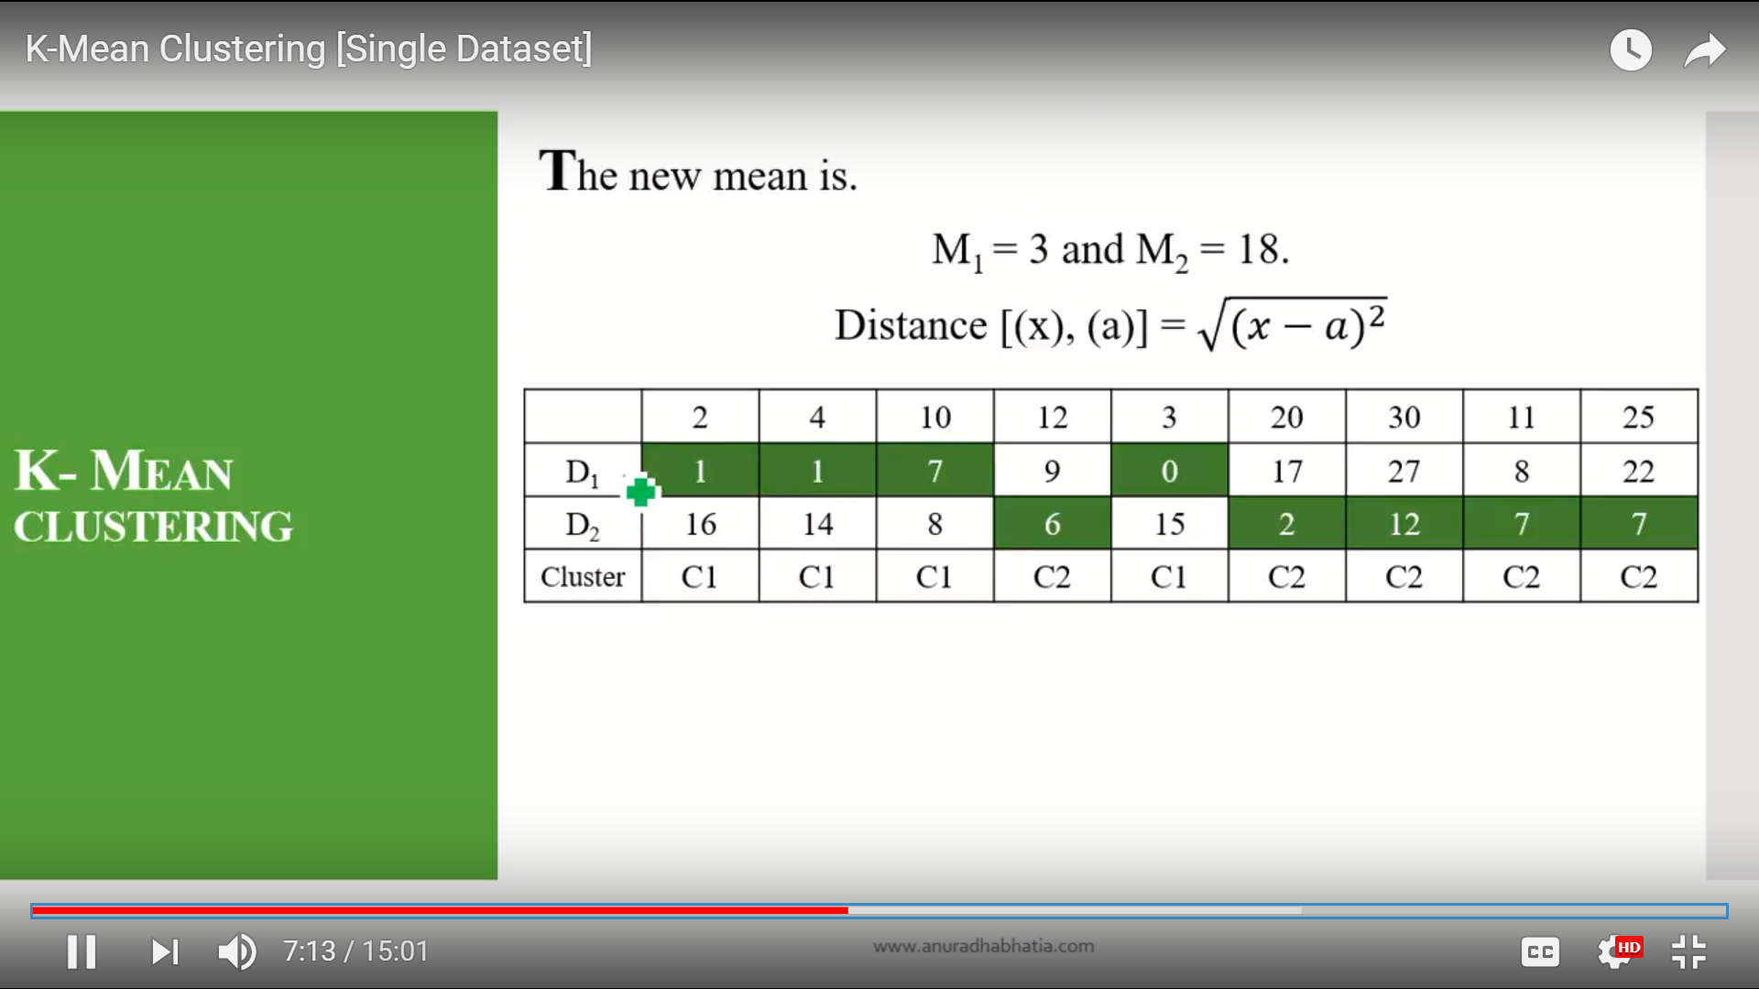

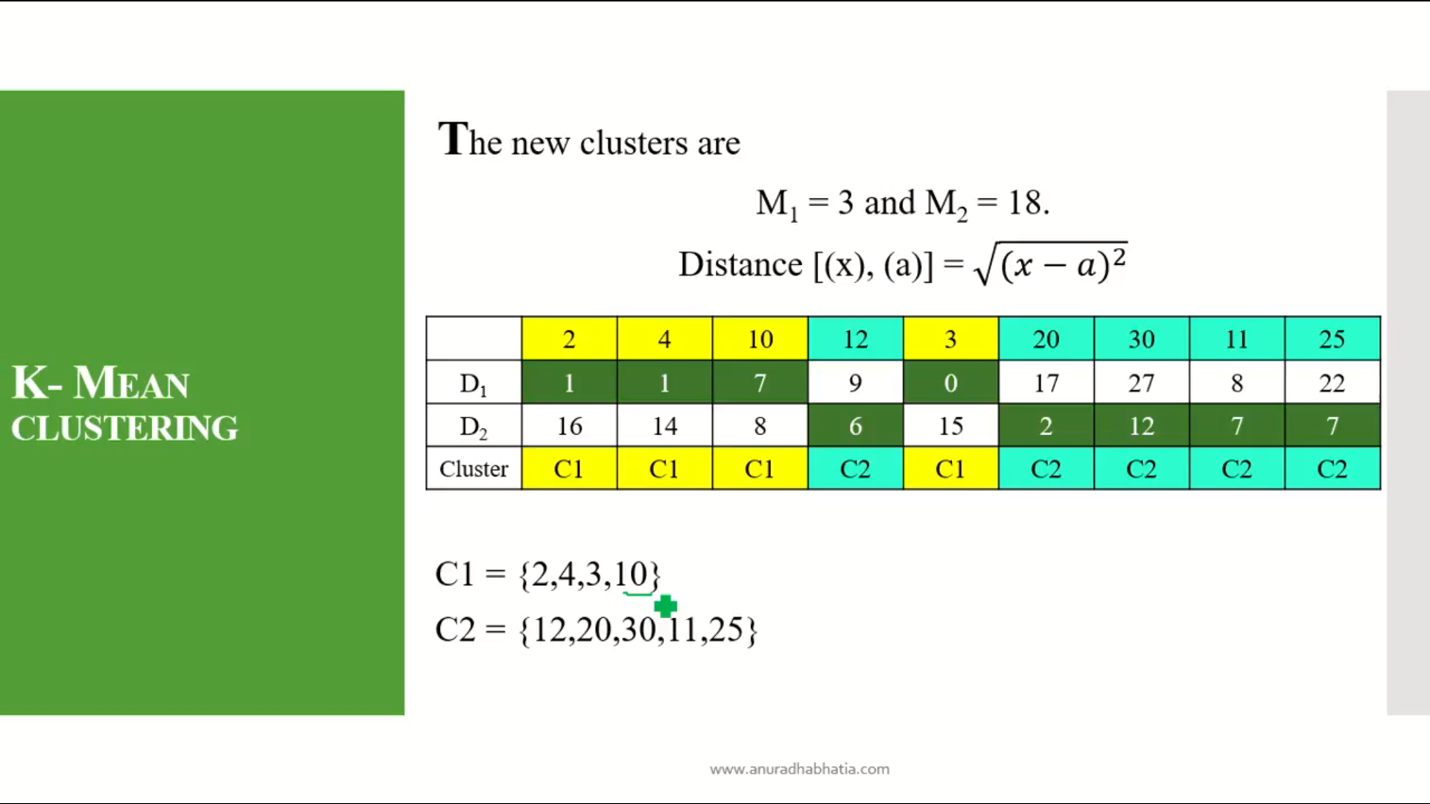

Here the 10 is moved to cluster 2 to cluster 1. So as the moment of item set between the cluster so this can not be final cluster so we start re calculating the mean again with these values of cluster C1 and C2.

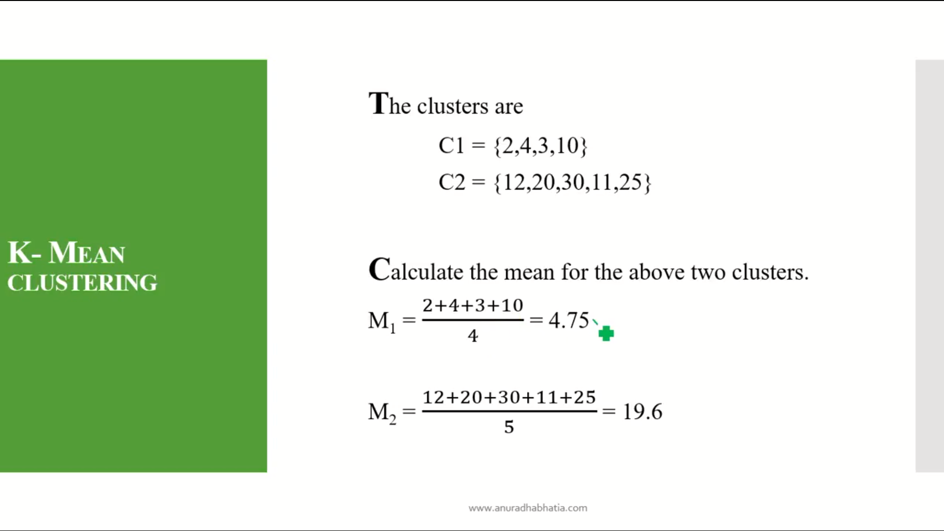

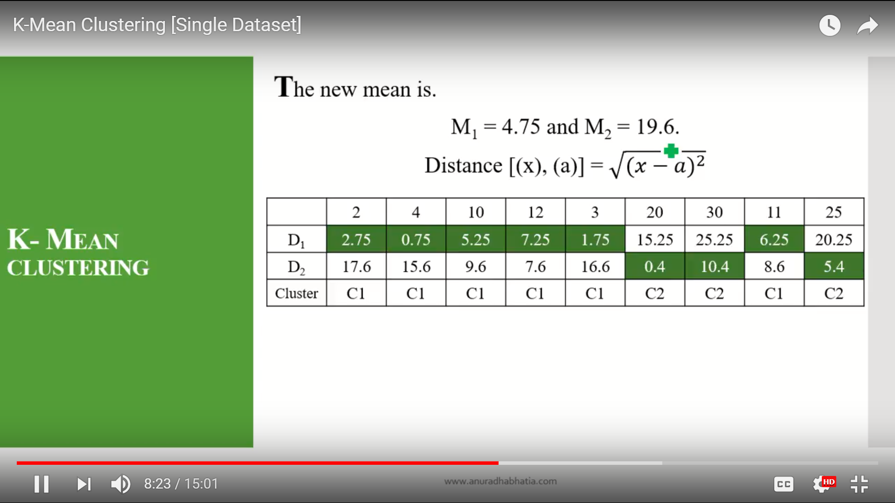

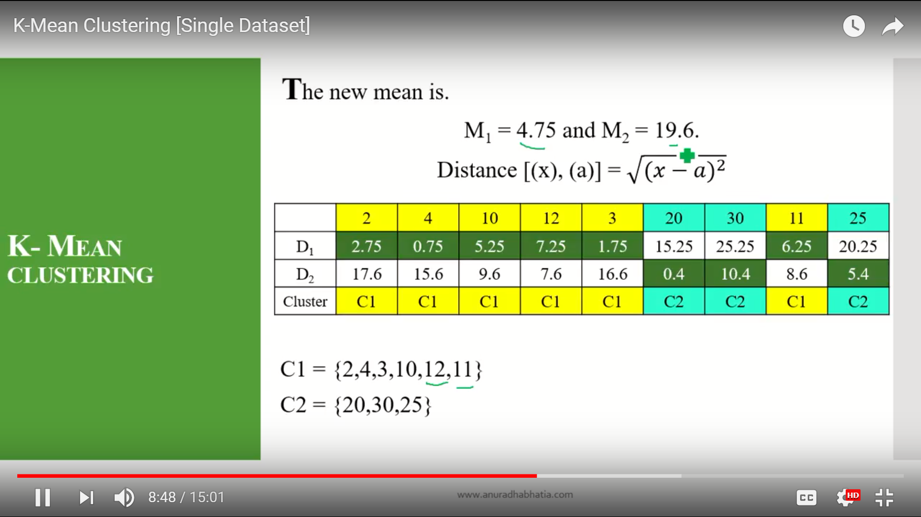

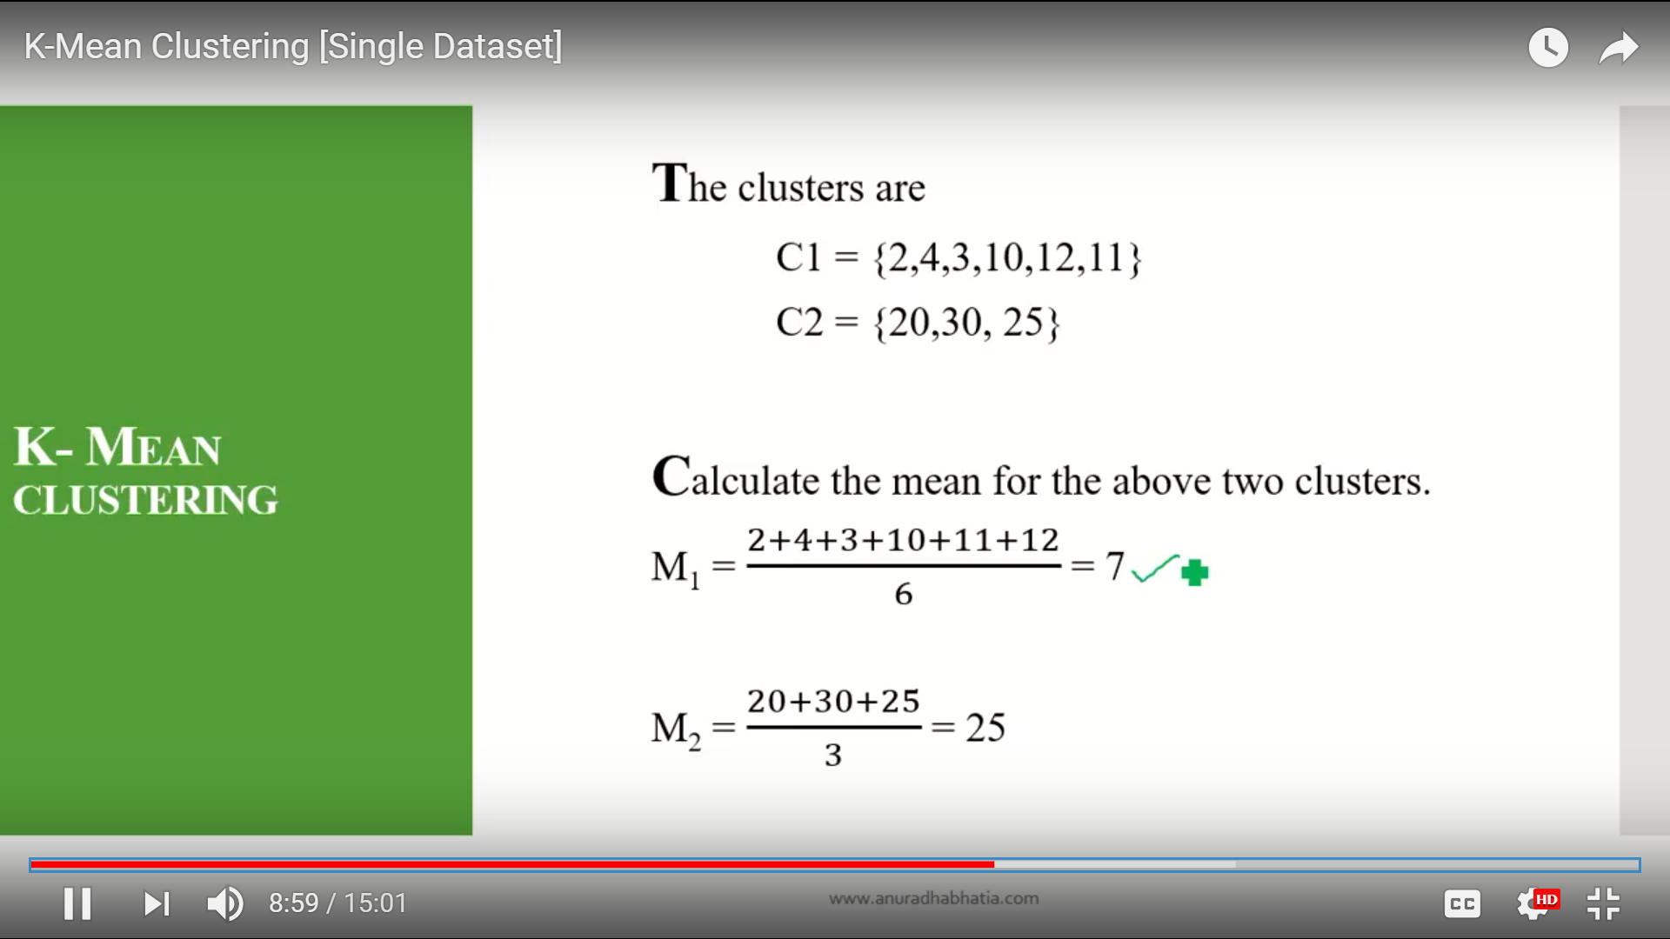

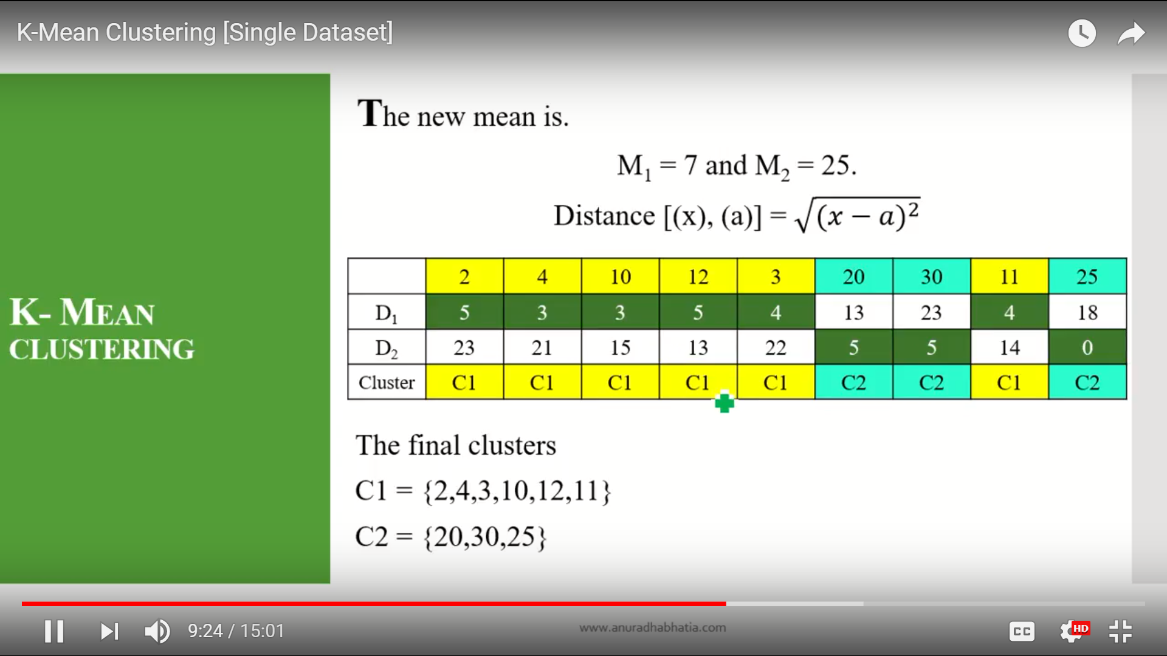

Here the the two clusters are same as previous.

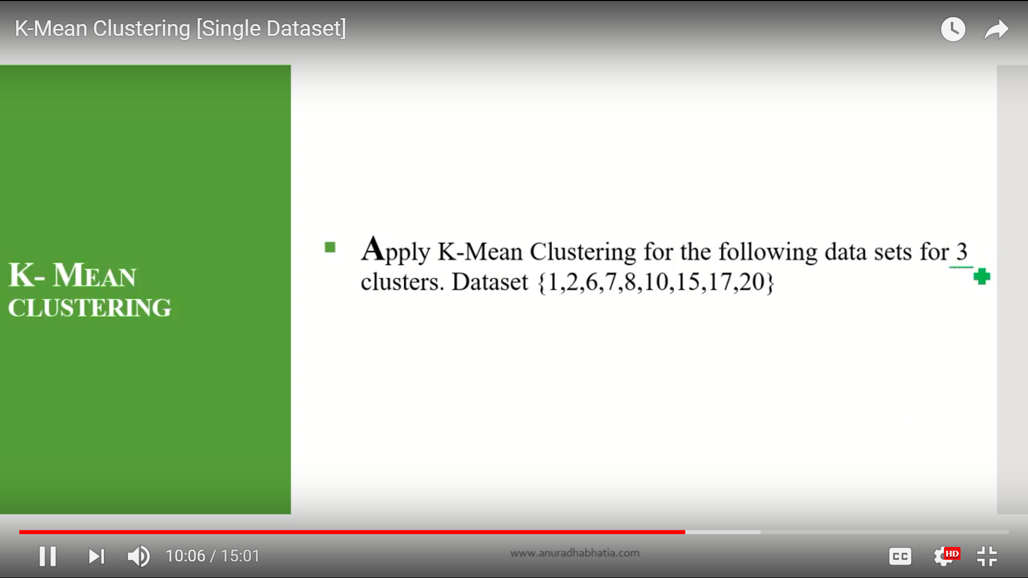

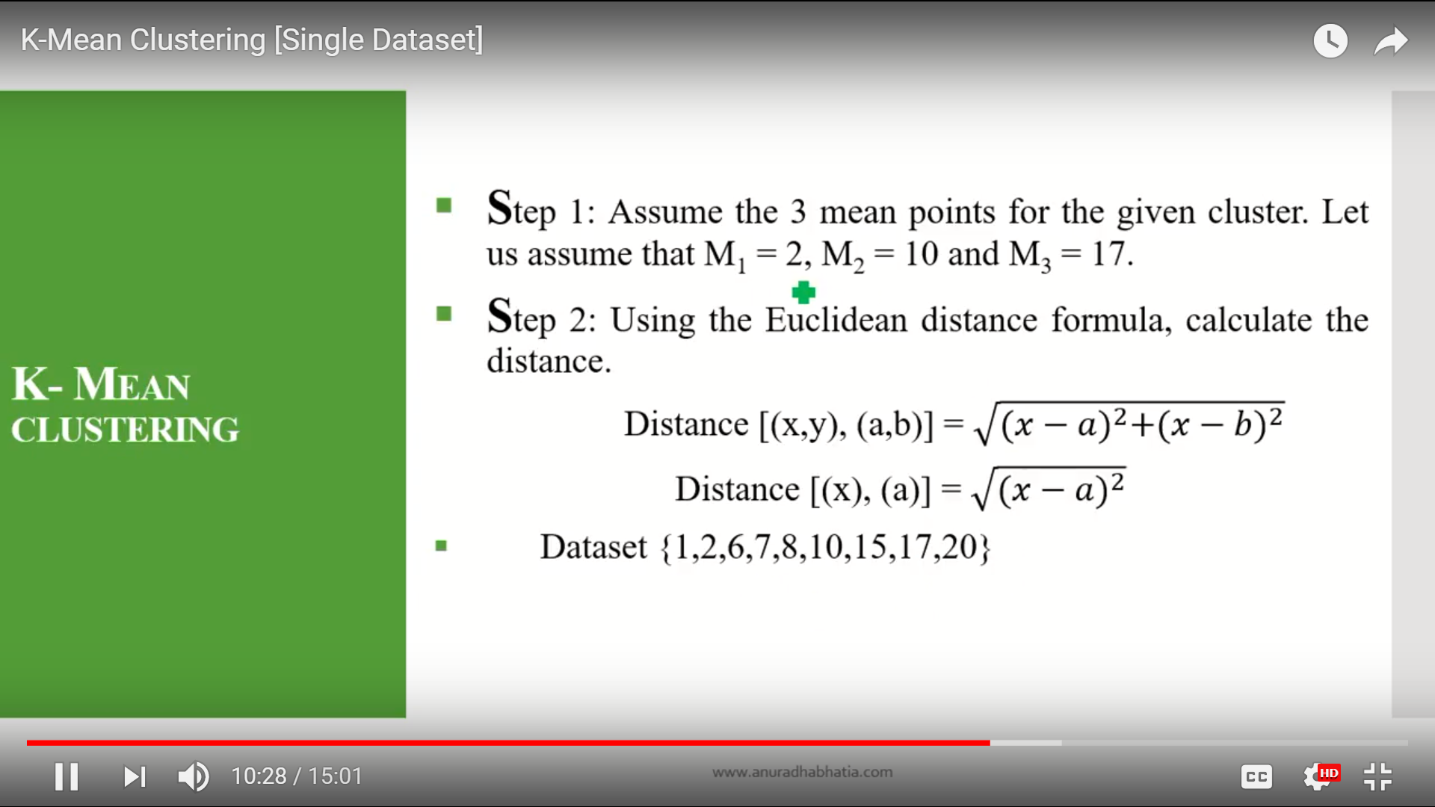

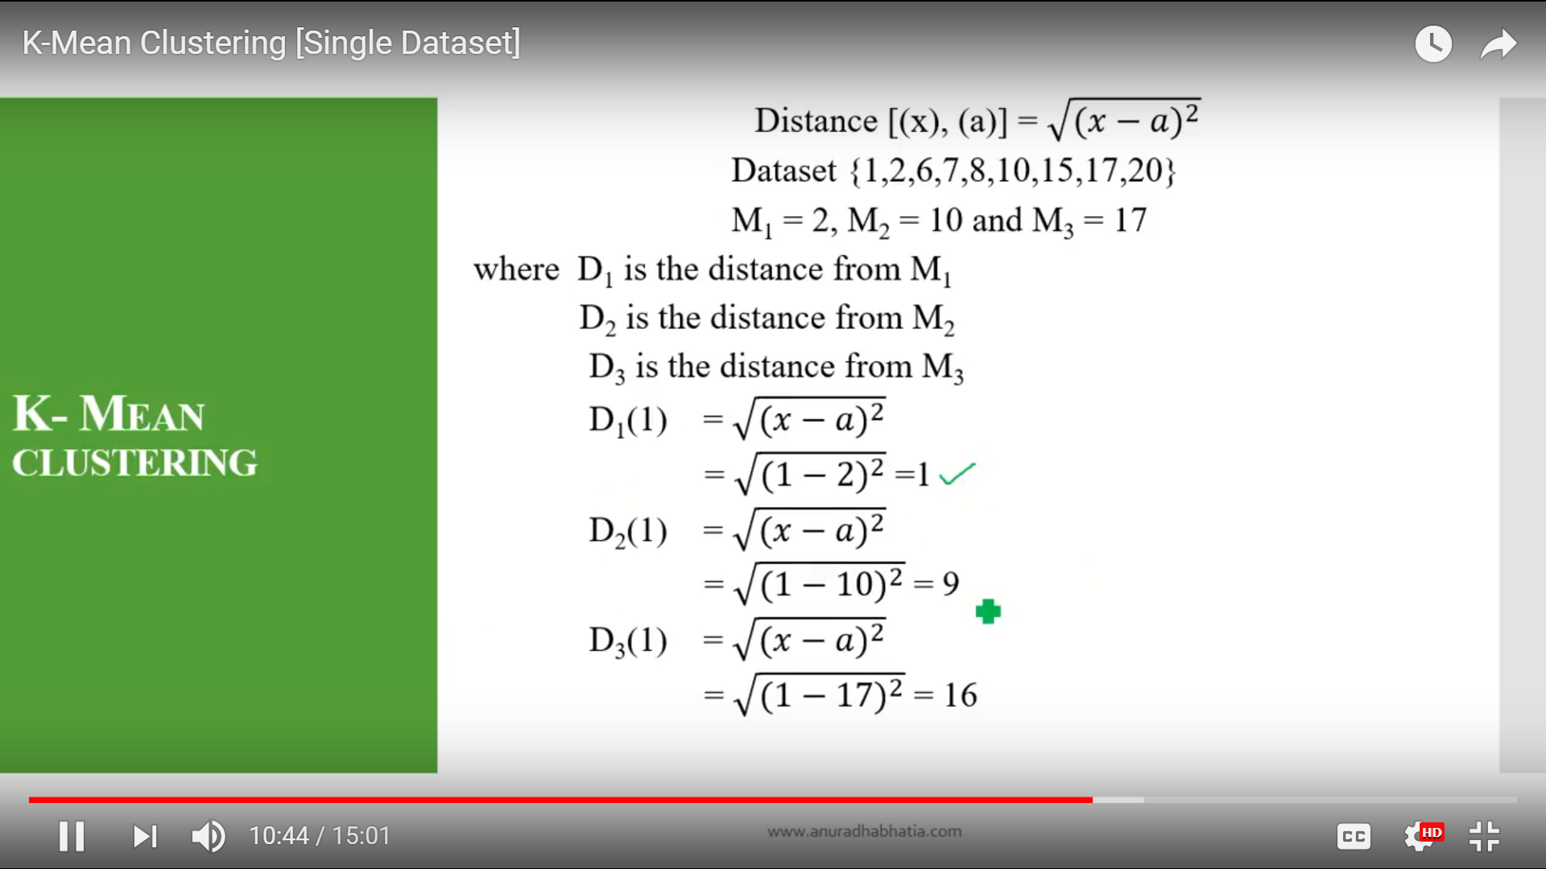

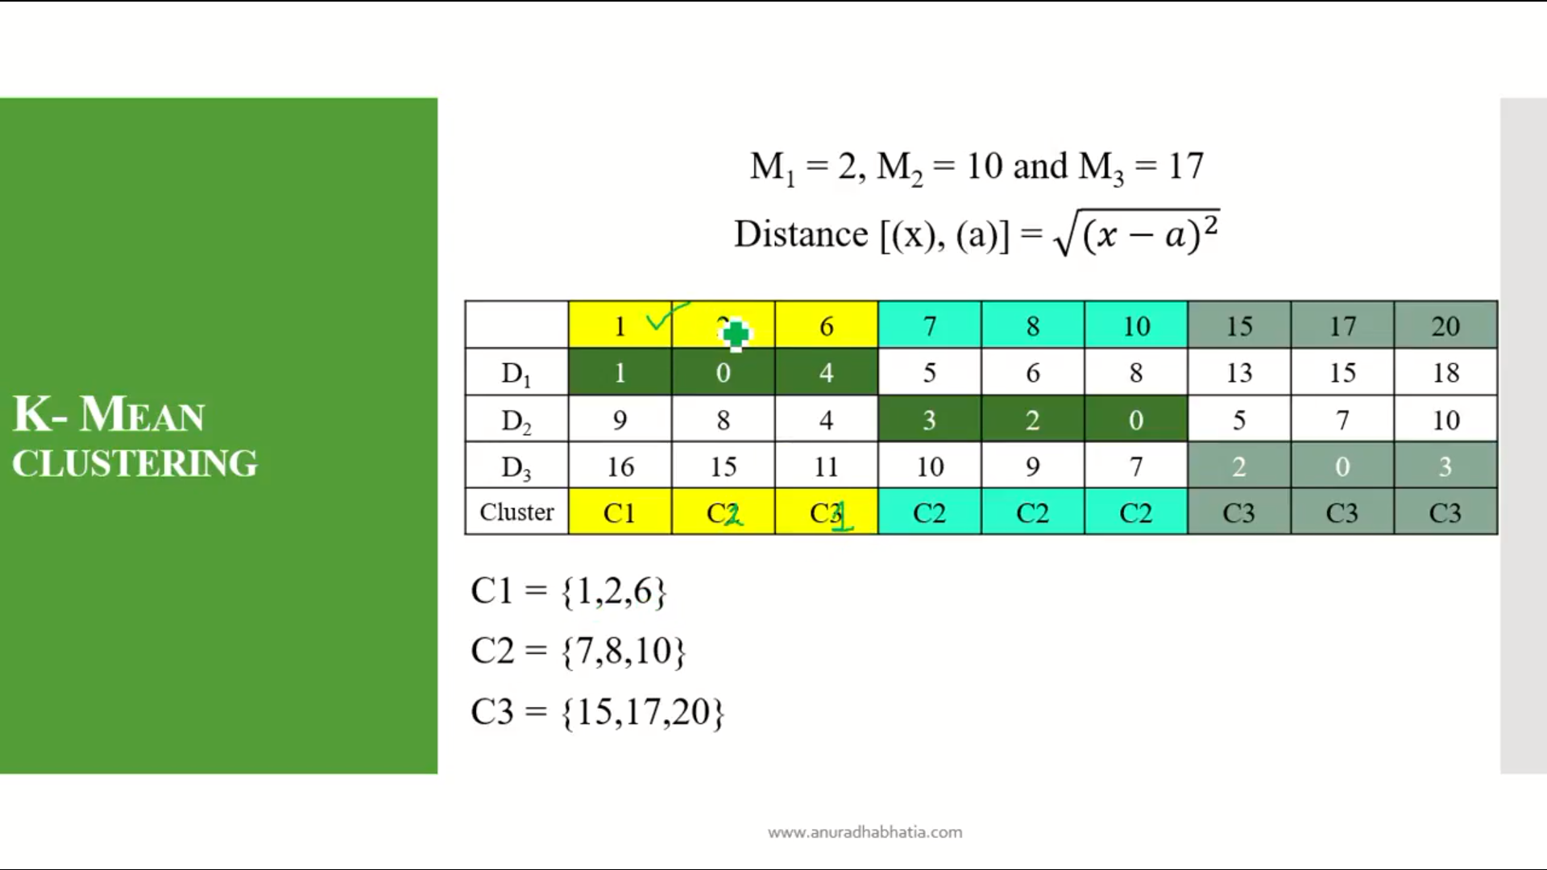

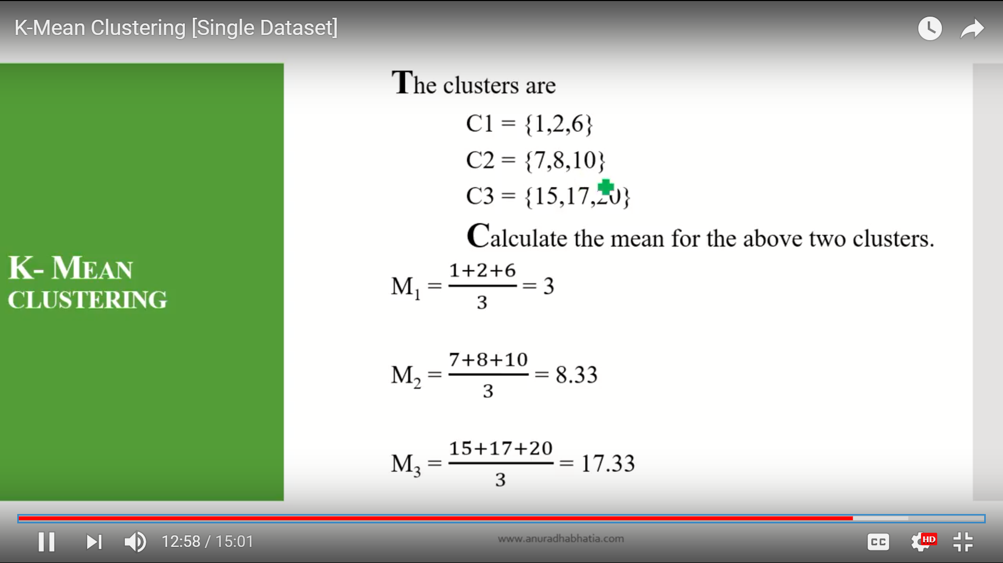

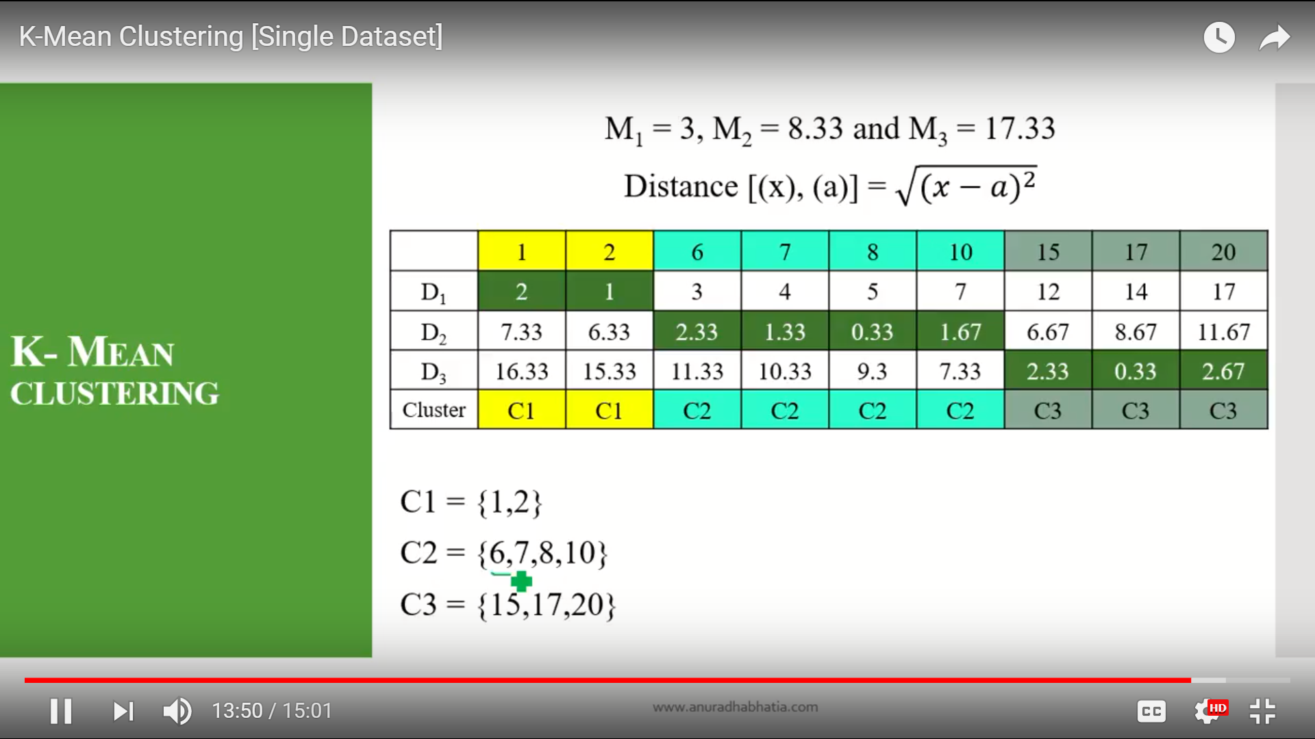

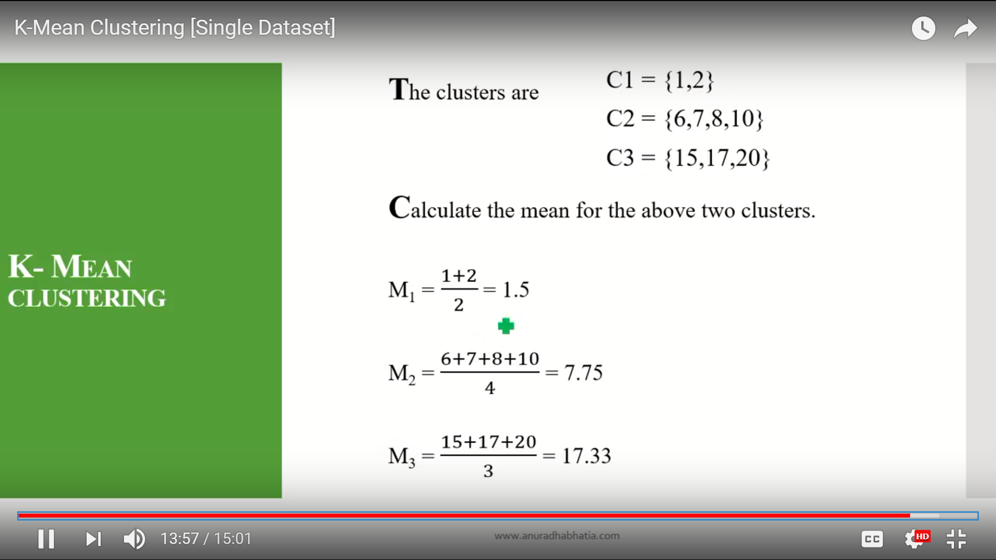

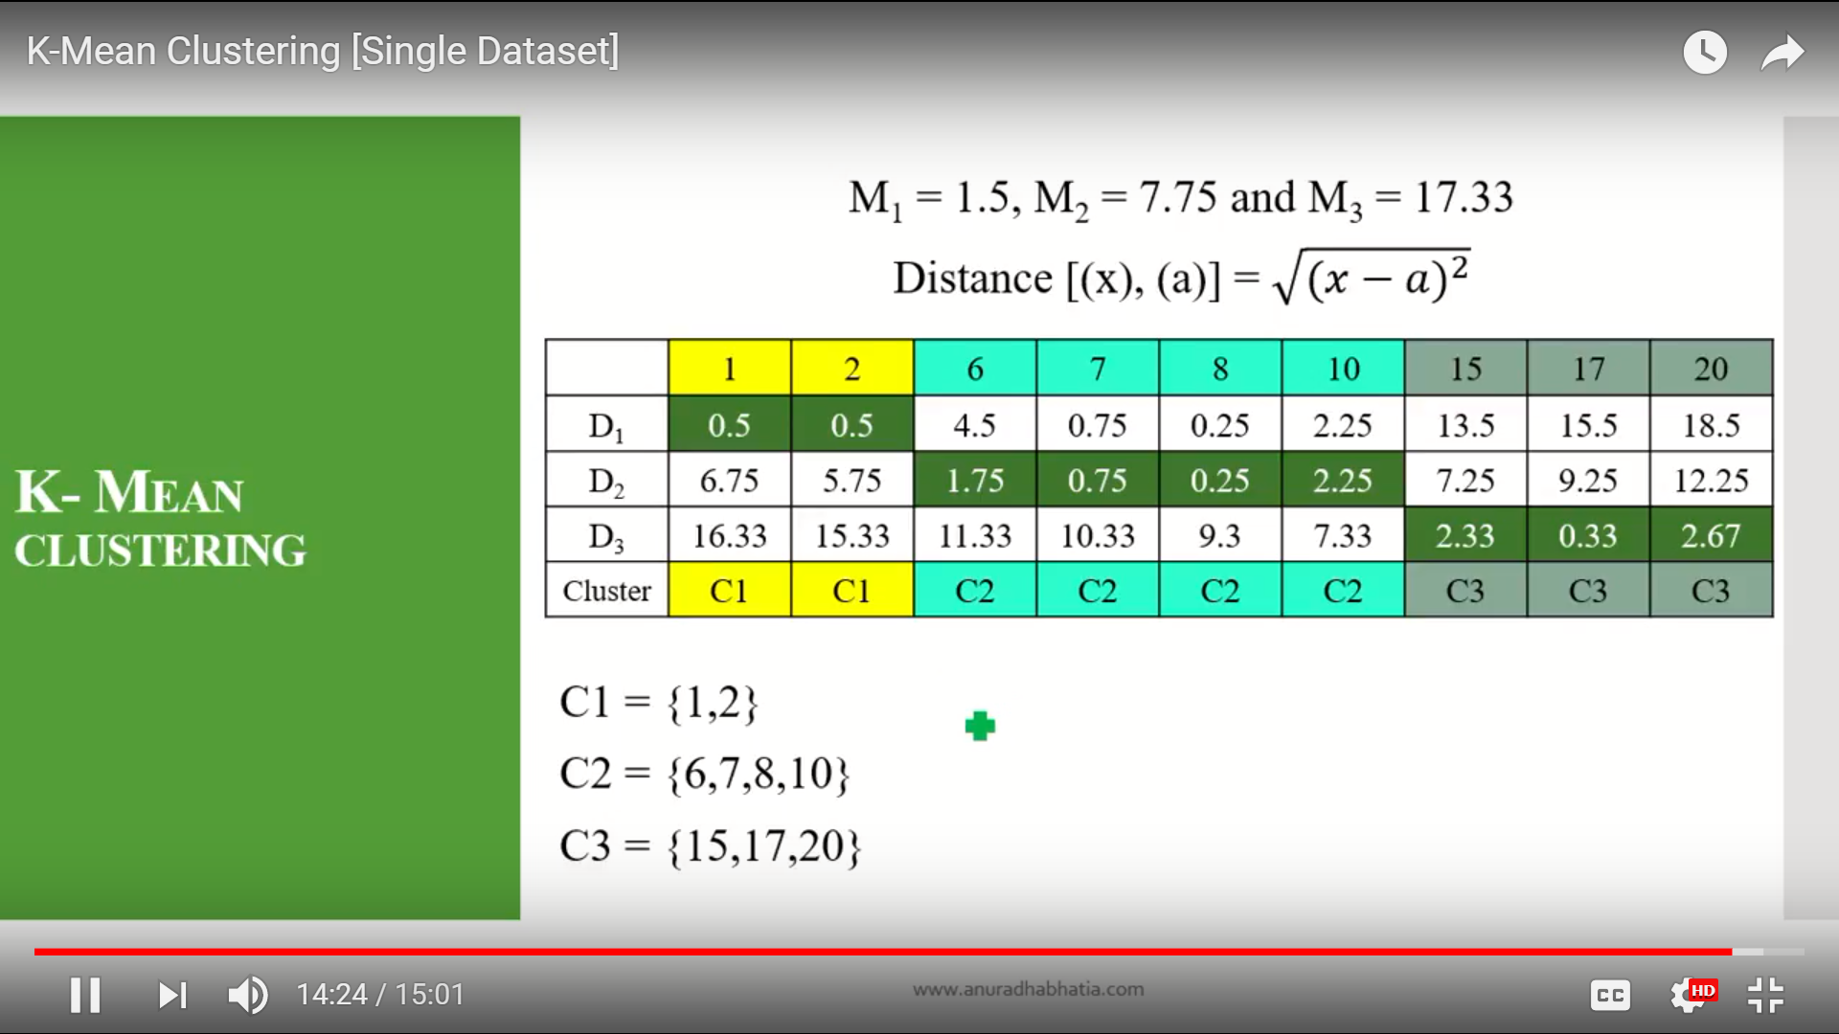

## PostHeaderIcon [MACHINE TRANSLATION – OVERVIEW](http://language.worldofcomputing.net/machine-translation/machine-translation-overview.html)

### WHAT IS MACHINE TRANSLATION?

The term **machine translation** (MT) is used in the sense of translation of one language to another. The ideal aim of machine translation systems is to produce the best possible translation without human assistance. Basically every machine translation system requires programs for translation and automated dictionaries and [grammars](http://language.worldofcomputing.net/grammar/what-is-grammar.html) to support translation.

The translation quality of the machine translation systems can be improved by pre-editing the input. Pre-editing means adjusting the input by marking prefixes, suffixes, clause boundaries, etc. Translation quality can also be improved by controlling the vocabulary. The output of the machine translation should be post-edited to make it perfect. Post-editing is required especially for health related information.

### TYPES OF MACHINE TRANSLATION SYSTEMS

Machine translation systems that produce translations between only two particular languages are called bilingual systems and those that produce translations for any given pair of languages are called multilingual systems. Multilingual systems may be either uni-directional or bi-directional. Multilingual systems are preferred to be bi-directional and bi-lingual as they have ability to translate from any given language to any other given language and vice versa.

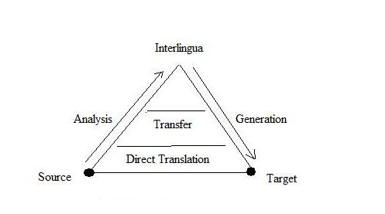

Figure: Machine Translation Pyramid

### DIRECT MACHINE TRANSLATION APPROACH

Direct translation approach is the oldest and less popular approach. Machine translation systems that use this approach are capable of translating a language, called source language (SL) directly to another language, called target language (TL). The analysis of SL texts is oriented to only one TL. Direct translation systems are basically bilingual and uni-directional. Direct translation approach needs only a little syntactic and semantic analysis. SL analysis is oriented specifically to the production of representations appropriate for one particular TL.

### INTERLINGUA APPROACH

[Interlingua approach](http://language.worldofcomputing.net/machine-translation/interlingual-machine-translation.html) intends to translate SL texts to that of more than one language. Translation is from SL to an intermediate form called interlingua (IL) and then from IL to TL. Interlingua may be artificial one or auxiliary language like Esperanto with universal vocabulary. [Interlingua approach](http://language.worldofcomputing.net/machine-translation/interlingual-machine-translation.html) requires complete resolution of all ambiguities in the SL text.

### TRANSFER APPROACH

Unlike interlingua approach, transfer approach has three stages involved. In the first stage, SL texts are converted into abstract SL-oriented representations. In the second stage, SL-oriented representations are converted into equivalent TL-oriented representations. Final texts are generated in the third stage. In transfer approach complete resolution of ambiguities of SL text is not required, but only the ambiguities inherent in the language itself are tackled. Three types of dictionaries are required: SL dictionaries, TL dictionaries and a bilingual transfer dictionary. Transfer systems have separate [grammars](http://language.worldofcomputing.net/grammar/what-is-grammar.html)for SL analysis, TL analysis and for the transformation of SL structures into equivalent TL forms.

### EMPIRICAL MACHINE TRANSLATION APPROACH

Empirical approach is the emerging one that uses large amount of raw data in the form of parallel [corpora](http://language.worldofcomputing.net/linguistics/introduction/what-is-corpus.html). The raw data consists of texts and their translations. [Example-based MT](http://language.worldofcomputing.net/machine-translation/example-based-machine-translation.html), analogy-based MT, memory-based MT, and case-based MT are the techniques that use empirical approach. Basically all these techniques use a [corpus](http://language.worldofcomputing.net/linguistics/introduction/what-is-corpus.html)or database of translated examples. Statistical machine translation is [corpus](http://language.worldofcomputing.net/linguistics/introduction/what-is-corpus.html) based but slightly different in the sense that it depends on statistical modelling of the word order of the target language and of source-target word equivalences. [Statistical machine translation](http://en.wikipedia.org/wiki/Statistical_machine_translation) automatically learns lexical and structural preferences from [corpora](http://language.worldofcomputing.net/linguistics/introduction/what-is-corpus.html). Statistical models offer good solution to ambiguity problem. They are robust and work well even if there are errors and the presence of new data. IBM researchers pioneered the first statistical approach to machine translation in 1980’s. IBM group relies on the source-channel approach, a framework for combining a word-based translation model and a [language model](http://en.wikipedia.org/wiki/Language_model). The translation model ensures that the machine translation system produces target hypothesis corresponding to the source sentence. The language model ensures the grammtically correct output.

The Essential NLP Guide for data scientists

* 1. Stemming

**What is Stemming?:**Stemming is the process of reducing the words(generally modified or derived) to their word stem or root form. The objective of stemming is to reduce related words to the same stem even if the stem is not a dictionary word. For example, in the English language-

1. ***beautiful*** and ***beautifully***are stemmed to ***beauti***
2. ***good, better*** and ***best*** are stemmed to ***good, better*** and ***best*** respectively

 2. Lemmatisation

**What is Lemmatisation?:**Lemmatisation is the process of reducing a group of words into their lemma or dictionary form. It takes into account things like POS(Parts of Speech), the meaning of the word in the sentence, the meaning of the word in the nearby sentences etc. before reducing the word to its lemma. For example, in the English Language-

1. ***beautiful*** and ***beautifully*** are lemmatised to ***beautiful*** and ***beautifully*** respectively.
2. ***good***, ***better*** and ***best*** are lemmatised to ***good***, ***good*** and ***good*** respectively.

 3. Word Embeddings

**What is Word Embeddings?:**Word Embeddings is the name of the techniques which are used to represent Natural Language in vector form of real numbers. They are useful because of computers’ inability to process Natural Language. So these Word Embeddings capture the essence and relationship between words in a Natural Language using real numbers. In Word Embeddings, a word or a phrase is represented in a fixed dimension vector of length say 100.

 4. Part-Of-Speech Tagging

**What is Part-Of-Speech Tagging?:**In Simplistic terms, Part-Of-Speech Tagging is the process of marking up of words in a sentence as *nouns*, *verbs*, *adjectives*, *adverbs etc*.

 5. Named Entity Disambiguation

**What is Named Entity Disambiguation?:**Named Entity Disambiguation is the process of identifying the mentions of entities in a sentence. For example, in the sentence-

“Apple earned a revenue of 200 Billion USD in 2016”

It is the task of Named Entity Disambiguation to infer that Apple in the sentence is the company Apple and not a fruit.

Named Entity, in general, requires a knowledge base of entities which it can use to link entities in the sentence to the knowledge base.

 6. Named Entity Recognition

**What is Named Entity Recognition?:** Named Entity Recognition is the task of identifying entities in a sentence and classifying them into categories like a person, organisation, date, location, time etc. For example, a NER would take in a sentence like –

“Ram of Apple Inc. travelled to Sydney on 5th October 2017”

and return something like

Ram  
of  
Apple *ORG*  
Inc. *ORG*  
travelled  
to  
Sydney *GPE*  
on  
5th *DATE*  
October *DATE*  
2017 *DATE*

 7. Sentiment Analysis

**What is Sentiment Analysis?:** Sentiment Analysis is a broad range of subjective analysis which uses Natural Language processing techniques to perform tasks such as identifying the sentiment of a customer review, positive or negative feeling in a sentence, judging mood via voice analysis or written text analysis etc. For example-

“I did not like the chocolate ice-cream” – is a negative experience of ice-cream.

“I did not hate the chocolate ice-cream” – may be considered as a neutral experience

There is a wide range of methods which are used to perform sentiment analysis starting from taking a count of negative and positive words in a sentence to using LSTMs with Word Embeddings.

 8. Semantic Text Similarity

**What is Semantic Text Similarity?:** Semantic Text Similarity is the process of analysing similarity between two pieces of text with respect to the meaning and essence of the text rather than analysing the syntax of the two pieces of text. Also, similarity is different than relatedness.

For example –

Car and Bus are similar but Car and fuel are related.

 9. Language Identification

**What is Language Identification?:**Language identification is the task of identifying the language in which the content is in.  It makes use of statistical as well as syntactical properties of the language to perform this task. It may also be considered as a special case of text classification.

 10.  Text Summarisation

**What is Text Summarisation?:**Text Summarisation is the process of shortening up of a text by identifying the important points of the text and creating a summary using these points. The goal of Text Summarisation is to retain maximum information along with maximum shortening of text without altering the meaning of the text.

**Natural Language Processing – Business Applications**

In this article, we delve into examples of how natural language processing (NLP) business applications can be applied at scale to address 5 pressing business questions.

**Five NLP Business Applications**

**1 – Customer service: *“How can I keep my customers happy?”***

[NLP is heavily used in customer service](http://www.nuance.com/for-business/natural-language-understanding/index.htm). The interactions between customers and companies contain a lot of useful breadcrumbs that point towards the reasons for customer dissatisfaction, and the interaction itself can be cause of discontent.

In order to keep a finger on the pulse of consumers’ intent, many companies now transcribe and analyze customer call recordings. They also deploy [chat bots and automated online assistants](https://www.techemergence.com/chatbot-use-cases/) to provide an immediate response to simple needs and decrease the load for customer service reps. Relevant NLP tasks include:

* **Speech recognition**, which converts spoken language into text. Advances in deep learning over the last 10 years have allowed major players to deploy this technology in commercial systems like Siri, Google Now, Skype’s translator etc. with good performances.
* **Question answering**, which involves exactly that—answering questions posed by humans in a natural language. When in 2011 IBM’s Watson outclassed the two best humans at Jeopardy!, Ken Jennings wrote on his video screen: “I, for one, welcome our new computer overlords.” The task was especially hard for the machine, since the game is renowned for its convoluted and often opaque questions about general knowledge. Similar technology is used today by many companies for chatbots, both for internal (HR, operations) and external (customer service, IoT) projects.

**2 – Reputation monitoring: *“What are people saying about me?”***

Relevant NLP tasks for this application include:

* **Sentiment analysis**, which determines the attitude, emotional state, judgment or intent of the writer. This is done by either assigning a polarity to the text (positive, neutral or negative) or trying to recognize the underlying mood (happy, sad, calm, angry…). What about the times when multiple attitudes need to be accounted for in the same sentence? For example, “The pizza was amazing, but the waiter was awful!”
* **Coreference resolution**, which connects pronouns to the right objects. This is a hard task, but it’s essential to interpret the text correctly. For example, if a customer writes: “A guy from the dealer called to ask if I liked my new car. Well, no man, it sucks?”, it’s important to recognize that “it” refers to the car and not the guy. The customer is complaining about the product, not the service. As Elon Musk says, “Brand is just a perception”. Right now, your customers are talking about you, influencing the way other consumers perceive your brand. NLP can help you stay on top of your in-the-trenches reputation.

**3 – Ad placement: *“Who is interested in my product?”***

Relevant NLP tasks for this application include:

* **Keyword matching**, which checks whether words of interest are included in some text. This is one of the easiest tasks in NLP, and at the same time one of the most remunerative. While this first approximation is often good enough, its lack of sophistication can produce pretty inappropriate results.
* **Sense disambiguation**, or identification of which sense of a word is used in a sentence. While the human brain is pretty good at this task, a computer won’t necessarily find it easy to recognize that the term pounds in the sentence, “I gained 20 pounds since the wedding!”,  most likely refers to the unit of mass rather than the currency. This is still an open problem in NLP.

**4 – Market intelligence: *“What’s happening with my competitors?”***

Relevant NLP tasks for this application include:

* **Event extraction**, which recognizes what’s happening to an entity. M&As, employment changes, deal closings and everything else that happens to organizations or people can be extracted automatically
* A structured database of events about companies, governments and people is an extremely powerful tool for analyzing the business ecosystem.
* **Sentence classification,**or putting a sentence in a predefined set of buckets. This is often used as a first pass to extract relevant content from large repositories, like the SEC’s EDGAR system. For example, “We expect a 15% increase in revenue next year,” can be classified as a forward-looking statement.

**5 – Regulatory compliance: *“Is my product a liability?”***

Relevant NLP tasks for this application include:

* **Named entity recognition (NER)**, which extracts the names of drugs, diseases, patients, and pharma companies using rule-based or statistical methods. Applying NER to a sentence will be able to convert it from, “Valium makes me sleepy,” to “{drug} makes me {symptom}.”
* **Relation detection**, used to identify the context in which the ADE is mentioned. This is often done with frames, or patterns of words that correspond to a concept, e.g. “I felt {symptom} after taking {drug}” is a pattern that matches the presence of side effects.

By applying these two tasks consecutively, we’ve identified that the patient is linking the drug Valium to the side effect sleepy. Both these tasks benefit from using ontologies i.e. structured domain knowledge (in this case biomedical) that provides the object dictionary and the relations between objects.

Ultimate Guide to Understand & Implement Natural Language Processing (with codes in Python)

The aim of the article is to teach the concepts of natural language processing and apply it on real data set.

1. Introduction to Natural Language Processing

NLP is a branch of data science that consists of systematic processes for analyzing, understanding, and deriving information from the text data in a smart and efficient manner. By utilizing NLP and its components, one can organize the massive chunks of text data, perform numerous automated tasks and solve a wide range of problems such as – automatic summarization, machine translation, named entity recognition, relationship extraction, sentiment analysis, speech recognition, and topic segmentation etc.

Before moving further, I would like to explain some terms that are used in the article:

* Tokenization – process of converting a text into tokens
* Tokens – words or entities present in the text
* Text object – a sentence or a phrase or a word or an article

Steps to install NLTK and its data:

Install Pip: run in terminal:

    sudo easy\_install pip

Install NLTK: run in terminal :

    sudo pip install -U nltk

Download NLTK data: run python shell (in terminal) and write the following code:

``` import nltk nltk.download() ```

Follow the instructions on screen and download the desired package or collection. Other libraries can be directly installed using pip.

2. Text Preprocessing

Since, text is the most unstructured form of all the available data, various types of noise are present in it and the data is not readily analyzable without any pre-processing. The entire process of cleaning and standardization of text, making it noise-free and ready for analysis is known as text preprocessing.

It is predominantly comprised of three steps:

* Noise Removal
* Lexicon Normalization
* Object Standardization

The following image shows the architecture of text preprocessing pipeline.

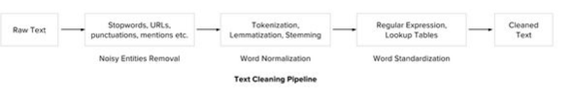

2.1 Noise Removal

Any piece of text which is not relevant to the context of the data and the end-output can be specified as the noise.

For example – language stopwords (commonly used words of a language – is, am, the, of, in etc), URLs or links, social media entities (mentions, hashtags), punctuations and industry specific words. This step deals with removal of all types of noisy entities present in the text.

2.2 Lexicon Normalization

Another type of textual noise is about the multiple representations exhibited by single word.

For example – “play”, “player”, “played”, “plays” and “playing” are the different variations of the word – “play”, Though they mean different but contextually all are similar. The step converts all the disparities of a word into their normalized form (also known as lemma). Normalization is a pivotal step for feature engineering with text as it converts the high dimensional features (N different features) to the low dimensional space (1 feature), which is an ideal ask for any ML model.

The most common lexicon normalization practices are :

* **Stemming:** Stemming is a rudimentary rule-based process of stripping the suffixes (“ing”, “ly”, “es”, “s” etc) from a word.
* **Lemmatization:**Lemmatization, on the other hand, is an organized & step by step procedure of obtaining the root form of the word, it makes use of vocabulary (dictionary importance of words) and morphological analysis (word structure and grammar relations).

2.3 Object Standardization

Text data often contains words or phrases which are not present in any standard lexical dictionaries. These pieces are not recognized by search engines and models.

Some of the examples are – acronyms, hashtags with attached words, and colloquial slangs. With the help of regular expressions and manually prepared data dictionaries, this type of noise can be fixed, the code below uses a dictionary lookup method to replace social media slangs from a text.

.Text to Features (Feature Engineering on text data)

To analyse a preprocessed data, it needs to be converted into features. Depending upon the usage, text features can be constructed using assorted techniques – Syntactical Parsing, Entities / N-grams / word-based features, Statistical features, and word embeddings. Read on to understand these techniques in detail.

3.1 Syntactic Parsing

Syntactical parsing invol ves the analysis of words in the sentence for grammar and their arrangement in a manner that shows the relationships among the words. Dependency Grammar and Part of Speech tags are the important attributes of text syntactics.

**Dependency Trees –**Sentences are composed of some words sewed together. The relationship among the words in a sentence is determined by the basic dependency grammar. Dependency grammar is a class of syntactic text analysis that deals with (labeled) asymmetrical binary relations between two lexical items (words). Every relation can be represented in the form of a triplet (relation, governor, dependent).: 

**Part of speech tagging** – Apart from the grammar relations, every word in a sentence is also associated with a part of speech (pos) tag (nouns, verbs, adjectives, adverbs etc). The pos tags defines the usage and function of a word in the sentence. H ere is a list of all possible pos-tags defined by Pennsylvania university. Following code using NLTK performs pos tagging annotation on input text. (it provides several implementations, the default one is perceptron tagger)

**A.Word sense disambiguation:** Some language words have multiple meanings according to their usage. For example, in the two sentences below:

*I. “Please book my flight for Delhi”*

*II. “I am going to read this book in the flight”*

“Book” is used with different context, however the part of speech tag for both of the cases are different. In sentence I, the word “book” is used as ***v*** ***erb***, while in II it is used as ***no*** ***un***. ([Lesk Algorithm](https://en.wikipedia.org/wiki/Lesk_algorithm) is also us ed for similar purposes)

**B.Improving word-based features:** A learning model could learn different contexts of a word when used word as the features, however if the part of speech tag is linked with them, the context is preserved, thus making strong features. For example:

*Sentence -“book my flight, I will read this book”*

*Tokens – (“book”, 2), (“my”, 1), (“flight”, 1), (“I”, 1), (“will”, 1), (“read”, 1), (“this”, 1)*

*Tokens with POS – (“book\_VB”, 1), (“my\_PRP$”, 1), (“flight\_NN”, 1), (“I\_PRP”, 1), (“will\_MD”, 1), (“read\_VB”, 1), (“this\_DT”, 1), (“book\_NN”, 1)*

**C. Normalization and Lemmatization**: POS tags are the basis of lemmatization process for converting a word to its base form (lemma).

**D.Efficient stopword removal** : P OS tags are also useful in efficient removal of stopwords.

For example, there are some tags which always define the low frequency / less important words of a language. For example: (**IN** – “within”, “upon”, “except”), (**CD** – “one”,”two”, “hundred”), (**MD** – “may”, “mu st” etc)

3.2 Entity Extraction (Entities as features)

Entities are defined as the most important chunks of a sentence – noun phrases, verb phrases or both. Entity Detection algorithms are generally ensemble models of rule based parsing, dictionary lookups, pos tagging and dependency parsing. The applicability of entity detection can be seen in the automated chat bots, content analyzers and consumer insights.

**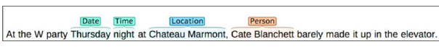**

Topic Modelling & Named Entity Recognition are the two key entity detection methods in NLP.

A. Named Entity Recognition (NER)

The process of detecting the named entities such as person names, location names, company names etc from the text is called as NER. For example :

*Sentence – Sergey Brin, the manager of Google Inc. is walking in the streets of New York.*

*Named Entities –  ( “person” : “Sergey Brin” ), (“org” : “Google Inc.”), (“location” : “New York”)*

A typical NER model consists of three blocks:

**Noun phrase identification:** This step deals with extracting all the noun phrases from a text using dependency parsing and part of speech tagging.

**Phrase classification:** This is the classification step in which all the extracted noun phrases are classified into respective categories (locations, names etc). Google Maps API provides a good path to disambiguate locations, Then, the open databases from dbpedia, wikipedia can be used to identify person names or company names. Apart from this, one can curate the lookup tables and dictionaries by combining information from different sources.

**Entity disambiguation:** Sometimes it is possible that entities are misclassified, hence creating a validation layer on top of the results is useful. Use of knowledge graphs can be exploited for this purposes. The popular knowledge graphs are – Google Knowledge Graph, IBM Watson and Wikipedia.

**B. Topic Modeling**

Topic modeling is a process of automatically identifying the topics present in a text corpus, it derives the hidden patterns among the words in the corpus in an unsupervised manner. Topics are defined as “a repeating pattern of co-occurring terms in a corpus”. A good topic model results in – “health”, “doctor”, “patient”, “hospital” for a topic – Healthcare, and “farm”, “crops”, “wheat” for a topic – “Farming”.

**C.  N-Grams as Features**

A combination of N words together are called N-Grams. N grams (N > 1) are generally more informative as compared to words (Unigrams) as features. Also, bigrams (N = 2) are considered as the most important features of all the others. The following code generates bigram of a text.

3.3 Statistical Features

Text data can also be quantified directly into numbers using several techniques described in this section:

A.  **Term Frequency – Inverse Document Frequency (TF – IDF**)

**B. Count / Density / Readability Features**

Count or Density based features can also be used in models and analysis. These features might seem trivial but shows a great impact in learning models. Some of the features are: Word Count, Sentence Count, Punctuation Counts and Industry specific word counts. Other types of measures include readability measures such as syllable counts, smog index and flesch reading ease

**3.4 Word Embedding (text vectors)**

4. Important tasks of NLP

This section talks about different use cases and problems in the field of natural language processing.

4.1 Text Classification

Text classification is one of the classical problem of NLP. Notorious examples include – Email Spam Identification, topic classification of news, sentiment classification and organization of web pages by search engines.

Text classification, in common words is defined as a technique to systematically classify a text object (document or sentence) in one of the fixed category. It is really helpful when the amount of data is too large, especially for organizing, information filtering, and storage purposes.

A typical natural language classifier consists of two parts: (a) Training (b) Prediction as shown in image below. Firstly the text input is processes and features are created. The machine learning models then learn these features and is used for predicting against the new text.

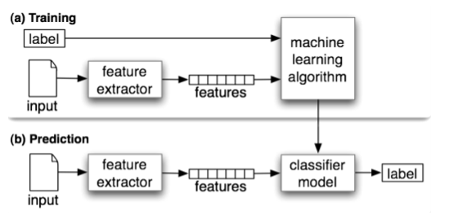

Here is a code that uses naive bayes classifier using text blob library (built on top of nltk).

**4.2 Text Matching / Similarity**

One of the important areas of NLP is the matching of text objects to find similarities. Important applications of text matching includes automatic spelling correction, data de-duplication and genome analysis etc.

A number of text matching techniques are available depending upon the requirement. This section describes the important techniques in detail.

**A. Levenshtein Distance** – The Levenshtein distance between two strings is defined as the minimum number of edits needed to transform one string into the other, with the allowable edit operations being insertion, deletion, or substitution of a single character. Following is the implementation for efficient memory computations.

**B. Phonetic Matching** – A Phonetic matching algorithm takes a keyword as input (person’s name, location name etc) and produces a character string that identifies a set of words that are (roughly) phonetically similar. It is very useful for searching large text corpuses, correcting spelling errors and matching relevant names. Soundex and Metaphone are two main phonetic algorithms used for this purpose

**C. Flexible String Matching** – A complete text matching system includes different algorithms pipelined together to compute variety of text variations. Regular expressions are really helpful for this purposes as well. Another common techniques include – exact string matching, lemmatized matching, and compact matching (takes care of spaces, punctuation’s, slangs etc).

**D. Cosine Similarity** – W hen the text is represented as vector notation, a general cosine similarity can also be applied in order to measure vectorized similarity. Following code converts a text to vectors (using term frequency) and applies cosine similarity to provide closeness among two text.

4.3 Coreference Resolution

Coreference Resolution is a process of finding relational links among the words (or phrases) within the sentences. Consider an example sentence: ” Donald went to John’s office to see the new table. He looked at it for an hour.“

Humans can quickly figure out that “he” denotes Donald (and not John), and that “it” denotes the table (and not John’s office). Coreference Resolution is the component of NLP that does this job automatically. It is used in document summarization, question answering, and information extraction. Stanford CoreNLP provides a python [wrapper](https://github.com/Wordseer/stanford-corenlp-python) for commercial purposes.

4.4 Other NLP problems / tasks

* **Text Summarization** – Given a text article or paragraph, summarize it automatically to produce most important and relevant sentences in order.
* **Machine Translation** – Automatically translate text from one human language to another by taking care of grammar, semantics and information about the real world, etc.
* **Natural Language Generation and Understanding** – Convert information from computer databases or semantic intents into readable human language is called language generation. Converting chunks of text into more logical structures that are easier for computer programs to manipulate is called language understanding.
* **Optical Character Recognition** – Given an image representing printed text, determine the corresponding text.
* **Document to Information** – This involves parsing of textual data present in documents (websites, files, pdfs and images) to analyzable and clean format.

5. Important Libraries for NLP (python)

* Scikit-learn: Machine learning in Python
* Natural Language Toolkit (NLTK): The complete toolkit for all NLP techniques.
* Pattern – A web mining module for the with tools for NLP and machine learning.
* TextBlob – Easy to use nl p tools API, built on top of NLTK and Pattern.
* spaCy – Industrial strength N LP with Python and Cython.
* Gensim – Topic Modelling for Humans
* Stanford Core NLP – NLP services and packages by Stanford NLP Group.

NLP

**Tokenization with nltk**

The NLTK module is a massive tool kit, aimed at helping you with the entire Natural Language Processing (NLP) methodology. NLTK will aid you with everything from splitting sentences from paragraphs, splitting up words, recognizing the part of speech of those words, highlighting the main subjects, and then even with helping your machine to understand what the text is all about. In this series, we're going to tackle the field of opinion mining, or sentiment analysis.

Now that you have all the things that you need, let's knock out some quick vocabulary:

* Corpus - Body of text, singular. Corpora is the plural of this. Example: A collection of medical journals.
* Lexicon - Words and their meanings. Example: English dictionary. Consider, however, that various fields will have different lexicons. For example: To a financial investor, the first meaning for the word "Bull" is someone who is confident about the market, as compared to the common English lexicon, where the first meaning for the word "Bull" is an animal. As such, there is a special lexicon for financial investors, doctors, children, mechanics, and so on.
* Token - Each "entity" that is a part of whatever was split up based on rules. For examples, each word is a token when a sentence is "tokenized" into words. Each sentence can also be a token, if you tokenized the sentences out of a paragraph.

Ex: from nltk.tokenize import sent\_tokenize, word\_tokenize

EXAMPLE\_TEXT = "Hello Mr. Smith, how are you doing today? The weather is great, and Python is awesome. The sky is pinkish-blue. You shouldn't eat cardboard."

print(sent\_tokenize(EXAMPLE\_TEXT))

print(word\_tokenize(EXAMPLE\_TEXT))

**Stop words with NLTK:**

For example, you may wish to completely cease analysis if you detect words that are commonly used sarcastically, and stop immediately. Sarcastic words, or phrases are going to vary by lexicon and corpus. For now, we'll be considering stop words as words that just contain no meaning, and we want to remove them.

You can do this easily, by storing a list of words that you consider to be stop words.

Here is how you might incorporate using the stop\_words set to remove the stop words from your text:

from nltk.corpus import stopwords

from nltk.tokenize import word\_tokenize

example\_sent = "This is a sample sentence, showing off the stop words filtration."

stop\_words = set(stopwords.words('english'))

word\_tokens = word\_tokenize(example\_sent)

filtered\_sentence = [w for w in word\_tokens if not w in stop\_words]

filtered\_sentence = []

for w in word\_tokens:

if w not in stop\_words:

filtered\_sentence.append(w)

print(word\_tokens)

print(filtered\_sentence)

Our output here:  
['This', 'is', 'a', 'sample', 'sentence', ',', 'showing', 'off', 'the', 'stop', 'words', 'filtration', '.']  
['This', 'sample', 'sentence', ',', 'showing', 'stop', 'words', 'filtration', '.']

Stemming

Stemming is an attempt to reduce a word to its stem or root form. Search engines usually treat words with the same stem as synonyms. Thus, the key terms of a query or document are represented by stems rather than by the original words. This reduces the dictionary size.

NLTK provides several famous stemmers interfaces, such as

1. [Porter stemmer](http://textanalysisonline.com/nltk-porter-stemmer)
2. [Lancaster Stemmer](http://textanalysisonline.com/nltk-lancaster-stemmer)
3. [Snowball Stemmer](http://textanalysisonline.com/nltk-snowball-stemmer)

**Stemming Code:**

The code for NLTK stemming code looks like this:

import nltk

from nltk.stem.porter import PorterStemmer

from nltk.stem.lancaster import LancasterStemmer

from nltk.stem import SnowballStemmer

def get\_tokens():

with open('/home/k/TEST/NLTK/stem\_sample.txt') as stem:

tokens = nltk.word\_tokenize(stem.read())

return tokens

def do\_stemming(filtered):

stemmed = []

for f in filtered:

stemmed.append(PorterStemmer().stem(f))

#stemmed.append(LancasterStemmer().stem(f))

#stemmed.append(SnowballStemmer('english').stem(f))

return stemmed

if \_\_name\_\_ == "\_\_main\_\_":

tokens = get\_tokens()

print("tokens = %s") %(tokens)

stemmed\_tokens = do\_stemming(tokens)

print("stemmed\_tokens = %s") %stemmed\_tokens

result = dict(zip(tokens, stemmed\_tokens))

print("{tokens:stemmed} = %s") %(result)

Output comparison

Depending on the stemming algorithms, we have a slightly different stemming. Here are the outputs:

**PorterStemmer:**  
{tokens:stemmed} = {'stemmed': 'stem', 'argu': 'argu', 'argue': 'argu', 'fished': 'fish', 'arguing': 'argu', 'catlike': 'catlik', 'argues': 'argu', 'catty': 'catti', 'argus': 'argu', 'cat': 'cat', 'cats': 'cat', 'stemming': 'stem', 'fishing': 'fish', 'stemmer': 'stemmer', 'argued': 'argu', 'fisher': 'fisher', 'argument': 'argument', 'stem': 'stem', 'fish': 'fish', 'arguments': 'argument'}

**LancasterStemmer:**  
{tokens:stemmed} = {'stemmed': 'stem', 'argu': 'argu', 'argue': 'argu', 'fished': 'fish', 'arguing': 'argu', 'catlike': 'catlik', 'argues': 'argu', 'catty': 'catty', 'argus': 'arg', 'cat': 'cat', 'cats': 'cat', 'stemming': 'stem', 'fishing': 'fish', 'stemmer': 'stem', 'argued': 'argu', 'fisher': 'fish', 'argument': 'argu', 'stem': 'stem', 'fish': 'fish', 'arguments': 'argu'}

**SnowballStemmer:**  
{tokens:stemmed} = {'stemmed': u'stem', 'argu': u'argu', 'argue': u'argu', 'fished': u'fish', 'arguing': u'argu', 'catlike': u'catlik', 'argues': u'argu', 'catty': u'catti', 'argus': u'argus', 'cat': u'cat', 'cats': u'cat', 'stemming': u'stem', 'fishing': u'fish', 'stemmer': u'stemmer', 'argued': u'argu', 'fisher': u'fisher', 'argument': u'argument', 'stem': u'stem', 'fish': u'fish', 'arguments': u'argument'}

**Part of Speech Tagging with NLTK**

One of the more powerful aspects of the NLTK module is the Part of Speech tagging that it can do for you. This means labeling words in a sentence as nouns, adjectives, verbs...etc. Even more impressive, it also labels by tense, and more. Here's a list of the tags, what they mean, and some examples:

POS tag list:

CC coordinating conjunction

CD cardinal digit

DT determiner

EX existential there (like: "there is" ... think of it like "there exists")

FW foreign word

IN preposition/subordinating conjunction

JJ adjective 'big'

JJR adjective, comparative 'bigger'

JJS adjective, superlative 'biggest'

LS list marker 1)

MD modal could, will

NN noun, singular 'desk'

NNS noun plural 'desks'

NNP proper noun, singular 'Harrison'

NNPS proper noun, plural 'Americans'

PDT predeterminer 'all the kids'

POS possessive ending parent's

PRP personal pronoun I, he, she

PRP$ possessive pronoun my, his, hers

RB adverb very, silently,

RBR adverb, comparative better

RBS adverb, superlative best

RP particle give up

TO to go 'to' the store.

UH interjection errrrrrrrm

VB verb, base form take

VBD verb, past tense took

VBG verb, gerund/present participle taking

VBN verb, past participle taken

VBP verb, sing. present, non-3d take

VBZ verb, 3rd person sing. present takes

WDT wh-determiner which

WP wh-pronoun who, what

WP$ possessive wh-pronoun whose

WRB wh-abverb where, when

How might we use this? While we're at it, we're going to cover a new sentence tokenizer, called the PunktSentenceTokenizer. This tokenizer is capable of unsupervised machine learning, so you can actually train it on any body of text that you use. First, let's get some imports out of the way that we're going to use:

import nltk

from nltk.corpus import state\_union

from nltk.tokenize import PunktSentenceTokenizer

Now, let's create our training and testing data:

train\_text = state\_union.raw("2005-GWBush.txt")

sample\_text = state\_union.raw("2006-GWBush.txt")

One is a State of the Union address from 2005, and the other is from 2006 from past President George W. Bush.

Next, we can train the Punkt tokenizer like:

custom\_sent\_tokenizer = PunktSentenceTokenizer(train\_text)

Then we can actually tokenize, using:

tokenized = custom\_sent\_tokenizer.tokenize(sample\_text)

Now we can finish up this part of speech tagging script by creating a function that will run through and tag all of the parts of speech per sentence like so:

def process\_content():

try:

for i in tokenized[:5]:

words = nltk.word\_tokenize(i)

tagged = nltk.pos\_tag(words)

print(tagged)

except Exception as e:

print(str(e))

process\_content()

The output should be a list of tuples, where the first element in the tuple is the word, and the second is the part of speech tag. It should look like:

##### **[('PRESIDENT', 'NNP'), ('GEORGE', 'NNP'), ('W.', 'NNP'), ('BUSH', 'NNP'), ("'S", 'POS'), ('ADDRESS', 'NNP'), ('BEFORE', 'NNP'), ('A', 'NNP'), ('JOINT', 'NNP'), ('SESSION', 'NNP'), ('OF', 'NNP'), ('THE', 'NNP'), ('CONGRESS', 'NNP'), ('ON', 'NNP'), ('THE', 'NNP'),**

## Chunking with NLTK:

Now that we know the parts of speech, we can do what is called chunking, and group words into hopefully meaningful chunks. One of the main goals of chunking is to group into what are known as "noun phrases." These are phrases of one or more words that contain a noun, maybe some descriptive words, maybe a verb, and maybe something like an adverb. The idea is to group nouns with the words that are in relation to them.

In order to chunk, we combine the part of speech tags with [regular expressions](https://pythonprogramming.net/regular-expressions-regex-tutorial-python-3/). Mainly from regular expressions, we are going to utilize the following:

+ = match 1 or more

? = match 0 or 1 repetitions.

\* = match 0 or MORE repetitions

. = Any character except a new line

See the tutorial linked above if you need help with regular expressions. The last things to note is that the part of speech tags are denoted with the "<" and ">" and we can also place regular expressions within the tags themselves, so account for things like "all nouns" (<N.\*>)

import nltk

from nltk.corpus import state\_union

from nltk.tokenize import PunktSentenceTokenizer

train\_text = state\_union.raw("2005-GWBush.txt")

sample\_text = state\_union.raw("2006-GWBush.txt")

custom\_sent\_tokenizer = PunktSentenceTokenizer(train\_text)

tokenized = custom\_sent\_tokenizer.tokenize(sample\_text)

def process\_content():

try:

for i in tokenized:

words = nltk.word\_tokenize(i)

tagged = nltk.pos\_tag(words)

chunkGram = r"""Chunk: {<RB.?>\*<VB.?>\*<NNP>+<NN>?}"""

chunkParser = nltk.RegexpParser(chunkGram)

chunked = chunkParser.parse(tagged)

chunked.draw()

except Exception as e:

print(str(e))

process\_content()

The result of this is something like:

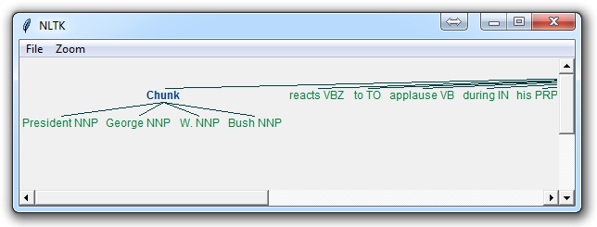

The main line here in question is:

chunkGram = r"""Chunk: {<RB.?>\*<VB.?>\*<NNP>+<NN>?}"""

This line, broken down:

<RB.?>\* = "0 or more of any tense of adverb," followed by:

<VB.?>\* = "0 or more of any tense of verb," followed by:

<NNP>+ = "One or more proper nouns," followed by

<NN>? = "zero or one singular noun."

## Named Entity Recognition with NLTK:

One of the most major forms of chunking in natural language processing is called "Named Entity Recognition." The idea is to have the machine immediately be able to pull out "entities" like people, places, things, locations, monetary figures, and more.

This can be a bit of a challenge, but NLTK is this built in for us. There are two major options with NLTK's named entity recognition: either recognize all named entities, or recognize named entities as their respective type, like people, places, locations, etc.

Here's an example:

import nltk

from nltk.corpus import state\_union

from nltk.tokenize import PunktSentenceTokenizer

train\_text = state\_union.raw("2005-GWBush.txt")

sample\_text = state\_union.raw("2006-GWBush.txt")

custom\_sent\_tokenizer = PunktSentenceTokenizer(train\_text)

tokenized = custom\_sent\_tokenizer.tokenize(sample\_text)

def process\_content():

try:

for i in tokenized[5:]:

words = nltk.word\_tokenize(i)

tagged = nltk.pos\_tag(words)

namedEnt = nltk.ne\_chunk(tagged, binary=True)

namedEnt.draw()

except Exception as e:

print(str(e))

process\_content()

Here, with the option of binary = True, this means either something is a named entity, or not. There will be no further detail. The result is:

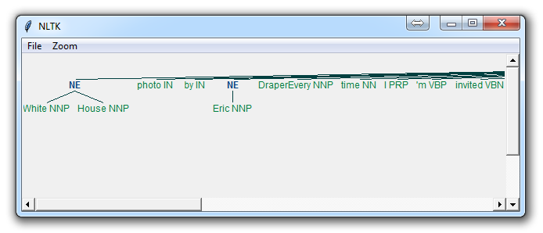

## Lemmatizing with NLTK:

A very similar operation to stemming is called lemmatizing. The major difference between these is, as you saw earlier, stemming can often create non-existent words, whereas lemmas are actual words.

So, your root stem, meaning the word you end up with, is not something you can just look up in a dictionary, but you can look up a lemma.

Some times you will wind up with a very similar word, but sometimes, you will wind up with a completely different word. Let's see some examples.

from nltk.stem import WordNetLemmatizer

lemmatizer = WordNetLemmatizer()

print(lemmatizer.lemmatize("cats"))

print(lemmatizer.lemmatize("cacti"))

print(lemmatizer.lemmatize("geese"))

print(lemmatizer.lemmatize("rocks"))

print(lemmatizer.lemmatize("python"))

print(lemmatizer.lemmatize("better", pos="a"))

print(lemmatizer.lemmatize("best", pos="a"))

print(lemmatizer.lemmatize("run"))

print(lemmatizer.lemmatize("run",'v'))

o/p: cat

cactus

goose

rock

python

good

best

run

run

Here, we've got a bunch of examples of the lemma for the words that we use. The only major thing to note is that lemmatize takes a part of speech parameter, "pos." If not supplied, the default is "noun." This means that an attempt will be made to find the closest noun, which can create trouble for you. Keep this inmind if you use lemmatizing!

## The corpora with NLTK:

In this part of the tutorial, I want us to take a moment to peak into the corpora we all downloaded! The NLTK corpus is a massive dump of all kinds of natural language data sets that are definitely worth taking a look at.

Almost all of the files in the NLTK corpus follow the same rules for accessing them by using the NLTK module, but nothing is magical about them. These files are plain text files for the most part, some are XML and some are other formats, but they are all accessible by you manually, or via the module and Python. Let's talk about viewing them manually.

Depending on your installation, your nltk\_data directory might be hiding in a multitude of locations. To figure out where it is, head to your Python directory, where the NLTK module is. If you do not know where that is, use the following code:

import nltk

print(nltk.\_\_file\_\_)

Run that, and the output will be the location of the NLTK module's \_\_init\_\_.py. Head into the NLTK directory, and then look for the data.py file.

The important blurb of code is:

if sys.platform.startswith('win'):

# Common locations on Windows:

path += [

str(r'C:\nltk\_data'), str(r'D:\nltk\_data'), str(r'E:\nltk\_data'),

os.path.join(sys.prefix, str('nltk\_data')),

os.path.join(sys.prefix, str('lib'), str('nltk\_data')),

os.path.join(os.environ.get(str('APPDATA'), str('C:\\')), str('nltk\_data'))

]

else:

# Common locations on UNIX & OS X:

path += [

str('/usr/share/nltk\_data'),

str('/usr/local/share/nltk\_data'),

str('/usr/lib/nltk\_data'),

str('/usr/local/lib/nltk\_data')

]

There, you can see the various possible directories for the nltk\_data. If you're on Windows, chances are it is in your appdata, in the local directory. To get there, you will want to open your file browser, go to the top, and type in %appdata%

Next click on roaming, and then find the nltk\_data directory. In there, you will have your corpora file. The full path is something like:   
C:\Users\yourname\AppData\Roaming\nltk\_data\corpora

Within here, you have all of the available corpora, including things like books, chat logs, movie reviews, and a whole lot more.

Now, we're going to talk about accessing these documents via NLTK. As you can see, these are mostly text documents, so you could just use normal Python code to open and read documents. That said, the NLTK module has a few nice methods for handling the corpus, so you may find it useful to use their methology. Here's an example of us opening the Gutenberg Bible, and reading the first few lines:

from nltk.tokenize import sent\_tokenize, PunktSentenceTokenizer

from nltk.corpus import gutenberg

# sample text

sample = gutenberg.raw("bible-kjv.txt")

tok = sent\_tokenize(sample)

for x in range(5):

print(tok[x])

## Wordnet with NLTK

[WordNet](https://wordnet.princeton.edu/) is a lexical database for the English language, which was created by Princeton, and is part of the NLTK corpus.

You can use WordNet alongside the NLTK module to find the meanings of words, synonyms, antonyms, and more. Let's cover some examples.

First, you're going to need to import wordnet:

from nltk.corpus import wordnet

Then, we're going to use the term "program" to find synsets like so:

syns = wordnet.synsets("program")

An example of a synset:

print(syns[0].name())

plan.n.01

Just the word:

print(syns[0].lemmas()[0].name())

plan

Definition of that first synset:

print(syns[0].definition())

a series of steps to be carried out or goals to be accomplished

Examples of the word in use:

print(syns[0].examples())

['they drew up a six-step plan', 'they discussed plans for a new bond issue']

Next, how might we discern synonyms and antonyms to a word? The lemmas will be synonyms, and then you can use .antonyms to find the antonyms to the lemmas. As such, we can populate some lists like:

synonyms = []

antonyms = []

for syn in wordnet.synsets("good"):

for l in syn.lemmas():

synonyms.append(l.name())

if l.antonyms():

antonyms.append(l.antonyms()[0].name())

print(set(synonyms))

print(set(antonyms))

{'beneficial', 'just', 'upright', 'thoroughly', 'in\_force', 'well', 'skilful', 'skillful', 'sound', 'unspoiled', 'expert', 'proficient', 'in\_effect', 'honorable', 'adept', 'secure', 'commodity', 'estimable', 'soundly', 'right', 'respectable', 'good', 'serious', 'ripe', 'salutary', 'dear', 'practiced', 'goodness', 'safe', 'effective', 'unspoilt', 'dependable', 'undecomposed', 'honest', 'full', 'near', 'trade\_good'} {'evil', 'evilness', 'bad', 'badness', 'ill'}

As you can see, we got many more synonyms than antonyms, since we just looked up the antonym for the first lemma, but you could easily balance this buy also doing the exact same process for the term "bad."

Next, we can also easily use WordNet to compare the similarity of two words and their tenses, by incorporating the [Wu and Palmer method](http://search.cpan.org/~tpederse/WordNet-Similarity-1.03/lib/WordNet/Similarity/wup.pm) for semantic related-ness.

Let's compare the noun of "ship" and "boat:"

w1 = wordnet.synset('ship.n.01')

w2 = wordnet.synset('boat.n.01')

print(w1.wup\_similarity(w2))

0.9090909090909091

w1 = wordnet.synset('ship.n.01')

w2 = wordnet.synset('car.n.01')

print(w1.wup\_similarity(w2))

0.6956521739130435

w1 = wordnet.synset('ship.n.01')

w2 = wordnet.synset('cat.n.01')

print(w1.wup\_similarity(w2))

0.38095238095238093

## Text Classification with NLTK:

Now that we're comfortable with NLTK, let's try to tackle text classification. The goal with text classification can be pretty broad. Maybe we're trying to classify text as about politics or the military. Maybe we're trying to classify it by the gender of the author who wrote it. A fairly popular text classification task is to identify a body of text as either spam or not spam, for things like email filters. In our case, we're going to try to create a sentiment analysis algorithm.

To do this, we're going to start by trying to use the movie reviews database that is part of the NLTK corpus. From there we'll try to use words as "features" which are a part of either a positive or negative movie review. The NLTK corpus movie\_reviews data set has the reviews, and they are labeled already as positive or negative. This means we can train and test with this data. First, let's wrangle our data.

import nltk

import random

from nltk.corpus import movie\_reviews

documents = [(list(movie\_reviews.words(fileid)), category)

for category in movie\_reviews.categories()

for fileid in movie\_reviews.fileids(category)]

random.shuffle(documents)

print(documents[1])

all\_words = []

for w in movie\_reviews.words():

all\_words.append(w.lower())

all\_words = nltk.FreqDist(all\_words)

print(all\_words.most\_common(15))

print(all\_words["stupid"])

## Naive Bayes Classifier with NLTK

Now it is time to choose an algorithm, separate our data into training and testing sets, and press go! The algorithm that we're going to use first is the [Naive Bayes classifier](http://en.wikipedia.org/wiki/Naive_Bayes_classifier). This is a pretty popular algorithm used in text classification, so it is only fitting that we try it out first. Before we can train and test our algorithm, however, we need to go ahead and split up the data into a training set and a testing set.

This is called supervised machine learning, because we're showing the machine data, and telling it "hey, this data is positive," or "this data is negative." Then, after that training is done, we show the machine some new data and ask the computer, based on what we taught the computer before, what the computer thinks the category of the new data is.

We can split the data with:

# set that we'll train our classifier with

training\_set = featuresets[:1900]

# set that we'll test against.

testing\_set = featuresets[1900:]

Next, we can define, and train our classifier like:

classifier = nltk.NaiveBayesClassifier.train(training\_set)

First we just simply are invoking the Naive Bayes classifier, then we go ahead and use .train() to train it all in one line.

Easy enough, now it is trained. Next, we can test it:

print("Classifier accuracy percent:",(nltk.classify.accuracy(classifier, testing\_set))\*100)

Boom, you have your answer. In case you missed it, the reason why we can "test" the data is because we still have the correct answers. So, in testing, we show the computer the data without giving it the correct answer. If it guesses correctly what we know the answer to be, then the computer got it right. Given the shuffling that we've done, you and me might come up with varying accuracy, but you should see something from 60-75% on average.

Next, we can take it a step further to see what the most valuable words are when it comes to positive or negative reviews:

classifier.show\_most\_informative\_features(15)

This is going to vary again for each person, but you should see something like:

Most Informative Features  
insulting = True neg : pos = 10.6 : 1.0  
ludicrous = True neg : pos = 10.1 : 1.0  
winslet = True pos : neg = 9.0 : 1.0  
detract = True pos : neg = 8.4 : 1.0  
breathtaking = True pos : neg = 8.1 : 1.0  
silverstone = True neg : pos = 7.6 : 1.0  
excruciatingly = True neg : pos = 7.6 : 1.0  
warns = True pos : neg = 7.0 : 1.0  
tracy = True pos : neg = 7.0 : 1.0  
insipid = True neg : pos = 7.0 : 1.0  
freddie = True neg : pos = 7.0 : 1.0  
damon = True pos : neg = 5.9 : 1.0  
debate = True pos : neg = 5.9 : 1.0  
ordered = True pos : neg = 5.8 : 1.0  
lang = True pos : neg = 5.7 : 1.0

What this tells you is the ratio of occurences in negative to positive, or visa versa, for every word. So here, we can see that the term "insulting" appears 10.6 more times as often in negative reviews as it does in positive reviews. Ludicrous, 10.1.

Now, let's say you were totally content with your results, and you wanted to move forward, maybe using this classifier to predict things right now. It would be very impractical to train the classifier, and retrain it every time you needed to use it. As such, you can save the classifier using the pickle module. Let's do that next.

## Investigating bias with NLTK

The most major issue is that we have a fairly biased algorithm. You can test this yourself by commenting-out the shuffling of the documents, then training against the first 1900, and leaving the last 100 (all positive) reviews. Test, and you will find you have very poor accuracy.

Conversely, you can test against the first 100 data sets, all negative, and train against the following 1900. You will find very high accuracy here. This is a bad sign. It could mean a lot of things, and there are many options for us to fix it.

That said, the project I have in mind for us suggests we go ahead and use a different data set anyways, so we will do that. In the end, we will find this new data set still contains some bias, and that is that it picks up negative things more often. The reason for this is that negative reviews tend to be "more negative" than positive reviews are positive. Handling this can be done with some simple weighting, but it can also get complex fast. Maybe a tutorial for another day.

## Twitter Sentiment Analysis with NLTK

Now that we have a sentiment analysis module, we can apply it to just about any text, but preferrably short bits of text, like from Twitter! To do this, we're going to combine this tutorial with the [Twitter streaming API tutorial](https://pythonprogramming.net/twitter-api-streaming-tweets-python-tutorial/).

The initial code from that tutorial is:

from tweepy import Stream

from tweepy import OAuthHandler

from tweepy.streaming import StreamListener

#consumer key, consumer secret, access token, access secret.

ckey="fsdfasdfsafsffa"

csecret="asdfsadfsadfsadf"

atoken="asdf-aassdfs"

asecret="asdfsadfsdafsdafs"

class listener(StreamListener):

def on\_data(self, data):

print(data)

return(True)

def on\_error(self, status):

print status

auth = OAuthHandler(ckey, csecret)

auth.set\_access\_token(atoken, asecret)

twitterStream = Stream(auth, listener())

twitterStream.filter(track=["car"])

That is enough to print out all of the data for the streaming live tweets that contain the term "car." We can use the json module to load the data var with json.loads(data), and then we can reference the tweet specifically with:

tweet = all\_data["text"]

Now that we have a tweet, we can easily pass this through our sentiment\_mod module!

from tweepy import Stream

from tweepy import OAuthHandler

from tweepy.streaming import StreamListener

import json

import sentiment\_mod as s

#consumer key, consumer secret, access token, access secret.

ckey="asdfsafsafsaf"

csecret="asdfasdfsadfsa"

atoken="asdfsadfsafsaf-asdfsaf"

asecret="asdfsadfsadfsadfsadfsad"

from twitterapistuff import \*

class listener(StreamListener):

def on\_data(self, data):

all\_data = json.loads(data)

tweet = all\_data["text"]

sentiment\_value, confidence = s.sentiment(tweet)

print(tweet, sentiment\_value, confidence)

if confidence\*100 >= 80:

output = open("twitter-out.txt","a")

output.write(sentiment\_value)

output.write('\n')

output.close()

return True

def on\_error(self, status):

print(status)

auth = OAuthHandler(ckey, csecret)

auth.set\_access\_token(atoken, asecret)

twitterStream = Stream(auth, listener())

twitterStream.filter(track=["happy"])

Along with that, we're also saving the results to an output file, twitter-out.txt.

Next, what data analysis would be complete without graphs? Let's combine yet another tutorial with this one to make a live streaming graph from the sentiment analysis on the Twitter API!

## Graphing Live Twitter Sentiment Analysis with NLTK with NLTK

Now that we have live data coming in from the Twitter streaming API, why not also have a live graph that shows the sentiment trend? To do this, we're going to combine this tutorial with the [live matplotlib graphing tutorial](https://pythonprogramming.net/python-matplotlib-live-updating-graphs/).

If you want to know more about how the code works, see that tutorial. Otherwise:

import matplotlib.pyplot as plt

import matplotlib.animation as animation

from matplotlib import style

import time

style.use("ggplot")

fig = plt.figure()

ax1 = fig.add\_subplot(1,1,1)

def animate(i):

pullData = open("twitter-out.txt","r").read()

lines = pullData.split('\n')

xar = []

yar = []

x = 0

y = 0

for l in lines[-200:]:

x += 1

if "pos" in l:

y += 1

elif "neg" in l:

y -= 1

xar.append(x)

yar.append(y)

ax1.clear()

ax1.plot(xar,yar)

ani = animation.FuncAnimation(fig, animate, interval=1000)

plt.show()

## Named Entity Recognition with Stanford NER Tagger

An alternative to NLTK's named entity recognition (NER) classifier is provided by the Stanford NER tagger. This tagger is largely seen as the standard in named entity recognition, but since it uses an advanced statistical learning algorithm it's more computationally expensive than the option provided by NLTK.

A big benefit of the Stanford NER tagger is that is provides us with a few different models for pulling out named entities. We can use any of the following:

* 3 class model for recognizing locations, persons, and organizations
* 4 class model for recognizing locations, persons, organizations, and miscellaneous entities
* 7 class model for recognizing locations, persons, organizations, times, money, percents, and dates

In order to move forward we'll need to download the models and a jar file, since the NER classifier is written in Java. These are available for free from the [Stanford Natural Language Processing Group](http://nlp.stanford.edu/software/CRF-NER.shtml#Download). Conveniently for us, NTLK provides a wrapper to the Stanford tagger so we can use it in the best language ever (ahem, Python)!

The parameters passed to the StanfordNERTagger class include:

1. Classification model path (3 class model used below)
2. Stanford tagger jar file path
3. Training data encoding (default of ASCII)

Here's how we set it up to tag a sentence with the 3 class model:

# -\*- coding: utf-8 -\*-

from nltk.tag import StanfordNERTagger

from nltk.tokenize import word\_tokenize

st = StanfordNERTagger('/usr/share/stanford-ner/classifiers/english.all.3class.distsim.crf.ser.gz',

'/usr/share/stanford-ner/stanford-ner.jar',

encoding='utf-8')

text = 'While in France, Christine Lagarde discussed short-term stimulus efforts in a recent interview with the Wall Street Journal.'

tokenized\_text = word\_tokenize(text)

classified\_text = st.tag(tokenized\_text)

print(classified\_text)

Once we've tokenized by word and classified the sentence, we see the tagger produces a list of tuples as follows:

[('While', 'O'), ('in', 'O'), ('France', 'LOCATION'), (',', 'O'), ('Christine', 'PERSON'), ('Lagarde', 'PERSON'), ('discussed', 'O'), ('short-term', 'O'), ('stimulus', 'O'), ('efforts', 'O'), ('in', 'O'), ('a', 'O'), ('recent', 'O'), ('interview', 'O'), ('with', 'O'), ('the', 'O'), ('Wall', 'ORGANIZATION'), ('Street', 'ORGANIZATION'), ('Journal', 'ORGANIZATION'), ('.', 'O')]

Nice! Each token is tagged (using our 3 class model) with either 'PERSON', 'LOCATION', 'ORGANIZATION', or 'O'. The 'O' simply stands for other, i.e., non-named entities.

[**Sentence iterator**](https://deeplearning4j.org/sentenceiterator#sentence-iterator)

A [sentence iterator](https://deeplearning4j.org/doc/org/deeplearning4j/word2vec/sentenceiterator/SentenceIterator.html) is used in both [Word2vec](https://deeplearning4j.org/word2vec.html) and [Bag of Words](https://deeplearning4j.org/bagofwords-tf-idf.html).

It feeds bits of text into a neural network in the form of vectors, and also covers the concept of documents in text processing.

In natural-language processing, a document or sentence is typically used to encapsulate a context which an algorithm should learn.

A few examples include analyzing Tweets and full-blown news articles. The purpose of the [sentence iterator](https://deeplearning4j.org/doc/org/deeplearning4j/word2vec/sentenceiterator/SentenceIterator.html) is to divide text into processable bits. Note the sentence iterator is input agnostic. So bits of text (a document) can come from a file system, the Twitter API or Hadoop.

Depending on how input is processed, the output of a sentence iterator will then be passed to a [tokenizer](https://deeplearning4j.org/org/deeplearning4j/word2vec/tokenizer/Tokenizer.html)for the processing of individual tokens, which are usually words, but could also be ngrams, skipgrams or other units. The tokenizer is created on a per-sentence basis by a [tokenizer factory](https://deeplearning4j.org/doc/org/deeplearning4j/word2vec/tokenizer/TokenizerFactory.html). The tokenizer factory is what is passed into a text-processing vectorizer.

Some typical examples are below:

SentenceIterator iter = new LineSentenceIterator(new File("your file"));

This assumes that each line in a file is a sentence.

You can also do list of strings as sentence as follows:

Collection<String> sentences = ...;

SentenceIterator iter = new CollectionSentenceIterator(sentences);

This will assume that each string is a sentence (document). Remember this could be a list of Tweets or articles – both are applicable.

You can iterate over files as follows:

SentenceIterator iter = new FileSentenceIterator(new File("your dir or file"));

This will parse the files line by line and return individual sentences on each one.

For anything complex, we recommend an actual machine-learning level pipeline, represented by the [UimaSentenceIterator](https://deeplearning4j.org/doc/org/deeplearning4j/text/sentenceiterator/UimaSentenceIterator.html).

The UimaSentenceIterator is capable of tokenization, part-of-speech tagging and lemmatization, among other things. The UimaSentenceIterator iterates over a set of files and can segment sentences. You can customize its behavior based on the AnalysisEngine passed into it.

The AnalysisEngine is the [UIMA](https://uima.apache.org/) concept of a text-processing pipeline. DeepLearning4j comes with standard analysis engines for all of these common tasks, allowing you to customize which text is being passed in and how you define sentences. The AnalysisEngines are thread-safe versions of the [opennlp](https://opennlp.apache.org/)pipelines. We also include [cleartk](https://cleartk.googlecode.com/)-based pipelines for handling common tasks.

For those using UIMA or curious about it, this employs the cleartk type system for tokens, sentences, and other annotations within the type system.

Here’s how to create a UimaSentenceItrator.

SentenceIterator iter = UimaSentenceIterator.create("path/to/your/text/documents");

You can also instantiate directly:

SentenceIterator iter = new UimaSentenceIterator(path,AnalysisEngineFactory.createEngine(AnalysisEngineFactory.createEngineDescription(TokenizerAnnotator.getDescription(), SentenceAnnotator.getDescription())));

For those familiar with Uima, this uses Uimafit extensively to create analysis engines. You can also create custom sentence iterators by extending SentenceIterator.

**Zipf’s Law**

Zipf’s law states that within a group or corpus of documents, the frequency of any word is inversely proportional to its rank in a frequency table. Thus the most frequent word will occur approximately twice as often as the second most frequent word, three times as often as the third most frequent word, etc. Zipf’s law is most easily observed by plotting the data on a log-log graph, with the axes being log(rank order) and log(term frequency).

freq\_by\_rank <- book\_words %>%

group\_by(book) %>%

mutate(rank = row\_number(),

`term freq` = n / total)

ggplot(freq\_by\_rank, aes(rank, `term freq`, color = book)) +

geom\_line() +

scale\_x\_log10() +

scale\_y\_log10()

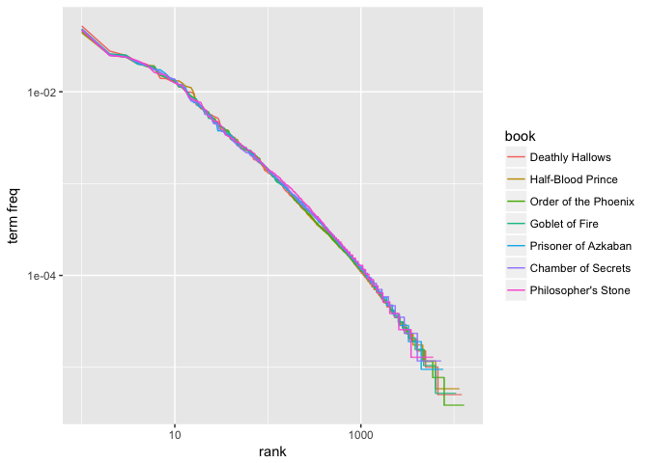

Our plot illustrates that the distribution is similar across the seven books. Furthermore, we can compare the distribution to a simple regression line. We see that the tails of the distribution deviate suggesting our distribution doesn’t follow Zipf’s law perfectly; however, it is close enough to generally state that the law approximately holds within our corpus of text.

lower\_rank <- freq\_by\_rank %>%

filter(rank < 500)

lm(log10(`term freq`) ~ log10(rank), data = lower\_rank)

##

## Call:

## lm(formula = log10(`term freq`) ~ log10(rank), data = lower\_rank)

##

## Coefficients:

## (Intercept) log10(rank)

## -0.9414 -0.9694

freq\_by\_rank %>%

ggplot(aes(rank, `term freq`, color = book)) +

geom\_abline(intercept = -0.9414, slope = -0.9694, color = "gray50", linetype = 2) +

geom\_line(size = 1.2, alpha = 0.8) +

scale\_x\_log10() +

scale\_y\_log10()

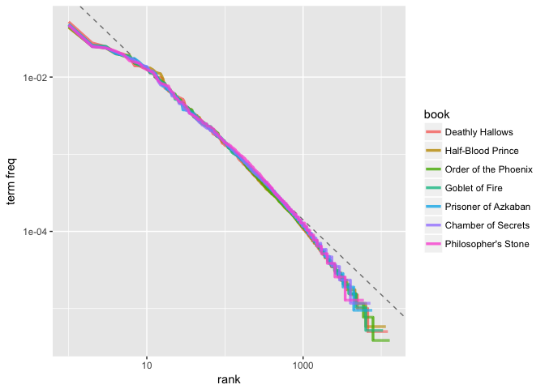

**Tf-Idf and Cosine similarity**

**Document 1**: The game of life is a game of everlasting learning

**Document 2**: The unexamined life is not worth living

**Document 3**: Never stop learning

Let us imagine that you are doing a search on these documents with the following query: **life learning**

The query is a free text query. It means a query in which the terms of the query are typed freeform into the search interface, without any connecting search operators.

Let us go over each step in detail to see how it all works.

**Step 1: Term Frequency (TF)**

Term Frequency also known as TF measures the number of times a term (word) occurs in a document. Given below are the terms and their frequency on each of the document.

**TF for Document 1**

|  |  |  |  |  |  |  |  |  |
| --- | --- | --- | --- | --- | --- | --- | --- | --- |
| **Document1** | **the** | **game** | **of** | **life** | **is** | **a** | **everlasting** | **learning** |
| **Term Frequency** | 1 | 2 | 2 | 1 | 1 | 1 | 1 | 1 |

**TF for Document 2**

|  |  |  |  |  |  |  |  |
| --- | --- | --- | --- | --- | --- | --- | --- |
| **Document2** | **the** | **unexamined** | **life** | **is** | **not** | **worth** | **living** |
| **Term Frequency** | 1 | 1 | 1 | 1 | 1 | 1 | 1 |

**TF for Document 3**

|  |  |  |  |
| --- | --- | --- | --- |
| **Document3** | **never** | **stop** | **learning** |
| **Term Frequency** | 1 | 1 | 1 |

In reality each document will be of different size. On a large document the frequency of the terms will be much higher than the smaller ones. Hence we need to **normalize** the document based on its size. A simple trick is to divide the term frequency by the total number of terms. For example in Document 1 the term **game** occurs **two** times. The total number of terms in the document is **10**. Hence the normalized term frequency is **2 / 10 = 0.2**. Given below are the normalized term frequency for all the documents.

**Normalized TF for Document 1**

|  |  |  |  |  |  |  |  |  |
| --- | --- | --- | --- | --- | --- | --- | --- | --- |
| **Document1** | **the** | **game** | **of** | **life** | **is** | **a** | **everlasting** | **learning** |
| **Normalized TF** | 0.1 | 0.2 | 0.2 | 0.1 | 0.1 | 0.1 | 0.1 | 0.1 |

**Normalized TF for Document 2**

|  |  |  |  |  |  |  |  |
| --- | --- | --- | --- | --- | --- | --- | --- |
| **Document2** | **the** | **unexamined** | **life** | **is** | **not** | **worth** | **living** |
| **Normalized TF** | 0.142857 | 0.142857 | 0.142857 | 0.142857 | 0.142857 | 0.142857 | 0.142857 |

**Normalized TF for Document 3**

|  |  |  |  |
| --- | --- | --- | --- |
| **Document3** | **never** | **stop** | **learning** |
| **Normalized TF** | 0.333333 | 0.333333 | 0.333333 |

Given below is the code in python which will do the normalized TF calculation.

|  |  |
| --- | --- |
| 1  2  3 | def termFrequency(term, document):      normalizeDocument = document.lower().split()      return normalizeDocument.count(term.lower()) / float(len(normalizeDocument)) |

**Step 2: Inverse Document Frequency (IDF)**

The main purpose of doing a search is to find out **relevant** **documents** matching the query. In the first step all terms are considered equally important. In fact certain terms that occur too frequently have little power in determining the relevance. We need a way to **weigh down** the effects of too frequently occurring terms. Also the terms that occur less in the document can be more relevant. We need a way to **weigh up** the effects of less frequently occurring terms. [Logarithms](https://janav.wordpress.com/2013/09/29/logarithms-in-real-life/" \t "_blank" \o "Logarithms in real life)helps us to solve this problem.

Let us compute IDF for the term **game**

IDF(**game**) = 1 + loge(Total Number Of Documents / Number Of Documents with term **game** in it)

There are 3 documents in all = Document1, Document2, Document3

The term game appears in Document1

IDF(**game**) = 1 + loge(3 / 1)

= 1 + 1.098726209

= 2.098726209

Given below is the IDF for terms occurring in all the documents. Since the terms: **the, life, is, learning** occurs in 2 out of 3 documents they have a lower score compared to the other terms that appear in only one document.

|  |  |
| --- | --- |
| **Terms** | **IDF** |
| the | 1.405507153 |
| game | 2.098726209 |
| of | 2.098726209 |
| life | 1.405507153 |
| is | 1.405507153 |
| a | 2.098726209 |
| everlasting | 2.098726209 |
| learning | 1.405507153 |
| unexamined | 2.098726209 |
| not | 2.098726209 |
| worth | 2.098726209 |
| living | 2.098726209 |
| never | 2.098726209 |
| stop | 2.098726209 |

Given below is the python code to calculate IDF

|  |  |
| --- | --- |
| 1  2  3  4  5  6  7  8  9  10 | def inverseDocumentFrequency(term, allDocuments):      numDocumentsWithThisTerm = 0      for doc in allDocuments:          if term.lower() in allDocuments[doc].lower().split():              numDocumentsWithThisTerm = numDocumentsWithThisTerm + 1        if numDocumentsWithThisTerm > 0:          return 1.0 + log(float(len(allDocuments)) / numDocumentsWithThisTerm)      else:          return 1.0 |

**Step 3: TF \* IDF**

Remember we are trying to find out relevant documents for the query: **life learning**

For each term in the query multiply its normalized term frequency with its IDF on each document. In Document1 for the term **life** the normalized term frequency is 0.1 and its IDF is 1.405507153. Multiplying them together we get **0.140550715**(0.1 \* 1.405507153). Given below is TF \* IDF calculations for **life and learning** in all the documents.

|  |  |  |  |
| --- | --- | --- | --- |
|  | **Document1** | **Document2** | **Document3** |
| **life** | 0.140550715 | 0.200786736 | 0 |
| **learning** | 0.140550715 | 0 | 0.468502384 |

**Step 4: Vector Space Model – Cosine Similarity**

From each document we derive a vector. If you need some refresher on vector refer [here](http://www.mathsisfun.com/algebra/vectors-dot-product.html). The set of documents in a collection then is viewed as a set of vectors in a vector space. Each term will have its own axis. Using the formula given below we can find out the similarity between any two documents.

Cosine Similarity (d1, d2) = Dot product(d1, d2) **/** ||d1|| \* ||d2||

Dot product (d1,d2) = d1[0] \* d2[0] + d1[1] \* d2[1] \* … \* d1[n] \* d2[n]

||d1|| = square root(d1[0]2 + d1[1]2 + ... + d1[n]2)

||d2|| = square root(d2[0]2 + d2[1]2 + ... + d2[n]2)

[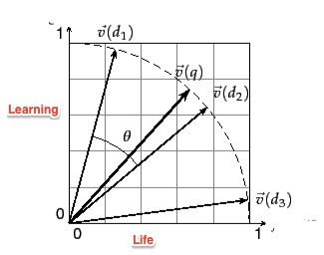](https://janav.files.wordpress.com/2013/10/cosinesimilarity.jpg)

Vectors deals only with numbers. In this example we are dealing with text documents. This was the reason why we used TF and IDF to convert text into numbers so that it can be represented by a vector.

Refer to the [link](http://nlp.stanford.edu/IR-book/html/htmledition/dot-products-1.html) for detailed explanation of cosine similarity and vector space model. I found the following explanation in the book [Mahout in Action](http://www.amazon.com/Mahout-Action-Sean-Owen/dp/1935182684) very useful.

The **cosine measure similarity** is another similarity metric that depends on envisioning user preferences as points in space.  Hold in mind the image of user preferences as points in an **n-dimensional space**. Now imagine two lines from the origin, or  point (0,0,…,0), to each of these two points. When two users are similar, they’ll have similar ratings, and so will be  relatively close in space—at least, they’ll be in roughly the same direction from the origin. The angle formed between these two lines will be relatively small. In contrast, when the two users are dissimilar, their points will be distant, and likely in different directions from the origin, forming a wide angle. This angle can be used as the basis for a similarity metric in the same way that the Euclidean distance was used to form a similarity metric. In this case, the cosine of the angle leads to a similarity value. **If you’re rusty on trigonometry, all you need to remember to understand this is that the cosine value is always between –1 and 1: the cosine of a small angle is near 1, and the cosine of a large angle near 180 degrees is close to –1. This is good, because small angles should map to high similarity, near 1, and large angles should map to near –1**.

The query entered by the user can also be represented as a vector. We will calculate the TF\*IDF for the query

|  |  |  |  |
| --- | --- | --- | --- |
|  | **TF** | **IDF** | **TF\*IDF** |
| **life** | 0.5 | 1.405507153 | 0.702753576 |
| **learning** | 0.5 | 1.405507153 | 0.702753576 |

Let us now calculate the cosine similarity of the query and Document1. You can do the calculation using this [tool](http://www.appliedsoftwaredesign.com/archives/cosine-similarity-calculator).

Cosine Similarity(Query,Document1) = Dot product(Query, Document1) **/** ||Query|| \* ||Document1||

**Dot product(Query, Document1)**

= ((0.702753576) \* (0.140550715) + (0.702753576)\*(0.140550715))

= 0.197545035151

**||Query||** = sqrt((0.702753576)2 + (0.702753576)2) = 0.993843638185

**||Document1||** = sqrt((0.140550715)2 + (0.140550715)2) = 0.198768727354

**Cosine Similarity(Query, Document)** = 0.197545035151 / (0.993843638185) \* (0.198768727354)

= 0.197545035151 / 0.197545035151

= 1

Given below is the similarity scores for all the documents and the query

|  |  |  |  |
| --- | --- | --- | --- |
|  | **Document1** | **Document2** | **Document3** |
| **Cosine Similarity** | 1 | 0.707106781 | 0.707106781 |

I plotted vector values for the query and documents in 2-dimensional space of life and learning. Document1 has the highest score of 1. This is not surprising as it has both the terms life and learning.

[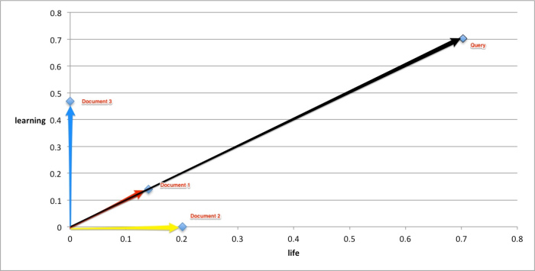](https://janav.files.wordpress.com/2013/10/cosinesimiarlity.jpeg)

Advertisements

# Cosine Similarity

## Cosine Similarity

Cosine similarity is a [Similarity Function](http://mlwiki.org/index.php?title=Similarity_Function&action=edit&redlink=1) that is often used in [Information Retrieval](http://mlwiki.org/index.php/Information_Retrieval)

* it measures the angle between two vectors, and in case of IR - the angle between two documents

### Derivation

* recall the definition of the [Dot Product](http://mlwiki.org/index.php/Dot_Product): v⋅w=∥v∥⋅∥w∥⋅cosθv⋅w=‖v‖⋅‖w‖⋅cos⁡θ
* or, by rearranging get cosθ=v⋅w∥v∥⋅∥w∥cos⁡θ=v⋅w‖v‖⋅‖w‖
* so, let's define the cosine similarity function as cosine(d1,d2)=dT1d2∥d1∥⋅∥d2∥cosine(d1,d2)=d1Td2‖d1‖⋅‖d2‖
* cosine is usually [−1,1][−1,1], but document vectors (see [Vector Space Model](http://mlwiki.org/index.php/Vector_Space_Model)) are usually non-negative, so the angle between two documents can never be greater than 90 degrees, and for document vectors cosine(d1,d2)∈[0,1]cosine(d1,d2)∈[0,1]
  + min cosine is 0 (max angle: the documents are orthogonal)
  + max cosine is 1 (min angle: the documents are the same)

### Cosine Normalization

If documents have unit length, then cosine similarity is the same as [Dot Product](http://mlwiki.org/index.php/Dot_Product)

* cosine(d1,d2)=dT1d2∥d1∥⋅∥d2∥=dT1d2cosine(d1,d2)=d1Td2‖d1‖⋅‖d2‖=d1Td2
* thus we can "unit-normalize" document vectors d′=d∥d∥d′=d‖d‖ and then compute dot product on them and get cosine
* this "unit-length normalization" is often called "cosine normalization" in IR

## Cosine Distance

* for documents cosine(d1,d2)∈[0,1]cosine(d1,d2)∈[0,1]
* it is max when two documents are the same
* how to define a distance? distance function should become larger as elements become less similar
* since maximal value of cosine is 1, we can define **cosine distance** as
* dc(d1,d2)=1−cosine(d1,d2)=1−dT1d2∥d1∥⋅∥d2∥dc(d1,d2)=1−cosine(d1,d2)=1−d1Td2‖d1‖⋅‖d2‖

### [Metricity](http://mlwiki.org/index.php/Distance_Functions)

Let's check if cosine distance is a proper metric, i.e. it satisfies all the requirements

* Let DD be the document space and d1,d2∈Dd1,d2∈D
* dc(d1,d2)⩾0dc(d1,d2)⩾0: checks - 0 is minimum
* dc(d1,d1)=0dc(d1,d1)=0 checks - 1−cos0=01−cos⁡0=0
* dc(d1,d2)=dc(d2,d1)dc(d1,d2)=dc(d2,d1): checks - angle is the same

What about the triangle inequality?

* under certain conditions is doesn't hold (Korenius2007) - so it's not a proper metric

## Cosine and [Euclidean Distance](http://mlwiki.org/index.php/Euclidean_Distance)

Euclidean distance ∥d1−d2∥=(d1−d2)T(d1−d2)−−−−−−−−−−−−−−−−√‖d1−d2‖=(d1−d2)T(d1−d2)

* ED is a proper metric

There's a connection between Cosine Distance end Euclidean Distance

* consider two unit-normalized vectors x1=d1/∥d1∥x1=d1/‖d1‖ and x2=d1/∥d1∥x2=d1/‖d1‖
* ∥x1−x2∥2=(x1−x2)T(x1−x2)=xT1x1−2xT1x2+xT2x2=∥x1∥2−2xT1x2+∥x2∥2=2−2xT1x2‖x1−x2‖2=(x1−x2)T(x1−x2)=x1Tx1−2x1Tx2+x2Tx2=‖x1‖2−2x1Tx2+‖x2‖2=2−2x1Tx2
* if vectors are unit-normalized, cosine = dot product, so we have
* ∥x1−x2∥2=2(1−xT1x2)=2(1−cosine(x1,x2))=2dc(x1,x2)‖x1−x2‖2=2(1−x1Tx2)=2(1−cosine(x1,x2))=2dc(x1,x2)

It can also make some sense visually:

* 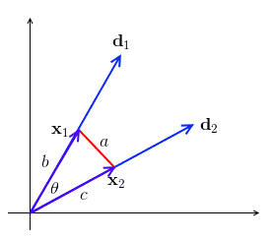
* recall the [Cosine Theorem](http://mlwiki.org/index.php?title=Cosine_Theorem&action=edit&redlink=1): a2=b2+c2−2bccosθa2=b2+c2−2bccos⁡θ
* b=c=1b=c=1, so we have a2=2(1−cosθ)a2=2(1−cos⁡θ)

Thus we can use Euclidean distance and interpret it as Cosine distance

## Other Properties

### Translation Non-Invariant

For [PCA](http://mlwiki.org/index.php/PCA) we usually do mean-correction

* but mean-correction affects the angle between documents
* can show that visually: the angle between two vectors are not translation-resistant
* 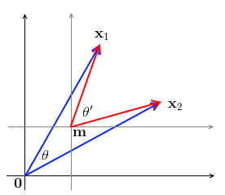
* i.e. if we have two vectors x1x1 and x2x2 and with θθ being the angle between them, when we translate the space by mm, we get a new angle θ′θ′ s.t. θ≠θ′θ≠θ′
* also note that when we translate, some elements may become negative!

**What is text analytics?**

*Text analysis* is about deriving high-quality structured data from unstructured text. Another name for text analytics is *text mining*. A good reason for using text analytics might be to extract additional data about customers from unstructured data sources to enrich customer master data, to produce new customer insight or to determine sentiment about products and services. Several text analytics use cases exist:

* Case management—for example, insurance claims assessment, healthcare patient records and crime-related interviews and reports
* Competitor analysis
* Fault management and field-service optimization
* Legal ediscovery in litigation cases
* Media coverage analysis
* Pharmaceutical drug trial improvement
* Sentiment analytics
* Voice of the customer

*Entity extraction,*the parsing and extracting of entities from raw text, is a key part of text analytics. Several examples of entity extraction exist:

* Company names
* Dates and times
* Domain-specific names such as names of diseases in pharmaceutical data
* Monetary amounts
* People’s names and social network handles
* Phrases, negative or positive
* Product names

In many cases, entity extraction can be turned into automated entity recognition, in which text is parsed and well-understood entities are automatically selected from the text by the software. This requirement is common. In the previous list of use cases, recognizing dates, times, monetary amounts and so on may be something that text analytics software can do out of the box, without you having to help it figure out what these extractions are. The benefit of this approach should be obvious. The time necessary to do entity extraction is drastically reduced, it can be done at scale across large volumes of text and it produces structured data that can be merged with enterprise data for further analysis.

**Proving its mettle**

Widely used data sources for text analytics include social networks—Facebook, LinkedIn and Twitter—along with internal email, inbound customer email, news articles, online discussion forums and customer relationship management (CRM) customer service notes. Other widely used sources include review websites such as TripAdvisor, documents such as PDF files and online forms such as applications containing text or forms containing structured data stored as text.

Text analytics has been around for many years, and with as much as 80 percent of data in enterprises now in unstructured form, it is proving its worth very quickly. A well-understood process for text analytics includes the following steps:

1. Extracting raw text
2. Tokenizing the text—that is, breaking it down into words and phrases
3. Detecting term boundaries
4. Detecting sentence boundaries
5. Tagging parts of speech—words such as nouns and verbs
6. Tagging named entities so that they are identified—for example, a person, a company, a place, a gene, a disease, a product and so on
7. Parsing—for example, extracting facts and entities from the tagged text
8. Extracting knowledge to understand concepts such as a personal injury within an accident claim

Text analytics can also be combined with other advanced analytics. For example, it can be combined with other data and with machine learning to predict the sentiment trend—such as negative sentiment predicted to increase or people who are likely to tweet negative sentiment based on their profile. Text analytics can also be combined with graph analysis, whereby people, places, activities and things are extracted from text using entity extraction and fed into a graph and graph analysis to discover completely new relationships you weren’t previously aware of.

Probably one of the most widely used forms of text analytics is sentiment analysis. Inbound customer email and social network data such as tweets may help determine positive, negative or neutral sentiment about your products and brands. *Sentiment analysis* is the process of determining a sentiment score from text. Companies want to determine these scores to be able to respond quickly to negative sentiment to minimize its impact and to make sure customer satisfaction and loyalty are constantly being improved. They also want to protect brands. Product managers want to use sentiment analysis to understand any problems with newly released products and services, so they can fix them quickly. In addition, finance departments want to take sentiment into account when doing financial planning—something that may be surprising to many.

**Negotiating hurdles**

All kinds of challenges are evident when using text analysis to analyze sentiment. For example, people tweet in multiple languages. Data quality can be poor. Many people also use emoticons, and different generations seem to speak their own language, even if it is all in one actual language of the world. Slang can also be an obvious challenge. And ambiguities can also exist—for example, a young person may tweet, “This new phone is sick!”

The good news is that text analytics is now mature enough to handle many of these characteristics. Ultimately, sentiment analysis is about opinions that may be transient and therefore have short-lived impact. Of course, an *opinion*consists of a number of elements including the name of a product or brand, perhaps a part of a product, the sentiment itself and even intent or desire—as in, “I really want to get that new *Star Wars* DVD.” Other elements include the opinion holder and when the opinion—the time of the tweet—was expressed.

New visualizations exist for text analytics to easily understand sentiment in a huge amount of text. Examples include word clouds that enable you to see how frequently words appear in a given corpus of text. Also, word trees and phrase nets offer other examples. The former allow you to choose a word or phrase and show you all the different contexts in which it appears; the latter show the relationships between different words used in a text.

Text analysis can be a computationally intensive process involving complex character-level operations such as pattern matching. Therefore, for large volumes scalability matters and is a major reason why people use platforms such as Apache Hadoop to do batch text analysis. However, you can also do the analysis in real time using streaming text analytics to react to sentiment or even to detect fraud as people are filling out online application forms, for example.

**Capitalizing on many flavors**

Today, you can find text analytics available on the cloud, on-premises in stand-alone text analytics offerings and at scale on Hadoop. IBM offers text analytics as part of the [IBM BigInsights Data Science module](http://www.ibm.com/analytics/us/en/technology/cloud-data-services/biginsights-on-cloud/?S_TACT=M1610MLW&iio=panalytics&cmp=m1610&ct=m1610mlw&cr=newsroom&cm=h&csot=-&ccy=-&cpb=-&cd=-). This solution includes web-based tooling to extract information that generates a language called Annotation Query Language (AQL) to do the analysis. IBM also includes application templates in BigInsights to get you up and running quickly with sentiment analysis.

Text analysis can also be done using search, which allows for indexing raw text and launching exploratory queries on that data to find content of interest. Connecting self-service business intelligence (BI) tools to search engines enables using search-based text analytics from within BI tools and to visualize the results in dashboards. Text analytics represents an exciting area that can generate significant business value.

**What Are Word Embeddings for Text?**

Word embeddings are a type of word representation that allows words with similar meaning to have a similar representation.

They are a distributed representation for text that is perhaps one of the key breakthroughs for the impressive performance of deep learning methods on challenging natural language processing problems.

In this post, you will discover the word embedding approach for representing text data.

After completing this post, you will know:

* What the word embedding approach for representing text is and how it differs from other feature extraction methods.
* That there are 3 main algorithms for learning a word embedding from text data.
* That you can either train a new embedding or use a pre-trained embedding on your natural language processing task.

Let’s get started.

**Overview**

This post is divided into 3 parts; they are:

1. What Are Word Embeddings?
2. Word Embedding Algorithms
3. Using Word Embeddings

**What Are Word Embeddings?**

A word embedding is a learned representation for text where words that have the same meaning have a similar representation.

It is this approach to representing words and documents that may be considered one of the key breakthroughs of deep learning on challenging natural language processing problems.

*One of the benefits of using dense and low-dimensional vectors is computational: the majority of neural network toolkits do not play well with very high-dimensional, sparse vectors. … The main benefit of the dense representations is generalization power: if we believe some features may provide similar clues, it is worthwhile to provide a representation that is able to capture these similarities.*Word embeddings are in fact a class of techniques where individual words are represented as real-valued vectors in a predefined vector space. Each word is mapped to one vector and the vector values are learned in a way that resembles a neural network, and hence the technique is often lumped into the field of deep learning.

Key to the approach is the idea of using a dense distributed representation for each word.

Each word is represented by a real-valued vector, often tens or hundreds of dimensions. This is contrasted to the thousands or millions of dimensions required for sparse word representations, such as a one-hot encoding.

*associate with each word in the vocabulary a distributed word feature vector … The feature vector represents different aspects of the word: each word is associated with a point in a vector space. The number of features … is much smaller than the size of the vocabulary*

The distributed representation is learned based on the usage of words. This allows words that are used in similar ways to result in having similar representations, naturally capturing their meaning. This can be contrasted with the crisp but fragile representation in a bag of words model where, unless explicitly managed, different words have different representations, regardless of how they are used.

There is deeper linguistic theory behind the approach, namely the “*distributional hypothesis*” by Zellig Harris that could be summarized as: words that have similar context will have similar meanings. For more depth see Harris’ 1956 paper “[Distributional structure](http://www.tandfonline.com/doi/pdf/10.1080/00437956.1954.11659520)“.

This notion of letting the usage of the word define its meaning can be summarized by an oft repeated quip by John Firth:

*You shall know a word by the company it keeps!*

**Word Embedding Algorithms**

Word embedding methods learn a real-valued vector representation for a predefined fixed sized vocabulary from a corpus of text.

The learning process is either joint with the neural network model on some task, such as document classification, or is an unsupervised process, using document statistics.

This section reviews three techniques that can be used to learn a word embedding from text data.

**1. Embedding Layer**

An embedding layer, for lack of a better name, is a word embedding that is learned jointly with a neural network model on a specific natural language processing task, such as language modeling or document classification.

It requires that document text be cleaned and prepared such that each word is one-hot encoded. The size of the vector space is specified as part of the model, such as 50, 100, or 300 dimensions. The vectors are initialized with small random numbers. The embedding layer is used on the front end of a neural network and is fit in a supervised way using the Backpropagation algorithm.

*… when the input to a neural network contains symbolic categorical features (e.g. features that take one of k distinct symbols, such as words from a closed vocabulary), it is common to associate each possible feature value (i.e., each word in the vocabulary) with a d-dimensional vector for some d. These vectors are then considered parameters of the model, and are trained jointly with the other parameters.*

The one-hot encoded words are mapped to the word vectors. If a multilayer Perceptron model is used, then the word vectors are concatenated before being fed as input to the model. If a recurrent neural network is used, then each word may be taken as one input in a sequence.

This approach of learning an embedding layer requires a lot of training data and can be slow, but will learn an embedding both targeted to the specific text data and the NLP task.

**2. Word2Vec**

Word2Vec is a statistical method for efficiently learning a standalone word embedding from a text corpus.

It was developed by Tomas Mikolov, et al. at Google in 2013 as a response to make the neural-network-based training of the embedding more efficient and since then has become the de facto standard for developing pre-trained word embedding.

Additionally, the work involved analysis of the learned vectors and the exploration of vector math on the representations of words. For example, that subtracting the “*man-ness*” from “*King*” and adding “*women-ness*” results in the word “*Queen*“, capturing the analogy “*king is to queen as man is to woman*“.

*We find that these representations are surprisingly good at capturing syntactic and semantic regularities in language, and that each relationship is characterized by a relation-specific vector offset. This allows vector-oriented reasoning based on the offsets between words. For example, the male/female relationship is automatically learned, and with the induced vector representations, “King – Man + Woman” results in a vector very close to “Queen.”*

Two different learning models were introduced that can be used as part of the word2vec approach to learn the word embedding; they are:

* Continuous Bag-of-Words, or CBOW model.
* Continuous Skip-Gram Model.

The CBOW model learns the embedding by predicting the current word based on its context. The continuous skip-gram model learns by predicting the surrounding words given a current word.

The continuous skip-gram model learns by predicting the surrounding words given a current word.

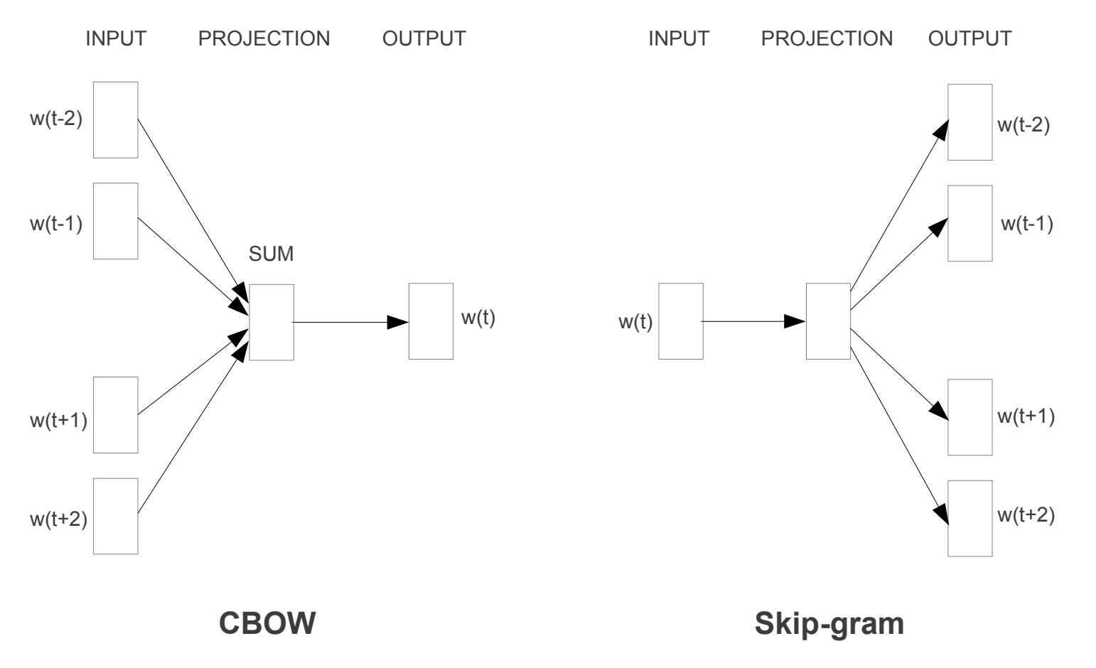

Word2Vec Training Models

Both models are focused on learning about words given their local usage context, where the context is defined by a window of neighboring words. This window is a configurable parameter of the model.

*The size of the sliding window has a strong effect on the resulting vector similarities. Large windows tend to produce more topical similarities […], while smaller windows tend to produce more functional and syntactic similarities.*

The key benefit of the approach is that high-quality word embeddings can be learned efficiently (low space and time complexity), allowing larger embeddings to be learned (more dimensions) from much larger corpora of text (billions of words).

**3. GloVe**

The Global Vectors for Word Representation, or GloVe, algorithm is an extension to the word2vec method for efficiently learning word vectors, developed by Pennington, et al. at Stanford.

Classical vector space model representations of words were developed using matrix factorization techniques such as Latent Semantic Analysis (LSA) that do a good job of using global text statistics but are not as good as the learned methods like word2vec at capturing meaning and demonstrating it on tasks like calculating analogies (e.g. the King and Queen example above).

GloVe is an approach to marry both the global statistics of matrix factorization techniques like LSA with the local context-based learning in word2vec.

Rather than using a window to define local context, GloVe constructs an explicit word-context or word co-occurrence matrix using statistics across the whole text corpus. The result is a learning model that may result in generally better word embeddings.

*GloVe, is a new global log-bilinear regression model for the unsupervised learning of word representations that outperforms other models on word analogy, word similarity, and named entity recognition tasks.*

**Using Word Embeddings**

You have some options when it comes time to using word embeddings on your natural language processing project.

This section outlines those options.

**1. Learn an Embedding**

You may choose to learn a word embedding for your problem.

This will require a large amount of text data to ensure that useful embeddings are learned, such as millions or billions of words.

You have two main options when training your word embedding:

1. **Learn it Standalone**, where a model is trained to learn the embedding, which is saved and used as a part of another model for your task later. This is a good approach if you would like to use the same embedding in multiple models.
2. **Learn Jointly**, where the embedding is learned as part of a large task-specific model. This is a good approach if you only intend to use the embedding on one task.

**2. Reuse an Embedding**

It is common for researchers to make pre-trained word embeddings available for free, often under a permissive license so that you can use them on your own academic or commercial projects.

For example, both word2vec and GloVe word embeddings are available for free download.

These can be used on your project instead of training your own embeddings from scratch.

You have two main options when it comes to using pre-trained embeddings:

1. **Static**, where the embedding is kept static and is used as a component of your model. This is a suitable approach if the embedding is a good fit for your problem and gives good results.
2. **Updated**, where the pre-trained embedding is used to seed the model, but the embedding is updated jointly during the training of the model. This may be a good option if you are looking to get the most out of the model and embedding on your task.

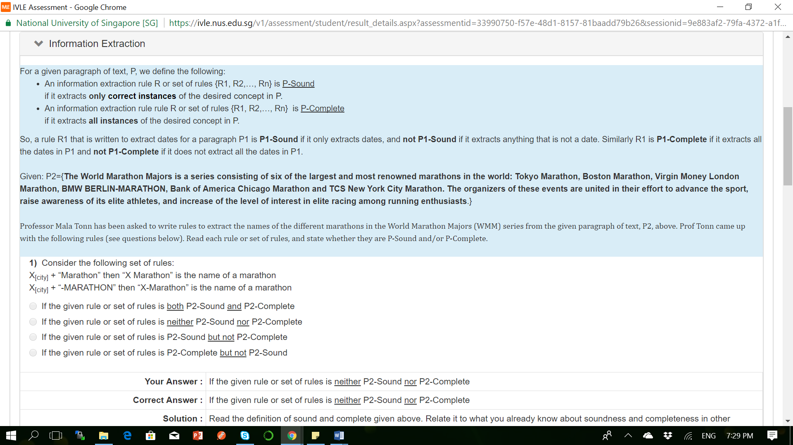

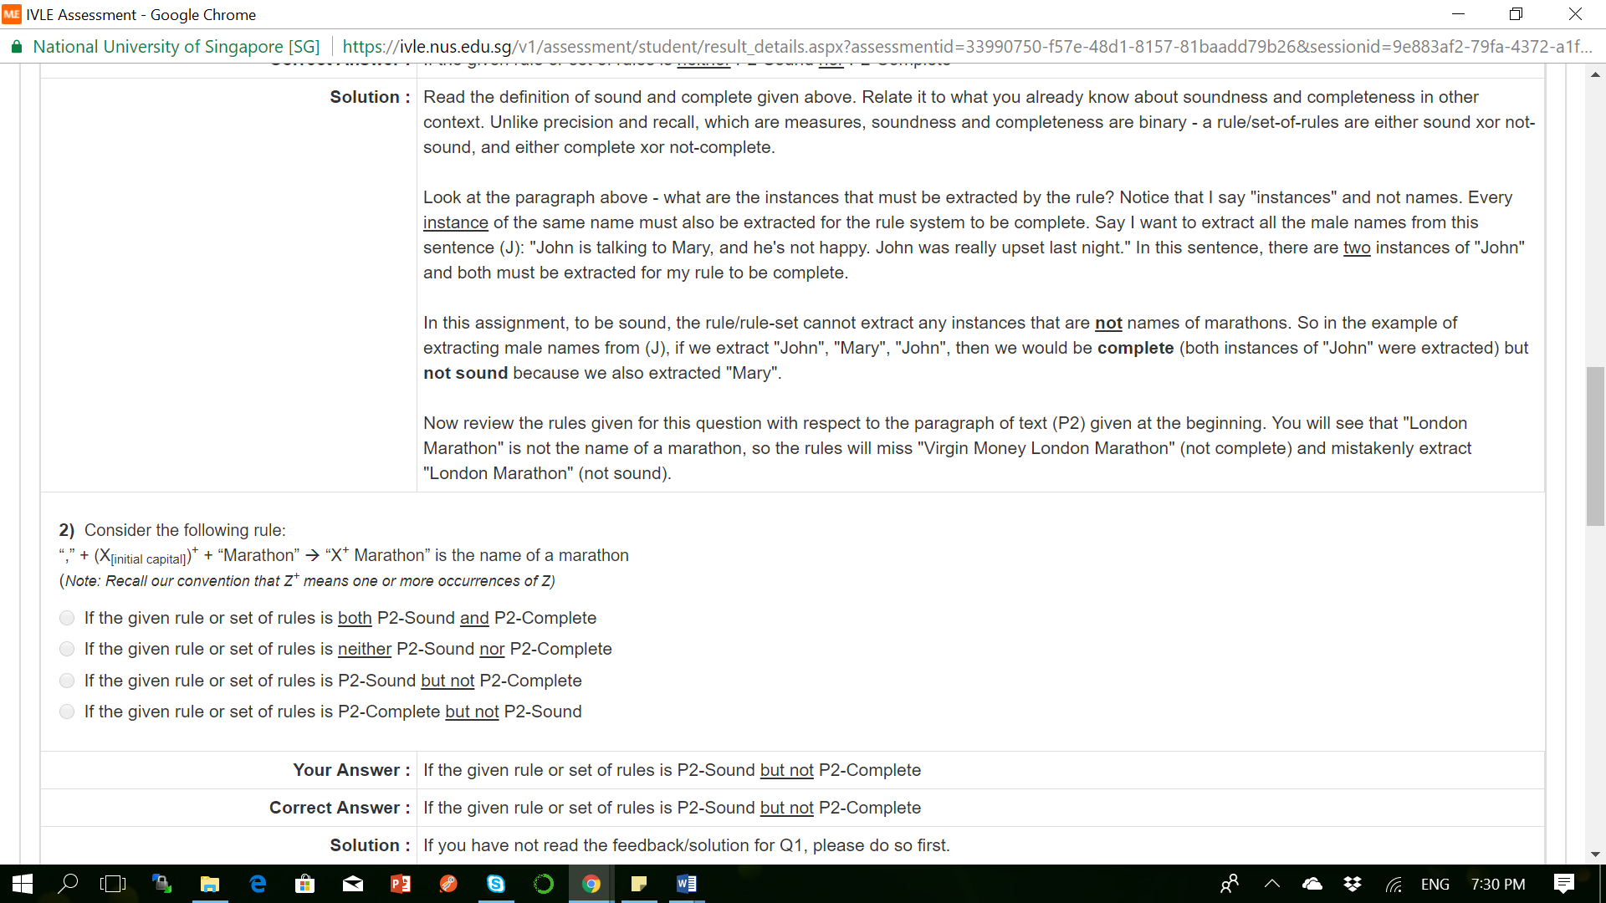

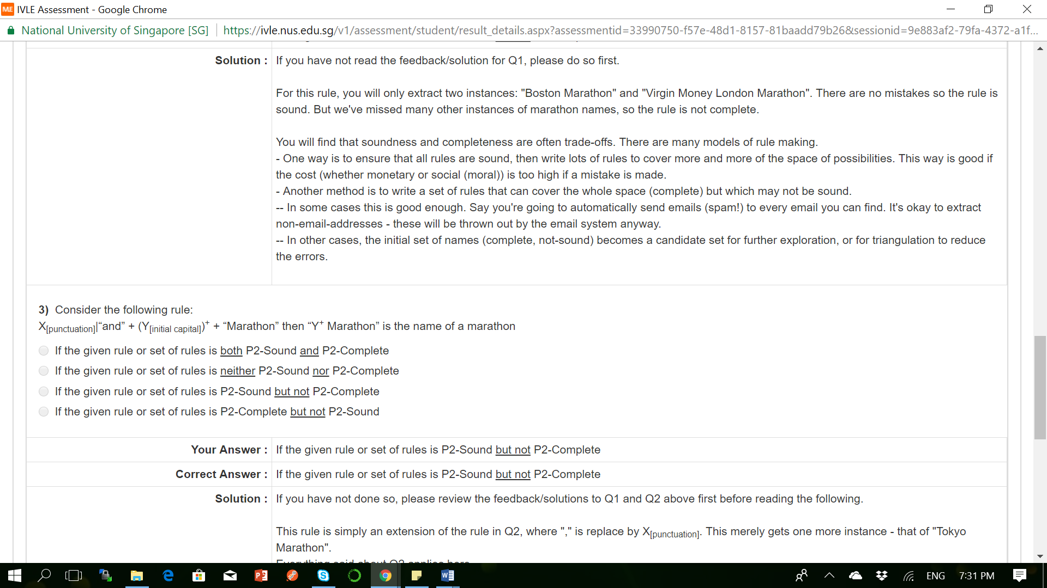

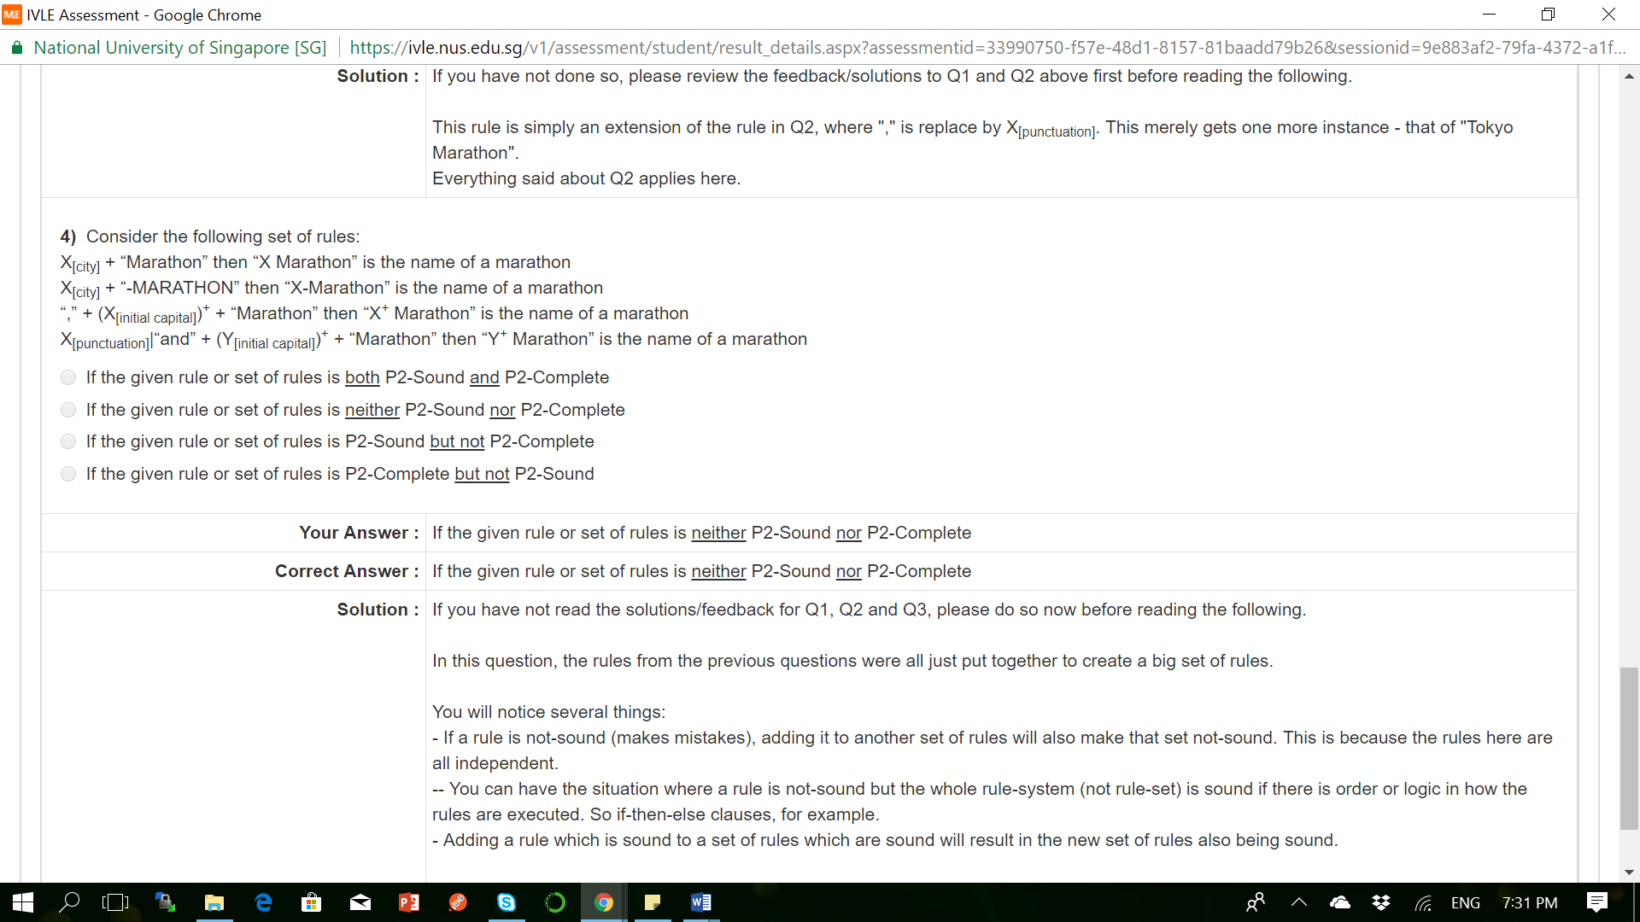

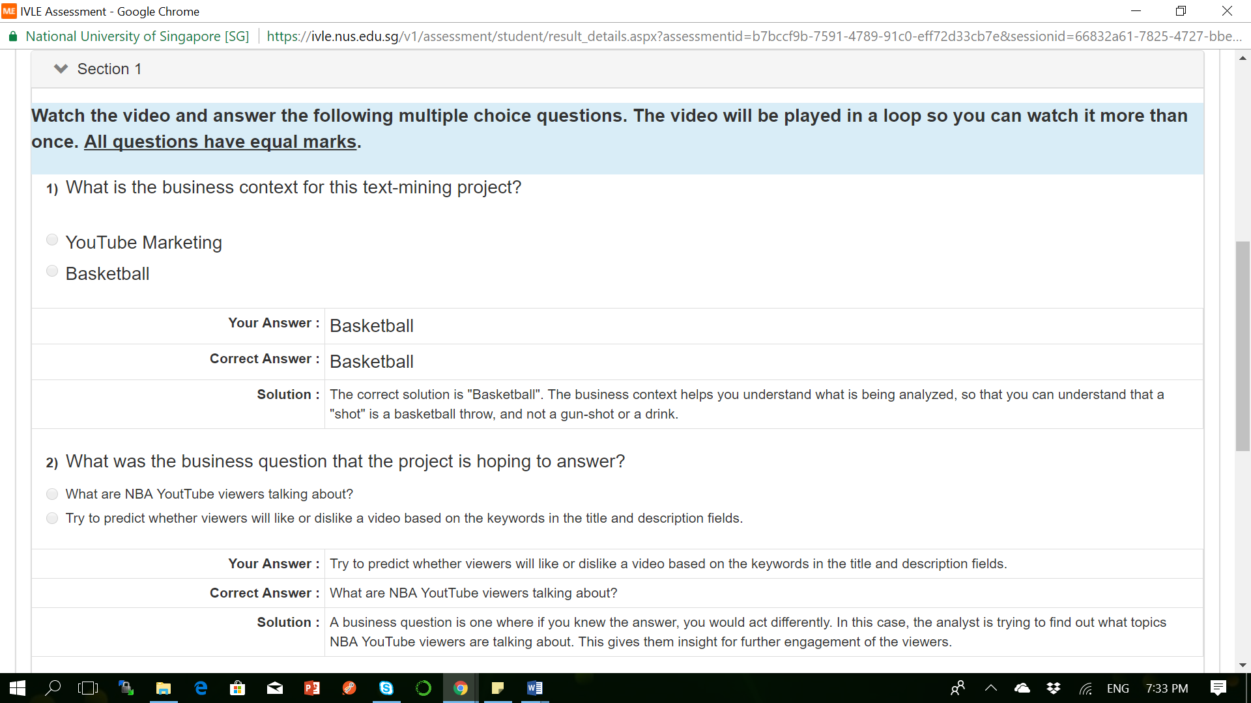

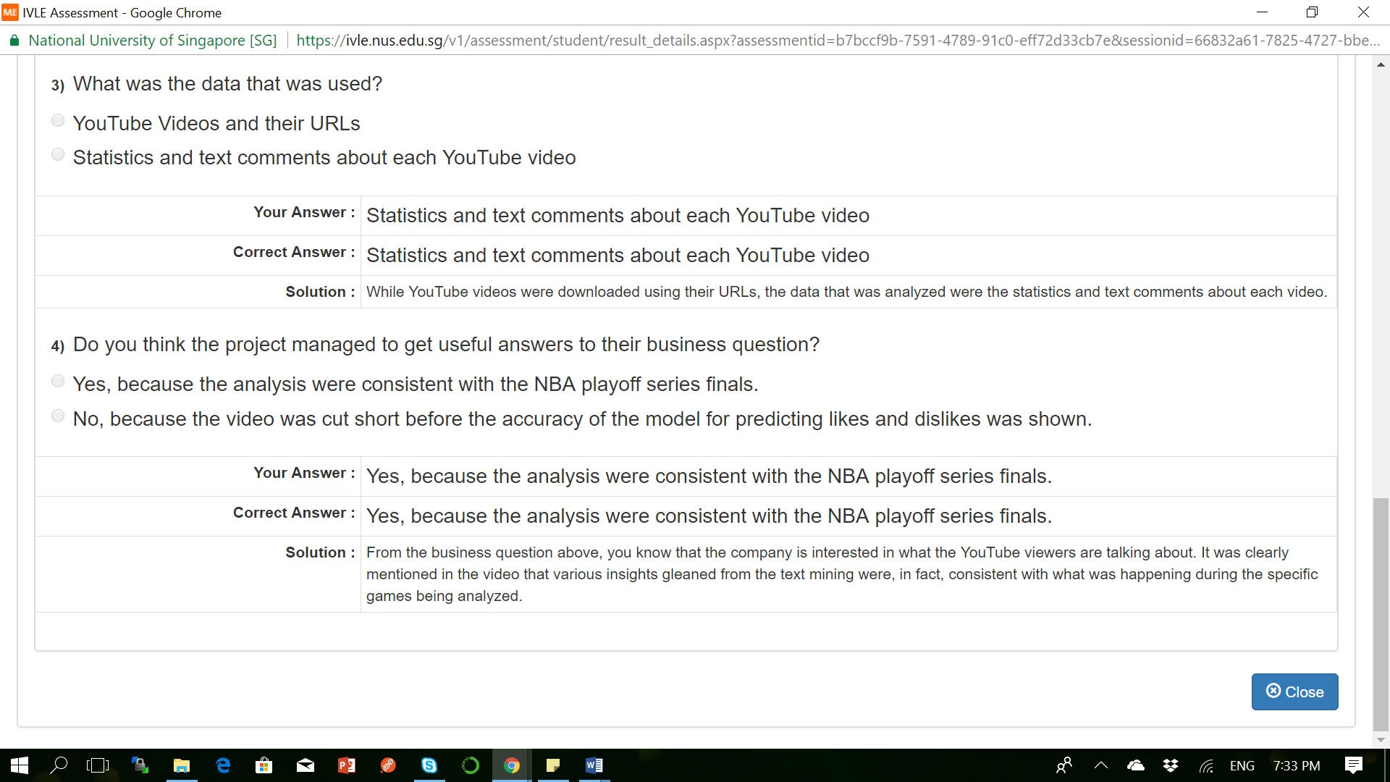

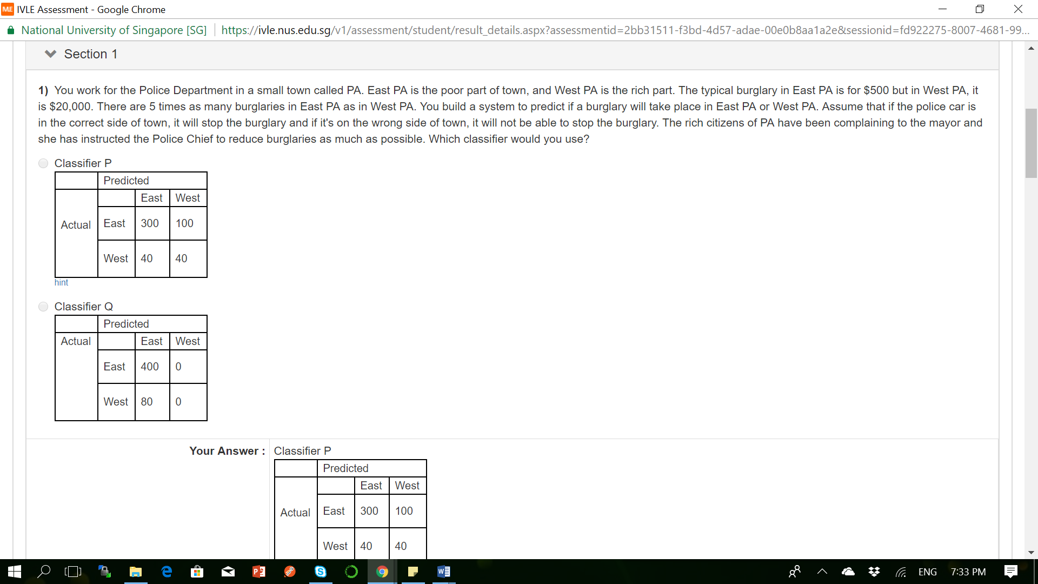

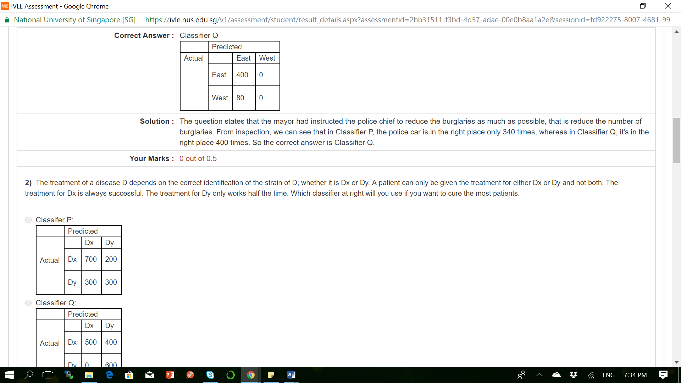

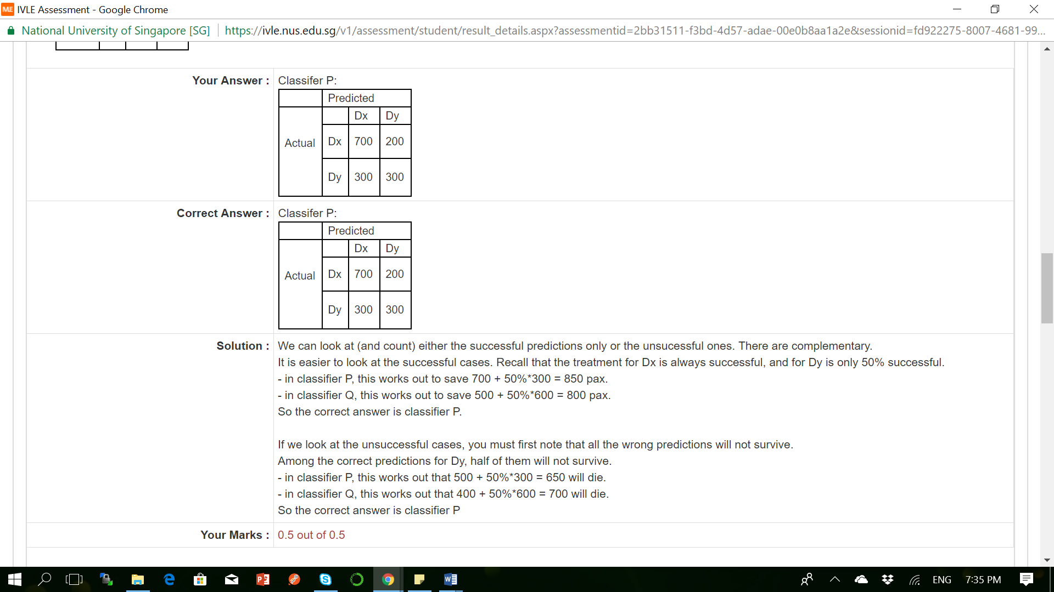

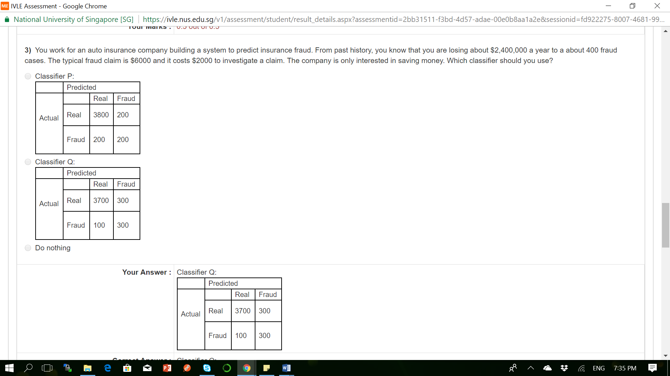

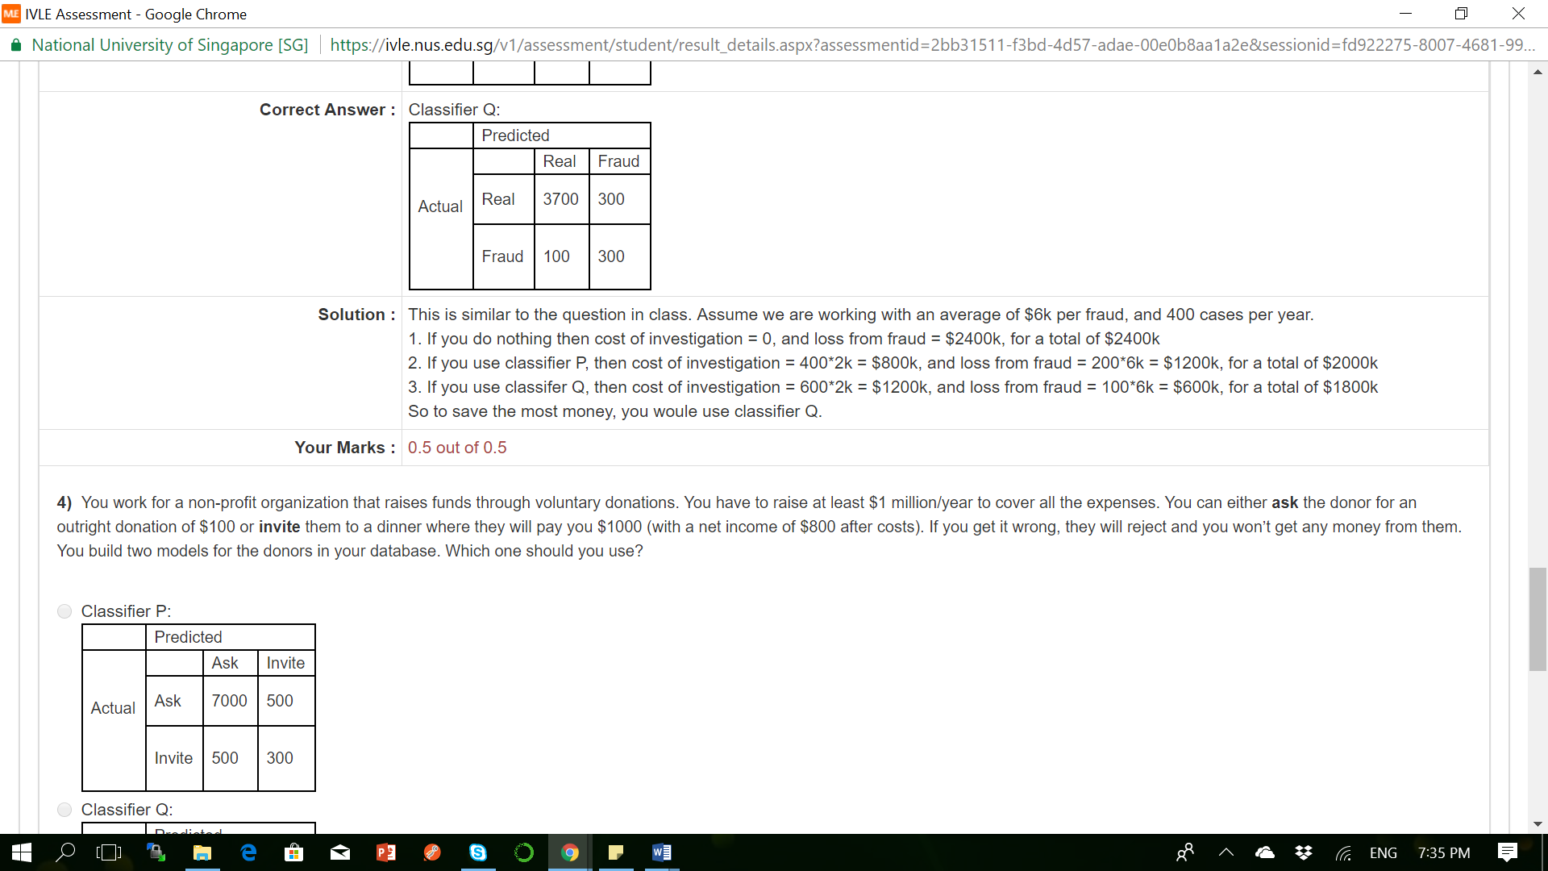

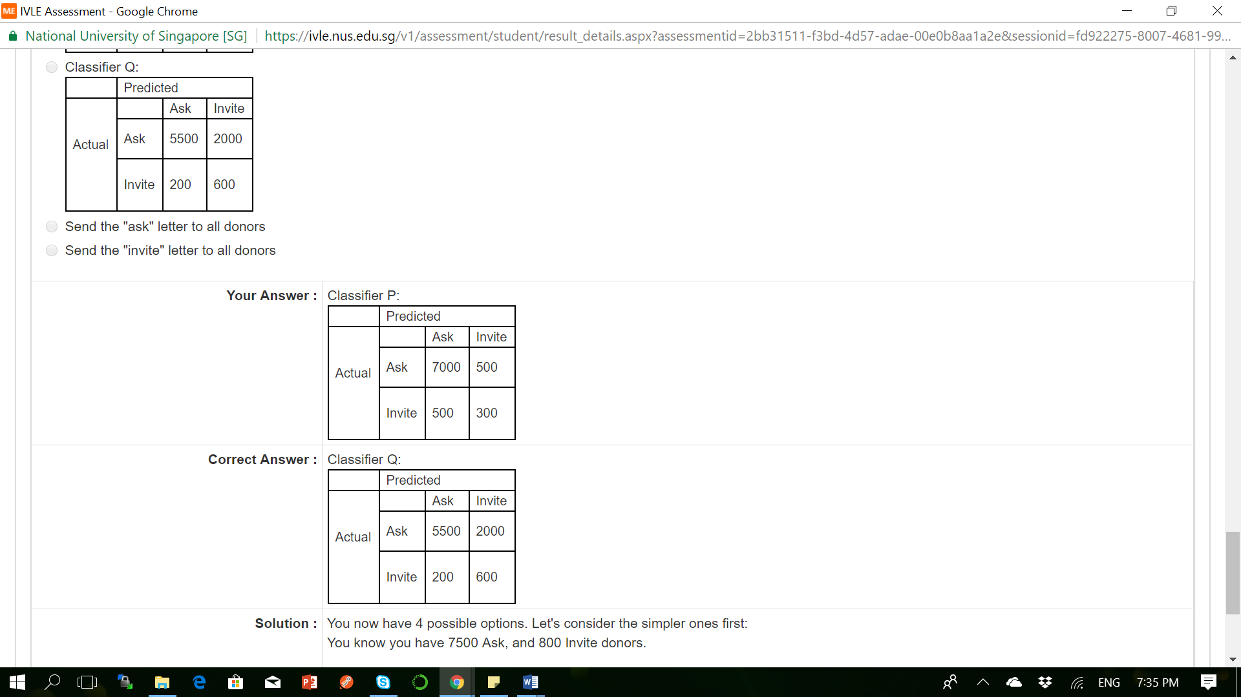

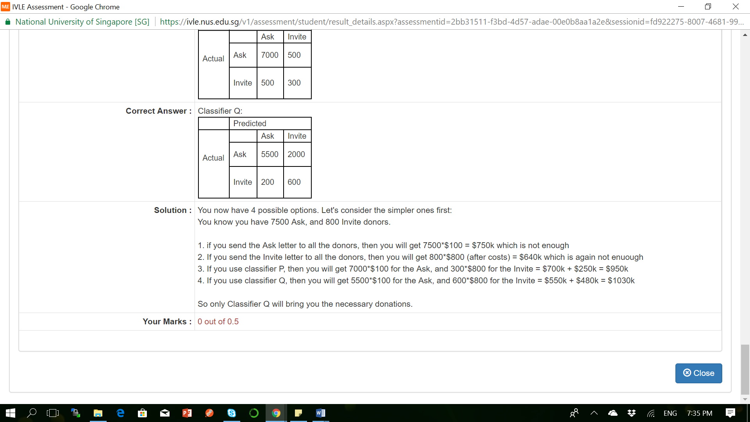

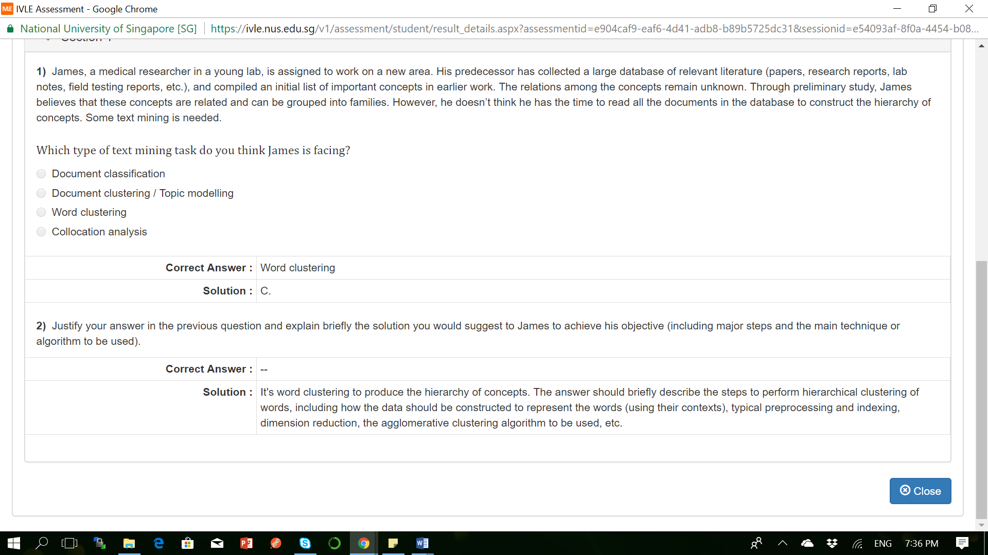

Skill Test Questions and Answers

**Q1 Which of the following techniques can be used for the purpose of keyword normalization, the process of converting a keyword into its base form?**

**Solution:** Lemmatization, Stemming

**2) N-grams are defined as the combination of N keywords together. How many bi-grams can be generated from given sentence:**

“Analytics Vidhya is a great source to learn data science”

**Solution: (C) 9**

Bigrams: Analytics Vidhya, Vidhya is, is a, a great, great source, source to, To learn, learn data, data science

**3) How many trigrams phrases can be generated from the following sentence, after performing following text cleaning steps:**

* Stopword Removal
* Replacing punctuations by a single space

**“#Analytics-vidhya is a great source to learn @data\_science.”**

**Solution: (C) 5**

After performing stopword removal and punctuation replacement the text becomes: “Analytics vidhya great source learn data science”

Trigrams – Analytics vidhya great, vidhya great source, great source learn, source learn data, learn data science

**4) Which of the following regular expression can be used to identify date(s) present in the text object:**

***“The next meetup on data science will be held on 2017-09-21, previously it happened on 31/03, 2016”***

A) \d{4}-\d{2}-\d{2}  
B) (19|20)\d{2}-(0[1-9]|1[0-2])-[0-2][1-9] C) (19|20)\d{2}-(0[1-9]|1[0-2])-([0-2][1-9]|3[0-1])  
D) None of the above

**Solution: (D)**

None if these expressions would be able to identify the dates in this text object.

**Question Context 5-6:**

You have collected a data of about 10,000 rows of tweet text and no other information. You want to create a tweet classification model that categorizes each of the tweets in three buckets – positive, negative and neutral.

**5) Which of the following models can perform tweet classification with regards to context mentioned above?**

A) Naive Bayes  
B) SVM  
C) None of the above

**Solution: (C)**

Since, you are given only the data of tweets and no other information, which means there is no target variable present. One cannot train a supervised learning model, both svm and naive bayes are supervised learning techniques.

**6) You have created a document term matrix of the data, treating every tweet as one document. Which of the following is correct, in regards to document term matrix?**

1. Removal of stopwords from the data will affect the dimensionality of data
2. Normalization of words in the data will reduce the dimensionality of data
3. Converting all the words in lowercase will not affect the dimensionality of the data

**Solution: 1 and 2**

Choices A and B are correct because stopword removal will decrease the number of features in the matrix, normalization of words will also reduce redundant features, and, converting all words to lowercase will also decrease the dimensionality.

**7) Which of the following features can be used for accuracy improvement of a classification model**?

A) Frequency count of terms  
B) Vector Notation of sentence  
C) Part of Speech Tag  
D) Dependency Grammar  
E) All of these

**Solution: (E)**

All of the techniques can be used for the purpose of engineering features in a model.

**8) What percentage of the total statements are correct with regards to Topic Modeling?**

1. It is a supervised learning technique
2. LDA (Linear Discriminant Analysis) can be used to perform topic modeling
3. Selection of number of topics in a model does not depend on the size of data
4. Number of topic terms are directly proportional to size of the data

**Solution: 0**

LDA is unsupervised learning model, LDA is latent Dirichlet allocation, not Linear discriminant analysis. Selection of the number of topics is directly proportional to the size of the data, while number of topic terms is not directly proportional to the size of the data. Hence none of the statements are correct.

**9) In Latent Dirichlet Allocation model for text classification purposes, what does alpha and beta hyperparameter represent-**

**Solution:**  Alpha: density of topics generated within documents, beta: density of terms generated within topics True

**10) Solve the equation according to the sentence “I am planning to visit New Delhi to attend Analytics Vidhya Delhi Hackathon”.**

A = (# of words with Noun as the part of speech tag)  
B = (# of words with Verb as the part of speech tag)  
C = (# of words with frequency count greater than one)

**What are the correct values of A, B, and C?**

**Solution:** D) 7, 4, 2

Nouns: I, New, Delhi, Analytics, Vidhya, Delhi, Hackathon (7)

Verbs: am, planning, visit, attend (4)

Words with frequency counts > 1: to, Delhi (2)

**11) In a corpus of N documents, one document is randomly picked. The document contains a total of T terms and the term “data” appears K times.**

**What is the correct value for the product of TF (term frequency) and IDF (inverse-document-frequency), if the term “data” appears in approximately one-third of the total documents?**

**Solution:**   K \* Log(3) / T

formula for TF is K/T

formula for IDF is log(total docs / no of docs containing “data”)

= log(1 / (⅓))

= log (3)

**Question Context 12 to 14:**

Refer the following document term matrix  
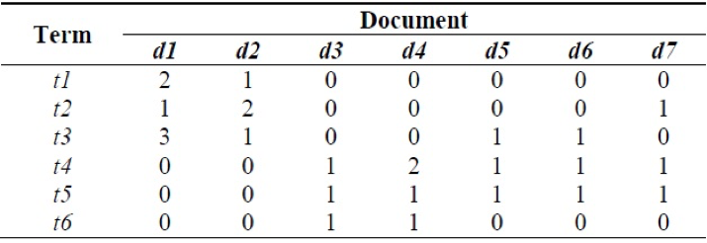

**12) Which of the following documents contains the same number of terms and the number of terms in the one of the document is not equal to least number of terms in any document in the entire corpus.**

**Solution: (C)** d2 and d4

Both of the documents d2 and d4 contains 4 terms and does not contain the least number of terms which is 3.

**13) Which are the most common and the rarest term of the corpus?**

**Solution: (A)** t4, t6

T5 is most common terms across 5 out of 7 documents, T6 is rare term only appears in d3 and d4

**14) What is the term frequency of a term which is used a maximum number of times in that document?**

**Solution:** t3 – 3/6

t3 is used max times in entire corpus = 3, tf for t3 is 3/6

**15) Which of the following technique is not a part of flexible text matching?**

**Solution:** Keyword Hashing

Except Keyword Hashing all other are the techniques used in flexible string matching

**16) True or False: Word2Vec model is a machine learning model used to create vector notations of text objects. Word2vec contains multiple deep neural networks**

A) TRUE  
B) FALSE

**Solution: (B)**

Word2vec also contains preprocessing model which is not a deep neural network

**17) Which of the following statement is(are) true for Word2Vec model?**

A) The architecture of word2vec consists of only two layers – continuous bag of words and skip-gram

**Solution: (C)** Skip-gram is a deep neural network model  
Word2vec contains the Continuous bag of words and skip-gram models, which are deep neural nets.

**18) With respect to this context-free dependency graphs, how many sub-trees exists in the sentence?**

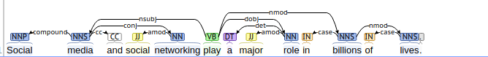  
A) 3  
B) 4  
C) 5  
D) 6

**Solution: (D)**

Subtrees in the dependency graph can be viewed as nodes having an outward link, for example:

Media, networking, play, role, billions, and lives are the roots of subtrees

**19) What is the right order for a text classification model components**

1. Text cleaning
2. Text annotation
3. Gradient descent
4. Model tuning
5. Text to predictors

**Solution:**  12534

A right text classification model contains – cleaning of text to remove noise, annotation to create more features, converting text-based features into predictors, learning a model using gradient descent and finally tuning a model.

**20) Polysemy is defined as the coexistence of multiple meanings for a word or phrase in a text object. Which of the following models is likely the best choice to correct this problem?**

**Solution:** Convolutional Neural Networks

CNNs are popular choice for text classification problems because they take into consideration left and right contexts of the words as features which can solve the problem of polysemy

**21) Which of the following models can be used for the purpose of document similarity?**

A) Training a word 2 vector model on the corpus that learns context present in the document  
B) Training a bag of words model that learns occurrence of words in the document  
C) Creating a document-term matrix and using cosine similarity for each document  
D) All of the above

**Solution: (D)**

word2vec model can be used for measuring document similarity based on context. Bag Of Words and document term matrix can be used for measuring similarity based on terms.

**22) What are the possible features of a text corpus**

1. Count of word in a document
2. Boolean feature – presence of word in a document
3. Vector notation of word
4. Part of Speech Tag
5. Basic Dependency Grammar
6. Entire document as a feature

**Solution:** 12345

Except for entire document as the feature, rest all can be used as features of text classification learning model.

**23) While creating a machine learning model on text data, you created a document term matrix of the input data of 100K documents. Which of the following remedies can be used to reduce the dimensions of data –**

1. Latent Dirichlet Allocation
2. Latent Semantic Indexing
3. Keyword Normalization

**Solution:** 1, 2, 3

All of the techniques can be used to reduce the dimensions of the data.

**24) Google Search’s feature – “Did you mean”, is a mixture of different techniques. Which of the following techniques are likely to be ingredients?**

1. Collaborative Filtering model to detect similar user behaviors (queries)
2. Model that checks for Levenshtein distance among the dictionary terms
3. Translation of sentences into multiple languages

**Solution:** C) 1, 2

Collaborative filtering can be used to check what are the patterns used by people, Levenshtein is used to measure the distance among dictionary terms.

**25) While working with text data obtained from news sentences, which are structured in nature, which of the grammar-based text parsing techniques can be used for noun phrase detection, verb phrase detection, subject detection and object detection.**

**Solution:** Dependency Parsing and Constituency Parsing

Dependency and constituent parsing extract these relations from the text

**26) Social Media platforms are the most intuitive form of text data. You are given a corpus of complete social media data of tweets. How can you create a model that suggests the hashtags?**

A) Perform Topic Models to obtain most significant words of the corpus  
B) Train a Bag of Ngrams model to capture top n-grams – words and their combinations  
C) Train a word2vector model to learn repeating contexts in the sentences  
D) All of these

**Solution: (D)**

All of the techniques can be used to extract most significant terms of a corpus.

**27) While working with context extraction from a text data, you encountered two different sentences: The tank is full of soldiers. The tank is full of nitrogen. Which of the following measures can be used to remove the problem of word sense disambiguation in the sentences?**

**Solution:** Compare the dictionary definition of an ambiguous word with the terms contained in its neighborhood

Option 1 is called Lesk algorithm, used for word sense disambiguation, rest others cannot be used.

**28) Collaborative Filtering and Content Based Models are the two popular recommendation engines, what role does NLP play in building such algorithms.**

A) Feature Extraction from text  
B) Measuring Feature Similarity  
C) Engineering Features for vector space learning model  
D) All of these

**Solution: (D)**

NLP can be used anywhere where text data is involved – feature extraction, measuring feature similarity, create vector features of the text.

**29) Retrieval based models and Generative models are the two popular techniques used for building chatbots. Which of the following is an example of retrieval model and generative model respectively.**

**Solution:**  Rule-based learning and Sequence to Sequence model

choice 2 best explains examples of retrieval based models and generative models

**30) What is the major difference between CRF (Conditional Random Field) and HMM (Hidden Markov Model)?**

**Solution:** CRF is Discriminative whereas HMM is Generative model

Questions and Answers

**Q1. A neural network model is said to be inspired from the human brain.**

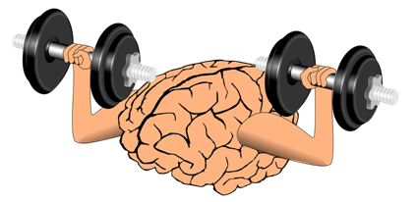

**The neural network consists of many neurons, each neuron takes an input, processes it and gives an output. Here’s a diagrammatic representation of a real neuron.**

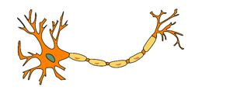

**Which of the following statement(s) correctly represents a real neuron?**

A. A neuron has a single input and a single output only

B. A neuron has multiple inputs but a single output only

C. A neuron has a single input but multiple outputs

D. A neuron has multiple inputs and multiple outputs

E. All of the above statements are valid

**Solution: (E)**

A neuron can have a single Input / Output or multiple Inputs / Outputs.

**Q2. Below is a mathematical representation of a neuron.**

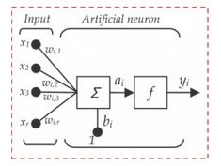**The different components of the neuron are denoted as:**

* **x1, x2,…, xN: These are inputs to the neuron. These can either be the actual observations from input layer or an intermediate value from one of the hidden layers.**
* **w1, w2,…,wN: The Weight of each input.**
* **bi: Is termed as Bias units. These are constant values added to the input of the activation function corresponding to each weight. It works similar to an intercept term.**
* **a:  Is termed as the activation of the neuron which can be represented as**
* **and y: is the output of the neuron**

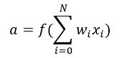

**Considering the above notations, will a line equation (y = mx + c) fall into the category of a neuron?**

A. Yes

B. No

**Solution: (A)**

A single neuron with no non-linearity can be considered as a linear regression function.

**Q3. Let us assume we implement an AND function to a single neuron. Below is a tabular representation of an AND function:**

|  |  |  |
| --- | --- | --- |
| **X1** | **X2** | **X1 AND X2** |
| **0** | **0** | **0** |
| **0** | **1** | **0** |
| **1** | **0** | **0** |
| **1** | **1** | **1** |

**The activation function of our neuron is denoted as:**

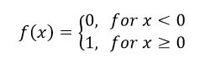

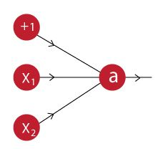

**What would be the weights and bias?**

**(Hint: For which values of w1, w2 and b does our neuron implement an AND function?)**

**Solution:** Bias = -1.5, w1 = 1, w2 = 1

A.

1. f(-1.5\*1 + 1\*0 + 1\*0) = f(-1.5) = 0
2. f(-1.5\*1 + 1\*0 + 1\*1) = f(-0.5) = 0
3. f(-1.5\*1 + 1\*1 + 1\*0) = f(-0.5) = 0
4. f(-1.5\*1 + 1\*1+ 1\*1) = f(0.5) = 1

**Q4. A network is created when we multiple neurons stack together. Let us take an example of a neural network simulating an XNOR function.**

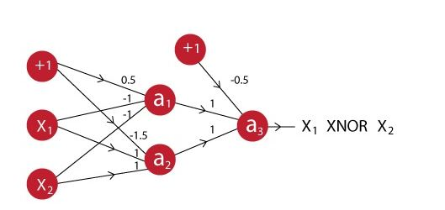

**You can see that the last neuron takes input from two neurons before it. The activation function for all the neurons is given by:**



**Suppose X1 is 0 and X2 is 1, what will be the output for the above neural network?**

A. 0

B. 1

**Solution: (A)**

Output of a1: f(0.5\*1 + -1\*0 + -1\*1) = f(-0.5) = 0

Output of a2: f(-1.5\*1 + 1\*0 + 1\*1) = f(-0.5) = 0

Output of a3: f(-0.5\*1 + 1\*0 + 1\*0) = f(-0.5) = 0

So the correct answer is A

**Q5. In a neural network, knowing the weight and bias of each neuron is the most important step. If you can somehow get the correct value of weight and bias for each neuron, you can approximate any function. What would be the best way to approach this?**

A. Assign random values and pray to God they are correct

B. Search every possible combination of weights and biases till you get the best value

C. Iteratively check that after assigning a value how far you are from the best values, and slightly change the assigned values values to make them better

D. None of these

**Solution: (C)**

Option C is the description of gradient descent.

**Q6. What are the steps for using a gradient descent algorithm?**

1. **Calculate error between the actual value and the predicted value**
2. **Reiterate until you find the best weights of network**
3. **Pass an input through the network and get values from output layer**
4. **Initialize random weight and bias**
5. **Go to each neurons which contributes to the error and change its respective values to reduce the error**

**Solution:** 4, 3, 1, 5, 2

**Q7. Suppose you have inputs as x, y, and z with values -2, 5, and -4 respectively. You have a neuron ‘q’ and neuron ‘f’ with functions:**

**q = x + y**

**f = q \* z**

**Graphical representation of the functions is as follows:**

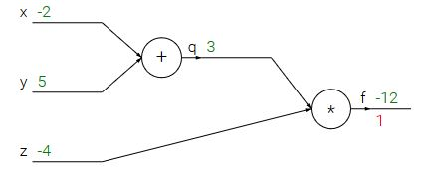

**What is the gradient of F with respect to x, y, and z?**

**(HINT: To calculate gradient, you must find (df/dx), (df/dy) and (df/dz))**

A. (-3,4,4)

B. (4,4,3)

C. (-4,-4,3)

D. (3,-4,-4)

**Solution: (C)**

Option C is correct.

**Q8. Now let’s revise the previous slides. We have learned that:**

* **A neural network is a (crude) mathematical representation of a brain, which consists of smaller components called neurons.**
* **Each neuron has an input, a processing function, and an output.**
* **These neurons are stacked together to form a network, which can be used to approximate any function.**
* **To get the best possible neural network, we can use techniques like gradient descent to update our neural network model.**

**Given above is a description of a neural network. When does a neural network model become a deep learning model?**

**Solution:**When you add more hidden layers and increase depth of neural network

More depth means the network is deeper. There is no strict rule of how many layers are necessary to make a model deep, but still if there are more than 2 hidden layers, the model is said to be deep.

**Q9. A neural network can be considered as multiple simple equations stacked together. Suppose we want to replicate the function for the below mentioned decision boundary.  
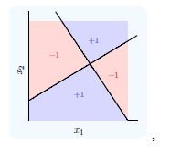**

**Using two simple inputs h1 and h2**

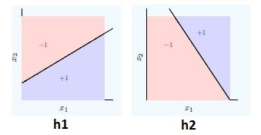

**What will be the final equation?**

**Solution:**  (h1 AND NOT h2) OR (NOT h1 AND h2)

**Q10. “Convolutional Neural Networks can perform various types of transformation (rotations or scaling) in an input”. Is the statement correct True or False?**

A. True

B. False

**Solution: (B)**

Data Preprocessing steps (viz rotation, scaling) is necessary before you give the data to neural network because neural network cannot do it itself.

**Q11. Which of the following techniques perform similar operations as dropout in a neural network?**

**Solution:** Bagging

Dropout can be seen as an extreme form of bagging in which each model is trained on a single case and each parameter of the model is very strongly regularized by sharing it with the corresponding parameter in all the other models.

**Q 12. Which of the following gives non-linearity to a neural network?**

**Solution:**Rectified Linear Unit

Rectified Linear unit is a non-linear activation function.

**Q13. In training a neural network, you notice that the loss does not decrease in the few starting epochs.**

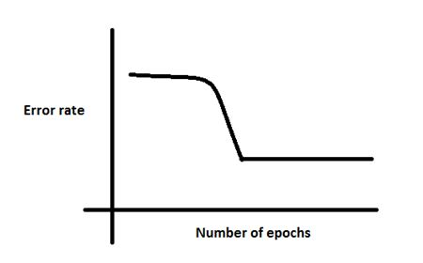

**The reasons for this could be:**

1. **The learning is rate is low**
2. **Regularization parameter is high**
3. **Stuck at local minima**

**What according to you are the probable reasons?**

A. 1 and 2

B. 2 and 3

C. 1 and 3

D. Any of these

**Solution: (D)**

The problem can occur due to any of the reasons mentioned.

**Q14. Which of the following is true about model capacity (where model capacity means the ability of neural network to approximate complex functions) ?**

**Solution:** As number of hidden layers increase, model capacity increases

**Q15. If you increase the number of hidden layers in a Multi Layer Perceptron, the classification error of test data always decreases. True or False?**

A. True

B. False

**Solution: (B)**

This is not always true. Overfitting may cause the error to increase.

**Q16.** **You are building a neural network where it gets input from the previous layer as well as from itself.**

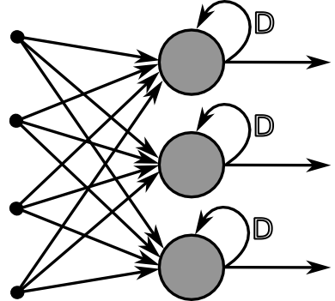

**Which of the following architecture has feedback connections?**

**Solution:**  Recurrent Neural network

**Q17. What is the sequence of the following tasks in a perceptron?**

1. **Initialize weights of perceptron randomly**
2. **Go to the next batch of dataset**
3. **If the prediction does not match the output, change the weights**
4. **For a sample input, compute an output**

**Solution:** 1, 4, 3, 2

**Q18. Suppose that you have to minimize the cost function by changing the parameters. Which of the following technique could be used for this?**

A. Exhaustive Search

B. Random Search

C. Bayesian Optimization

D. Any of these

**Solution: (D)**

Any of the above mentioned technique can be used to change parameters.

**Q19. First Order Gradient descent would not work correctly (i.e. may get stuck) in which of the following graphs?**

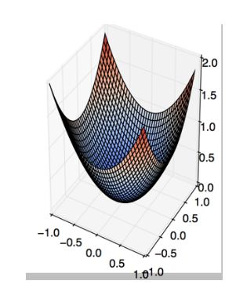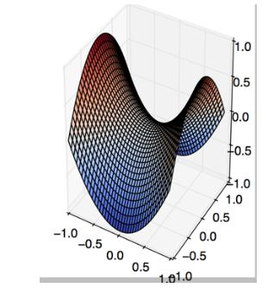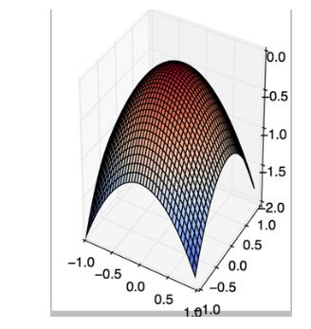

A B C

D. None of these

**Solution: (B)**

This is a classic example of saddle point problem of gradient descent.

**Q20. The below graph shows the accuracy of a trained 3-layer convolutional neural network vs the number of parameters (i.e. number of feature kernels).**

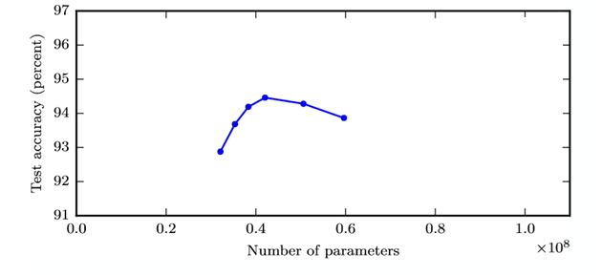  
**The trend suggests that as you increase the width of a neural network, the accuracy increases till a certain threshold value, and then starts decreasing.**

**What could be the possible reason for this decrease?**

**Solution:** As the number of kernels increase, they start to correlate with each other which in turn helps overfitting

As mentioned in option C, the possible reason could be kernel correlation.

**Q21. Suppose we have one hidden layer neural network as shown above. The hidden layer in this network works as a dimensionality reductor. Now instead of using this hidden layer, we replace it with a dimensionality reduction technique such as PCA.**

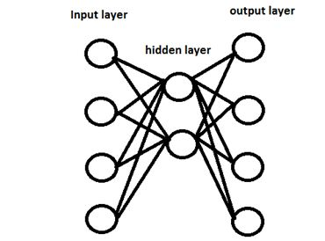

**Would the network that uses a dimensionality reduction technique always give same output as network with hidden layer?**

A. Yes

B. No

**Solution: (B)**

Because PCA works on correlated features, whereas hidden layers work on predictive capacity of features.

**Q22. Can a neural network model the function (y=1/x)?**

A. Yes

B. No

**Solution: (A)**

Option A is true, because activation function can be reciprocal function.

**Q23. In which neural net architecture, does weight sharing occur?**

A. Convolutional neural Network

B. Recurrent Neural Network

C. Fully Connected Neural Network

D. Both A and B

**Solution: (D)**

Option D is correct.

**Q24. Batch Normalization is helpful because**

**Solution:** It normalizes (changes) all the input before sending it to the next layer

**Q25. Instead of trying to achieve absolute zero error, we set a metric called bayes error which is the error we hope to achieve. What could be the reason for using bayes error?**

A. Input variables may not contain complete information about the output variable

B. System (that creates input-output mapping) may be stochastic

C. Limited training data

D. All the above

**Solution: (D)**

In reality achieving accurate prediction is a myth. So we should hope to achieve an “achievable result”.

**Q26. The number of neurons in the output layer should match the number of classes (Where the number of classes is greater than 2) in a supervised learning task. True or False?**

A. True

B. False

**Solution: (B)**

It depends on output encoding. If it is one-hot encoding, then its true. But you can have two outputs for four classes, and take the binary values as four classes(00,01,10,11).

**Q27. In a neural network, which of the following techniques is used to deal with overfitting?**

A. Dropout

B. Regularization

C. Batch Normalization

D. All of these

**Solution: (D)**

All of the techniques can be used to deal with overfitting.

**Q28. Y = ax^2 + bx + c (polynomial equation of degree 2)**

**Can this equation be represented by a neural network of single hidden layer with linear threshold?**

A. Yes

B. No

**Solution: (B)**

The answer is no because having a linear threshold restricts your neural network and in simple terms, makes it a consequential linear transformation function.

**Q29. What is a dead unit in a neural network?**

**Solution:** A unit which doesn’t update during training by any of its neighbour

**Q30. Which of the following statement is the best description of early stopping?**

**Solution:**Simulate the network on a test dataset after every epoch of training. Stop training when the generalization error starts to increase

**Q31. What if we use a learning rate that’s too large?**

Solution: Network will not converge

Option B is correct because the error rate would become erratic and explode.

**Q32. The network shown in Figure 1 is trained to recognize the characters H and T as shown below:**

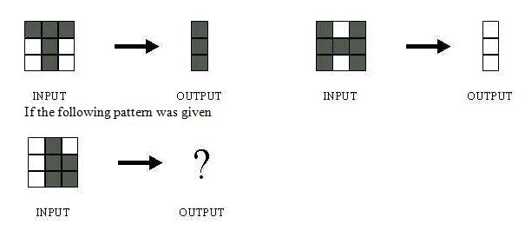

**What would be the output of the network?**

1. 
2. 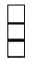
3. 
4. Could be A or B depending on the weights of neural network

**Solution: (D)**

Without knowing what are the weights and biases of a neural network, we cannot comment on what output it would give.

**Q33. Suppose a convolutional neural network is trained on ImageNet dataset (Object recognition dataset). This trained model is then given a completely white image as an input.The output probabilities for this input would be equal for all classes. True or False?**

A. True

B. False

**Solution: (B)**

There would be some neurons which are do not activate for white pixels as input. So the classes wont be equal.

**Q34. When pooling layer is added in a convolutional neural network, translation in-variance is preserved. True or False?**

A. True

B. False

**Solution: (A)**

Translation invariance is induced when you use pooling.

**Q35. Which gradient technique is more advantageous when the data is too big to handle in RAM simultaneously?**

A. Full Batch Gradient Descent

B. Stochastic Gradient Descent

**Solution: (B)**

Option B is correct.

**Q36. The graph represents gradient flow of a four-hidden layer neural network which is trained using sigmoid activation function per epoch of training. The neural network suffers with the vanishing gradient problem.**

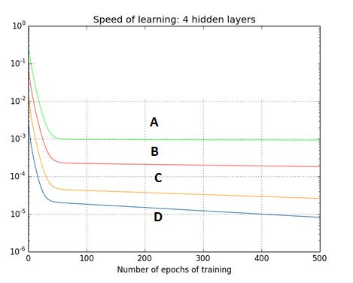

**Which of the following statements is true?**

**Solution:**Hidden layer 1 corresponds to D, Hidden layer 2 corresponds to C, Hidden layer 3 corresponds to B and Hidden layer 4 corresponds to A

This is a description of a vanishing gradient problem. As the backprop algorithm goes to starting layers, learning decreases.

**Q37. For a classification task, instead of random weight initializations in a neural network, we set all the weights to zero. Which of the following statements is true?**

**Solution:** The neural network will train but all the neurons will end up recognizing the same thing

**Q38. There is a plateau at the start. This is happening because the neural network gets stuck at local minima before going on to global minima.**



**To avoid this, which of the following strategy should work?**

**Solution:**Jitter the learning rate, i.e. change the learning rate for a few epochs

Option C can be used to take a neural network out of local minima in which it is stuck.

**Q39. For an image recognition problem (recognizing a cat in a photo), which architecture of neural network would be better suited to solve the problem?**

**Solution:** Convolutional Neural Network

Convolutional Neural Network would be better suited for image related problems because of its inherent nature for taking into account changes in nearby locations of an image

**Q40.** **Suppose while training, you encounter this issue. The error suddenly increases after a couple of iterations.**

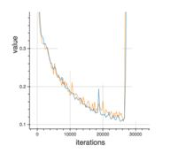

**You determine that there must a problem with the data. You plot the data and find the insight that, original data is somewhat skewed and that may be causing the problem.**

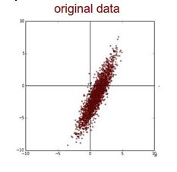

**What will you do to deal with this challenge?**

**Solution:**Apply PCA and then Normalize

First you would remove the correlations of the data and then zero center it.

**Q41. Which of the following is a decision boundary of Neural Network?**

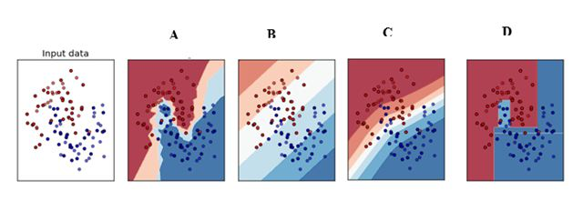

A) B

B) A

C) D

D) C

E) All of these

**Solution: (E)**

A neural network is said to be a universal function approximator, so it can theoretically represent any decision boundary.

**Q42. In the graph below, we observe that the error has many “ups and downs”**

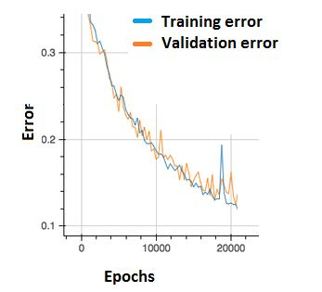

**Should we be worried?**

A. Yes, because this means there is a problem with the learning rate of neural network.

B. No, as long as there is a cumulative decrease in both training and validation error, we don’t need to worry.

**Solution: (B)**

Option B is correct. In order to decrease these “ups and downs” try to increase the batch size.

**Q43. What are the factors to select the depth of neural network?**

1. Type of neural network (eg. MLP, CNN etc)
2. Input data
3. Computation power, i.e. Hardware capabilities and software capabilities
4. Learning Rate
5. The output function to map

A. 1, 2, 4, 5

B. 2, 3, 4, 5

C. 1, 3, 4, 5

D. All of these

**Solution: (D)**

All of the above factors are important to select the depth of neural network

**Q44. Consider the scenario. The problem you are trying to solve has a small amount of data. Fortunately, you have a pre-trained neural network that was trained on a similar problem. Which of the following methodologies would you choose to make use of this pre-trained network?**

**Solution:** Freeze all the layers except the last, re-train the last layer

If the dataset is mostly similar, the best method would be to train only the last layer, as previous all layers work as feature extractors.

**Q45. Increase in size of a convolutional kernel would necessarily increase the performance of a convolutional network.**

A. True

B. False

**Solution: (B)**

Increasing kernel size would not necessarily increase performance. This depends heavily on the dataset.